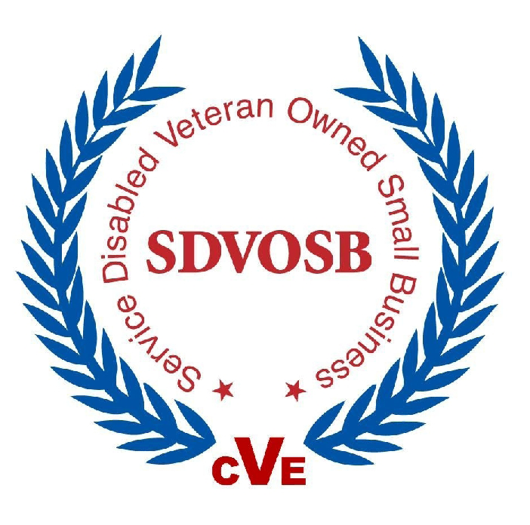

SAG Corporation, established in 1985, is an industry leader in manpower/personnel focused research and reporting, economic analysis, econometric modeling and custom software design. A Service-Disabled Veteran-Owned Small Business, SAG offers multi-disciplinary technical support.

Business Solutions…SAG develops human resource tools and employs state-of-the-art statistical and econometric modeling techniques to help clients find answers to problems. We support cost/benefit analysis, database consolidation, workforce management, research and analysis of personnel and compensation issues, employee retention, total ownership costing, compensation system analysis, and data collection and analysis.

Department of Veterans Affairs Related Support…SAG Corporation has provided on-site support for the past two years to the VA Office of the Actuary, developing predictive models to be used to forecast utilization of VA services and benefits. Conducted a Program Review and Assessment of the Health Eligibility Center’s Informatics Division and supported the VA Burial Program Evaluation to assist in ascertaining the extent to which VA’s Burial Program has reached its stated goals and impact this program has had on the lives of veterans and their families. Performed Concurrent Receipt Analysis study for OSD and an Analysis and Reporting of Attitudes, Opinions and Post Service Earnings of Retired Military for the Defense Manpower Data Center (DMDC). Performed post 9/11 GI Bill Analysis of Cost Effectiveness for the Defense Manpower Data Center and U.S. Navy using Veterans Benefit Administration and DMDC data.

Workforce Assessment...SAG supported the Congressionally directed Military Death Benefits Study under contract to OSD. The study was briefed to Congress resulting in an increase in both the Military Death Benefit and SGLI insurance. Also supported an IRS pay study on pay-banding and civilian manpower work force assessment and the Ninth, Tenth and Eleventh Quadrennial Reviews of Military Compensation. Briefed Congressman Tom Davis’ staffers as they prepared for new Government Reform Committee initiatives. Supported the development of a Registered Nurse Supply and Demand Model for DHHS and the Defense Advisory Committee on Military Compensation (DACMC) for OSD. Performed studies for the Small Business Administration to Determine the Effects of Extended Reserve and National Guard Activations on Small Business, Veteran Entrepreneurship, and Longitudinal Analysis of Veteran-Owned and Veteran Business Owners.

Cost/Benefit Analysis …SAG specialize in defensible analysis of policy proposals that realistically assess and compare total taxpayer costs vs. benefits.
- The Navy Pharmacy Officer Manning study reviewed manning requirements and proposed a more cost-effective mix of military, civilian, and contractor support.
- The BRAC Analysis of RTC Consolidation analyzed training structure and consolidation opportunities and assessed the Navy's cost and return on investment (ROI) for the proposed consolidation of Navy recruit training activities at NTC Great Lakes. The study included a review of the Cost of Base Realignment Actions (COBRA) model and use of configuration analysis as a proxy for cost analysis. Our staff has also performed Functional Economic Analysis (FEA) and Activity Based Costing (ABC).

Information Technology…SAG provides custom database design, development and maintenance; custom applications; website development and hosting; and legacy system software conversion. We provide full-service support for hardware, software and data integration. Support the U.S. Navy and web-enabled U.S. Army Selective Reenlistment Bonus Systems (SRB) as well as the web-enabled U.S. Navy Officer Personnel Planning System (NOPPS) operating on an Oracle-based Navy Manpower Program and Budgeting System (NMPBS).

Our People…we offer a professional team with direct experience in the economic analysis of personnel and workforce management issues. Our staff includes policy experts, applied economists, compensation experts, operations research analysts, software engineers, and service disabled military veterans.

Our Clients…we assist both private and public sector clients, including the following:
- Department of Defense and the Military Services
- Department of Veterans Affairs
- Department of Health and Human Services
- Small Business Administration
- Department of Labor
- Internal Revenue Service

Contracts…SAG is available on a MOBIS GSA schedule, and a subcontractor on VETS GWAC, COMPLETRS, DHHS PSC, and Seaport-e contracts.

NAICS codes…541511, 541611, 541618, 541690, 541720, 541990

Please Contact…Richard Parodi, (703) 854-1472, rparodi@sagcorp.com or visit SAG’s website at http://www.sagcorp.com

