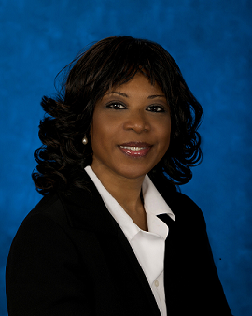
Director for Strategic Outreach

Mrs. Bankston-Carter is the Director of Strategic Outreach at OSDBU. Ms. Bankston-Carter has served on a task force with the then Senator Barrack Obama, Secretary’s Seamless Transition Task Force, the Severely Wounded Warriors taskforce and numerous other committees of service to veterans and the nation.
Chanel Bankston-Carter’s educational background began at the University of Arkansas, Fayetteville, where she received a Bachelor of Science in Human Development Family Studies with an emphasis on Juvenile Delinquency. She received her Masters of Science in Counseling Psychology from the University of Texas. She is currently pursuing a Doctoral degree in Human Services with an emphasis in Counseling Studies from the University of Washington.
Ms. Bankston-Carter is an Army veteran. She worked for Fort Hood’s Social Work Services as a Family Advocacy Counselor and also worked as a National Supervisor for Concentra Managed Care.

Chanel’s passion for veterans began when she worked in private practice as a Counselor for veteran’s that were being medically discharged, transitioning, or retiring from the military. Her VA career began at the Department of Veterans Affairs Waco, TX Regional Office, where she was out-based at Fort Hood, Texas as a Counseling Psychologist, providing vocational rehabilitation counseling and employment services to veterans or active duty service members being medically discharged from the military. From there she moved to Washington, D.C. Veterans Affairs Central Office and worked as a Rehabilitation Counseling Specialist/Liaison for the Eastern United States. She has also worked for the Office of the Secretary, Center for Women Veterans and was the Director of the Customer Service Center at VA Central Office.

Mrs. Bankston-Carter is very active in her community, serving on the Superintendent Advisory Counsel for Prince William County Public Schools and Principal Advisory Counsel. She is a member of the Alpha Kappa Alpha Sorority, Inc. She is also very active in the military community and with Women Veterans. She is a graduate of the 2002 and 2008 VA Leadership Programs.

