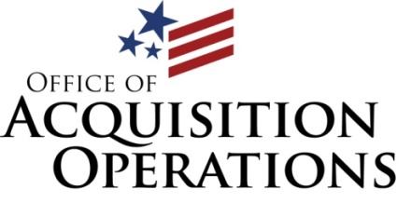
7:30-9:00AM Check-in and networking

9:00-9:05AM National Anthem, USMC Ceremonial Platoon, Quantico

9:10-9:20AM Welcome Remarks: Mr. Elegear Primus Deputy, Associate Executive Director, Strategic Acquisition Center

9:25-9:40AM Mr. Greg Giddens, Principal Executive Director, Office of Acquisition, Logistics and Construction

9:45:-10:10AM Mr. Michael Feil, MyVA Task Force
10:15-10:40AM Mr. Tom Murphy, Veterans Benefits Administration

10:40-10:50AM BREAK

10:55-11:20AM Ms. Anita Hanson, Deputy Under Secretary for Management, National Cemetery Administration

11:25-11:50AM Mr. Craig Robinson, Associate Deputy Assistant Secretary, National Acquisition Center

11:55-12:20PM Mr. Ricky Lemmon, Acting Deputy Procurement & Logistics Officer,
Veterans Health Administration (VHA)

12:20-1:20PM Lunch

1:25-1:50PM Mr. Thomas Leney, Executive Director, Office of Small Disadvantaged
Business Utilization

1:55-2:20PM Ms. Penny Nechanicky, National Director, Prosthetics & Sensory Aids, VHA

2:25- 2:50PM Mr. David Elizalde, Deputy Chief Logistics Officer, VHA

2:50-3:00PM BREAK

3:05-3:45PM Panel Session/Question and Answer (panel to be made up of speakers and/or Subject Matter Experts in each field)
Ms. Barb Stuetzer, Legal Representative, Office of General Counsel

3:50PM -End Closing Remarks: Ms. Phyllis Bower, Executive Director, OAO

