Department of Veterans Affairs
Senior Executive Biography

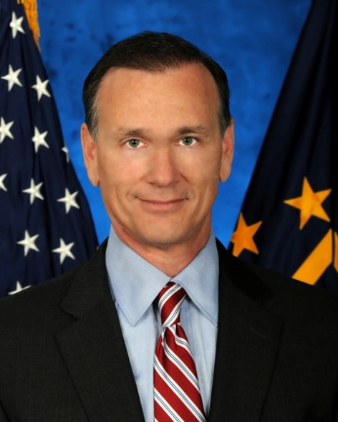
Joseph Viani, MSS
Executive Director for the Human Capital Investment Plan
Office of Human Resources and Administration

Joseph A. Viani was selected as the Executive Director for the Human Capital Investment Plan (HCIP) in September, 2010. As the Executive Director for the HCIP, and the Human Resources and Administration’s (HR&A) Strategic Management Group (SMG), Mr. Viani is responsible for managing the overall HCIP transformational portfolio valued at nearly $300 million annually. Prior to becoming the Executive Director, Mr. Viani served as the Director, HRA/SMG. Before joining the VA in October 2009, he leveraged his expertise in operational, strategic planning, and leadership as an associate at Booz Allen Hamilton.

CAREER CHRONOLOGY:

2010 – Present Executive Director, Human Capital Investment Plan
Senior Executive Service
2009 – 2010 Director, Strategic Management Group, Veterans Administration, Washington, D.C.
2008 – 2009 Consultant Associate Level III, Booz Allen Hamilton, McLean, VA
2003 – 2008 Assistant Director Manpower Personnel & Policy, Office of the Assistant Secretary of Defence/Reserve Affairs, Pentagon, Washington D.C. US
2006 – 2007 Director, Air Operations/Senior Joint Air Forces Liaison, U.S. Embassy
Islamabad, Pakistan
2001 – 2003 Director, Operations and Requirements, HQ, U.S. Air Force, Pentagon
Washington, D.C.
2000 – 2001 Division Chief, Requirements, HQ, U.S. Air Force, Pentagon, Washington, D.C.

MAJOR MILITARY ASSIGNMENTS/AWARDS/DECORATIONS:

Immediately prior to his corporate experience, Mr. Viani (Colonel, USAF) served as the Senior U.S. Air Force advisor and the Director of Air Operations, Islamabad, Pakistan during Operation Enduring Freedom. Mr. Viani’s assignments have been a mix of staff, operational, joint, and executive level duties, including Assistant Director, Office of the Assistant Secretary of Defense, and Director for Operations and Requirements to the Chief, Air Force Reserves, Pentagon. Mr. Viani was assigned to the Pentagon on September 11, 2001 and served as the Director of Operations, Crisis Action Team in the immediate response to the Pentagon attack. Prior to his Pentagon assignment, Mr. Viani was the Deputy Division Chief, HQUSCENTCOM, during operations DESERT FOCUS, THUNDER, and STRIKE. Mr. Viani flew the HC-130N/P, Combat Search and Rescue and B-52H aircraft with evaluator and instructor qualifications. Mr. Viani completed a 28 year career upon his retirement from the U.S. Air Force as a Colonel in 2008.
EDUCATION:

Graduate Air Command and Staff College
Masters, Strategic Studies, U.S. Army War College
1979 B.A. English Literature from the University of Florida

AWARDS AND HONORS:

Defense Superior Service Medal
Legion of Merit
Defense Meritorious Service Medal

PROFESSIONAL MEMBERSHIPS AND ASSOCIATIONS:

Air Force Association – Member
Reserve Officers Association – Member

