Christy L. Jackiewicz
Outreach Program Manager
Acting Mentor Protégé Program Manager

GSA’s Office of Small Business Utilization

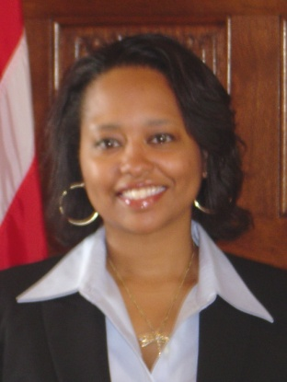
Christy is currently managing a National Outreach Program to improve access to information and opportunities for small businesses. She has 25 years of public service with GSA which has included contracting and policy prior to taking a job in the small businesses office in 2000. Christy achieved her MBA in 2003 and has also been a small business owner, blogger, and non-profit business developer which gave her a deeper love for this community of entrepreneurs.

Christy has been mentored by many GSA leaders through structured and informal relationships. She continues those relationships to help improve her impact on the way the government engages with small businesses. Christy has a passion for sustainable business practices, access to opportunities to change policy, and frequently tweets for GSA on the coming issues that will affect small businesses.

She is known for constantly seeking out creative and modern ways to connect and respond to the changing needs of others.

