Department of Veterans Affairs
Senior Executive Biography

Thomas J. Murphy
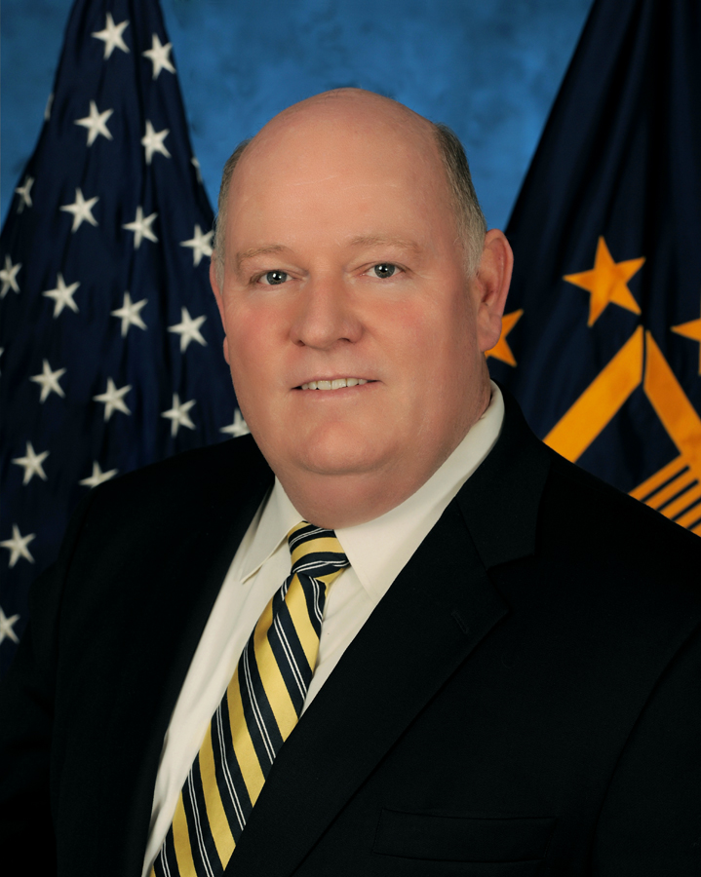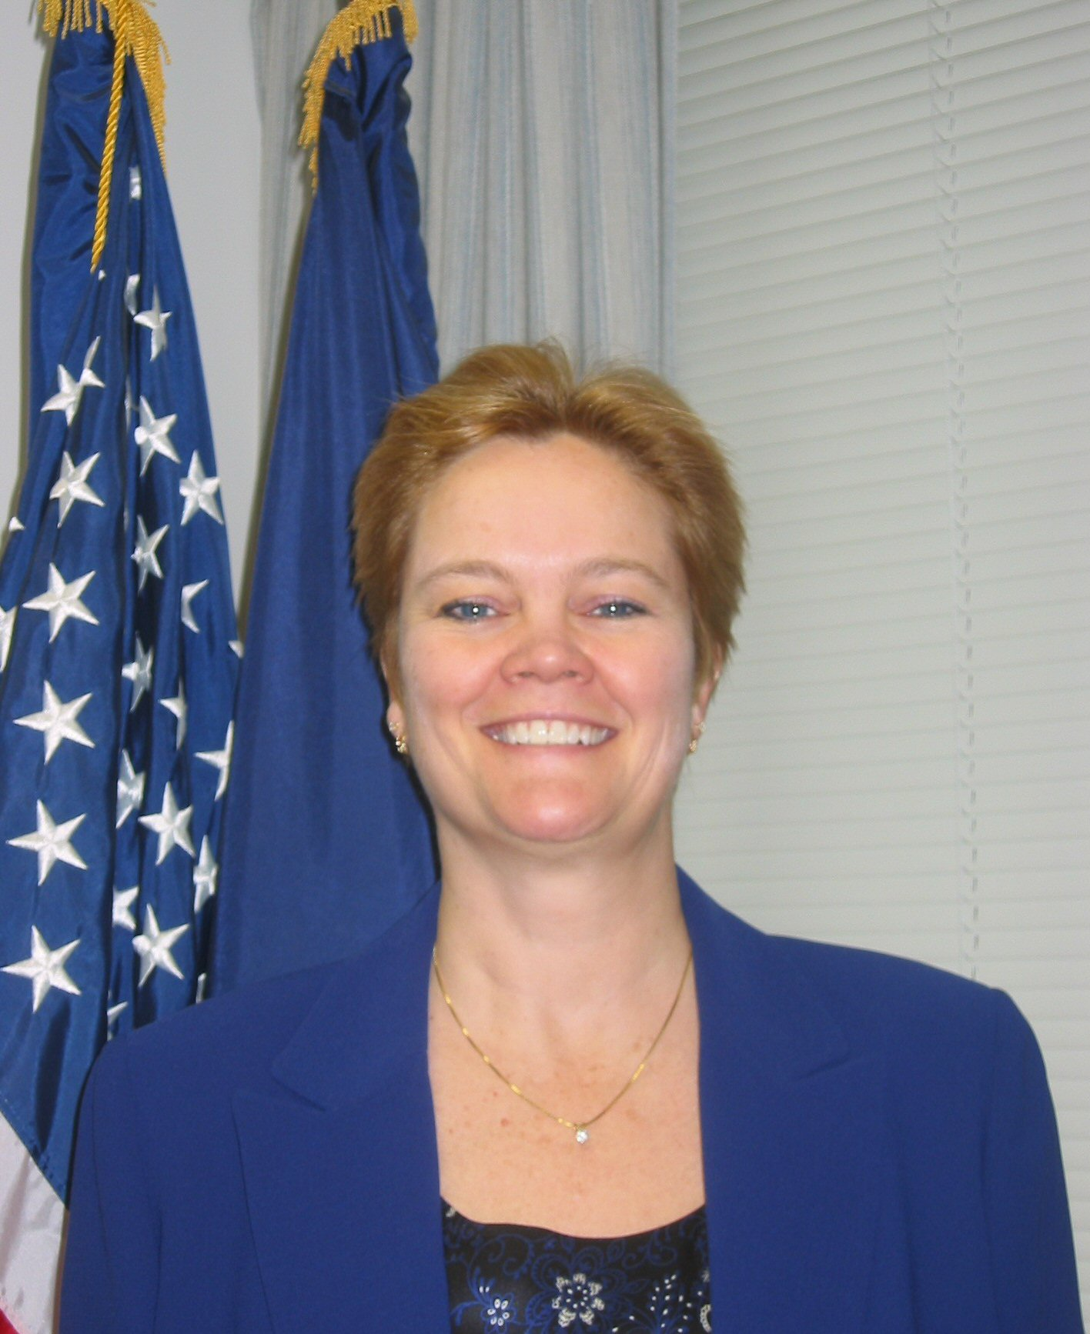
Director
Compensation Service

Thomas J. Murphy was appointed Director of Compensation Service on August 1, 2010. As Director, Mr. Murphy is responsible for the development and implementation of policies and procedures related to the administration of VA disability and death compensation programs, which paid $60.1 billion dollars in benefits in fiscal year 2014 to over 4.3 million eligible veterans and dependents.

Prior to his appointment as Compensation Director, Mr. Murphy served as a the Director of the San Juan, Puerto Rico Regional Office and was responsible for the administering of federal benefits and services to over 151,000 veterans and beneficiaries living in Puerto Rico, Vieques, Culebra, and the U.S. Virgin Islands. Programs included compensation, pension, insurance, home loan guaranty, and vocational rehabilitation.

Mr. Murphy joined the Veterans Benefits Administration from The Home Depot where he was a Director, Merchandise Planning. In this position, he directed the merchandise planning of the hardware department in over 1,950 stores with over $8.5 billion in annual sales. Prior to joining The Home Depot, Mr. Murphy was a Senior Tactical Planning Manager for Qwest Communications, responsible for common systems growth of the local telephone network in 5 western states.

Mr. Murphy worked for the Federal Government for 10 Years in the Department of Defense in a variety of positions, including such positions as Logistics Manager, Administrative Officer, Training Manager, Staffing Specialist, and Chief of Employee Services. He joined the Federal Government from Litton, Saudi Arabia Limited where he was a Training Manager, Senior Engineering Instructor, and Installation and Checkout Engineer.

He retired from the military as a Major after service 15 years in the Colorado National Guard and 6 years in the Marine Corps Reserve. His military assignments included Assistant Deputy Chief of Staff for Personnel, Battalion Operations Officer, Battery Commander, and Battery Fire Direction Officer.

Mr. Murphy and his wife reside in the Washington, DC Metropolitan Area.

CAREER CHRONOLOGY:
August 2010 – Present: Director, Compensation Service
August 2009 – July 2010: Director, San Juan Regional Office

EDUCATION:
1994 – Masters of Business Administration, University of Colorado
1986 – Bachelor of Science, Human Resource Management, Colorado Christian University

