ORDERING INSTRUCTIONS FOR USING
THE
STRATEGIC ACQUISITION CENTER (SAC)

Da Vinci Si Robotic Surgical System

Contract Number VA119-14-D-0001

February 28, 2014

1. Background: 3
2. Compliance with FAR: 3
3. Developing Your Requirement(s): 3
4. Ordering Procedures 4
5. Contact Information 7

- Background:
On February 28, 2014, the Strategic Acquisition Center (SAC) established a Sole Source Requirements Contract (VA119-14-D-0001) with Intuitive Surgical, Inc. The Da Vinci Si Robotic Surgical System, (henceforth referred to as Da Vinci System), simplifies Minimally Invasive Surgery (MIS) procedures. These techniques are proven to reduce the risk of infection, minimize blood loss when compared to traditional procedures, significantly reducing postoperative pain leading to a faster patient recovery time, reduce patient hospital stay, and contribute to positive psychological outcomes as it pertains to postsurgical scarring.
The Da Vinci System is consistent with Veteran Affairs (VA) policies to standardize the types and categories of supplies and services to ensure consistency with patient care and particular needs. The Da Vinci System is approved by the United States Food and Drug Administration (FDA) Centers for Devices and Radiological Health (CDRH).

The above mentioned Requirements Contract consists of the Da Vinci System, accessories for the system, services consisting of installation, proctoring, surgeon training, and one-year manufacturer’s warranty and maintenance services.

This guide is intended to simplify the process for acquiring the Da Vinci System, accessories and services.

1.1 Period of Performance – Base Year with Four (4) One (1) Year Option:

Base Year: March 10, 2014 – March 9, 2015
Option Year 1: March 10, 2015 – March 9, 2016
Option Year 2: March 10, 2016 – March 9, 2017
Option Year 3: March 10, 2017 – March 9, 2018
Option Year 4: March 10, 2018 – March 9, 2019

- Compliance with FAR:
FAR Part 16.503 Requirements Contracts;
FAR Part 16.505 Ordering
FAR Part 12 Acquisition of Commercial Items
FAR Part 13 Simplified Acquisition Procedures

- Developing Your Requirement(s):
  - Since this is a Requirements contract under FAR Part 16.503, the Contracting Officer is not required to synopsize orders.

  - Individual orders shall list the CLINs associated with the services and/or supplies to be delivered on each order. Orders shall be within scope and issued within the period of performance, this can be done by reviewing the base contract.

  - Minimum ordering limitation is $5,000.00.

  - Performance-based acquisition methods must be used to the maximum extent practical, if the contract or order is for a service (see FAR 37.102(a) and FAR 37.6).

  - For Task Orders and Delivery Orders place by another agency outside the Strategic Acquisition Center, the ordering agency shall:

- Develop an Acquisition Plan (Subpart 7.1);

- Comply with conditions and limitations imposed on the use of funds (e.g. 31 U.S.C. 1501(a)(1)); and

- Comply with all FAR requirements for a bundled contract when the order meets the definition of “bundled contract” (see FAR 2.101(b)).

  - Architect and Engineering as defined in FAR 2.101(b) and procedures set under FAR 36 is not within the scope of this contract.

  - No protest under Subpart 33.1 is authorized in connection with the issuance or proposed issuance of an order under a task order or delivery order, except for:

- A protest on the grounds that the order increases the scope, period, or maximum value of the contract; or

- A protest of an order valued in excess of $10 million. Protest of orders in excess of $10 million may only be filed with the Government Accountability Office in accordance with the procedures at FAR 33.104.

3.9 Awards under Public Law 111-5, American Recovery and Reinvestment Act do not apply

3.10 Warranties:
a) System Warranty (Section 8.0, Page 152) Contractor shall provide a twelve month warranty that includes product support for delivered da Vinci Si Robotic Surgical System.

b) Instruments and Accessories (Section B.5, Paragraph 2 on Page 158) The Contractor warrants and implies that the items delivered hereunder are merchantable and fit for use for the particular purpose described in this contract.” The Endoscope and Camera will have a 1 year warranty for manufacturer defects and Accessories will have a 90 day warranty for manufacture defects.

- Decentralized Ordering Procedures
  - Customers may contact Intuitive as they develop their requirement. Coordinating with Intuitive Surgical, Inc. may be important for requirement development and Market Research (See 4.6)

  - The SOW may be utilized in developing and refining your requirement. See Contract—Statement of Work, beginning on Page 146.

  - Budget for your requirement utilizing the Schedule of Supplies/Services, beginning on Page 5 of the Contract.

NOTE: The SAC is a fee-for-service organization.

  - If your organization has a Service Level Agreement (SLA) with the Office of Acquisition Operations (OAO), the fee will be assessed on a quarterly basis through the Supply Fund office. The SAC charges a nominal fee of two-percent (2%) on obligations for all orders placed against this contract. The savings afforded by this contract, which includes an average discount of 1.5% from Intuitive Surgical, Inc. commercially published catalog and offset the cost of the SLA fee. Although the discounts offset the cost of the fee, it is important to budget for this fee.
4.5 Prior to placing your Delivery/Task Orders, please send the list of items you’re ordering to
Intuitive Surgical, Inc. by e-mail, order.support@intusurg.com to include Item Number and
Quantity, in order to obtain shipping charges. Please send all Delivery/Task Orders via e-mail
only.

4.6 Listed below is the phone number if you have questions regarding an order
Phone Number: 1-800-876-1310 Opt 4.

4.7 Place the Order (eCMS procedures)
Ordering agencies will place all Delivery/Task Orders through eCMS including actions under the micro-purchase threshold of $3,000.00). PURCHASE CARDS ORDERS WILL NOT BE ACCEPTED BY THE CONTRACTOR. The following are eCMS procedures for placing an order with eCMS.
Create a purchase order transaction in IFCAP to obligate funds.
From your Contracting Module desktop highlight the prerequisite contract action in eCMS and click on either right click on the Action ID or left click on the icon to get the Process Coach. NOTE: the contract action copied should be an IDC-Con action type.
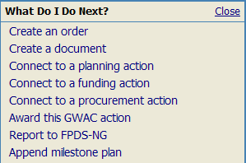
- Click on .
- Click the radio button.
- Click .
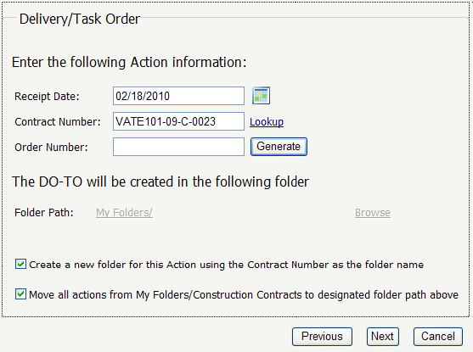
- Enter the Contract Number (VA119-14-D-0001).
- Generate an Order Number (Should be a “J”).
- Determine whether to create a new folder or use the existing folder.
- Create a folder by either checking the box to create a folder using the Contract Number and uncheck the Move all actions box.
-or-
Uncheck the boxes and use the My Folder or Browse links to move the
action to an existing folder, new folder, or new drawer. After selecting a
folder the Folder Path will change. NOTE: If this award action will be used by
others for generating orders, you probably want to use the existing folder.
- Click .
- Click the radio button.
- Click .
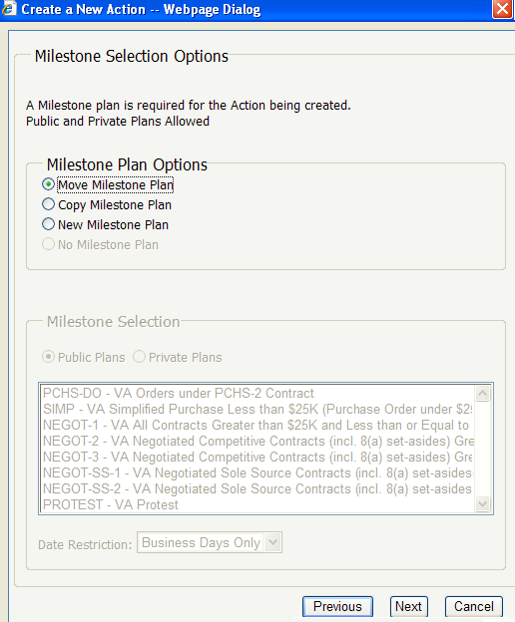
NOTE: It is recommended that you move an existing milestone plan to the action being created and update it from that action.
–or–
- Click the if you also want a milestone plan in the source action.
–or–
- Click .
- Select a Public Plan or Private Plan if selecting a New Milestone Plan.
- Select the .
- Click .
NOTE: Make sure that the milestone plan you select has the 5 ‘Phase’ milestones.
- If the Contract has items, you will need to determine whether or not to copy the items (uncheck any unwanted items).
- Click .
- Click .
Open the Order action to the tab. Update the title, from the copied action, as needed. Add comments if desired.
Navigate to the tab and complete the data values.
Navigate to the tab and add, edit or delete items as necessary.
Navigate to the tab and add , rename , or delete files as necessary. For documents that are connected through related actions you can copyor move the document(s) to the current action.
Navigate to the tab and report the order to FPDS. NOTE: For additional assistance with reporting to FPDS, please refer to your FPDS Reporting User’s Guide.
Navigate to the tab and award the order in eCMS. NOTE: For additional assistance with awarding, please refer to your FPDS Reporting User’s Guide.

Congratulations! You have successfully awarded your order in eCMS. The next step is to ensure that your contract file is properly documented.

4.8 Document Your File (eCMS)
In addition to any and all contract file documentation required at your local office, you must, at a minimum, include the following documentation in the purchase file (also known as eCMS Briefcase):

- Date of order;
- Contract Number and Order Number;
- For supplies and services, contract item number and description, quantity, and unit price or estimated cost or fee;
- Delivery or performance schedule;
- Place of delivery or performance (including consignee);
- Any packaging, packing, and shipping instructions;
- Accounting and appropriation data; and
- Method of payment and payment office;

- Contact Information
  - VA Enterprise-level Support staff
Questions? Need help? We’re here to help:

James Poe, Contracting Officer, Strategic Acquisition Center
james.poe@va.gov

Gregory Hanks, Contract Specialist, Strategic Acquisition Center
gregory.hanks2@va.gov

