Ricky L. Lemmon, BS 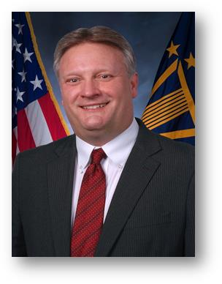
Director, Service Area Office - Central Region
Veterans Health Administration

Mr. Ricky Lemmon is serving as the Acting Chief Procurement & Logistics Officer, effective Monday, October 19, 2015.

Mr. Lemmon joined the Senior Executive Service on November 5, 2012 as the Director, Veterans Health Administration, Service Area Office (SAO) Central Region in Murfreesboro, TN. In this role he provides operational oversight to seven Network Contracting Offices and the Program Contracting Activity Central (PCAC). SAO Central Network Contracting Offices provide procurement support to Veterans Integrated Service Networks 9, 10, 11, 12, 16, and 23. PCAC provides procurement support to national program offices that include VA Office of Asset and Enterprise Management, VHA Office of Informatics and Analytics, and Workforce Management and Consulting. The SAO Central Region is comprised of over 800 personnel that annually contract for over $3 billion dollars of goods and services in support of VA Medical Centers and other customers. During his tenure with the Veterans Health Administration, Mr. Lemmon has provided leadership in many of the acquisition transformational initiatives that have occurred. These initiatives included the development of an organizational structure for VHA Network Contracting Activities that was based on product line teams, and development and implementation of the ordering officer concept that allowed VHA to eliminate approximately 900 warrants held by non-acquisition personnel.

CAREER CHRONOLOGY:
2012 – Present Director Service Area Office Central Region, Department of Veterans Affairs
2009 – 2012 Deputy Director Service Area Office Central Region, Department of Veterans Affairs
2004 – 2009 Network Contract Manager, VISN 15, Department of Veterans Affairs
2001 – 2004 Assistant Health Systems Acquisition Manger, VISN 15, Department of Veterans Affairs

EDUCATION:
B.S. 1986, Oral Roberts University, Tulsa, OK

PROFESSIONAL CERTIFICATIONS:

Level III Federal Acquisition Certificate in Contracting
Level III Contracting Officer Warrant

PROFESSIONAL MEMBERSHIPS AND ASSOCIATIONS:

Member of the National Contract Management Association (NCMA), since 1995.

