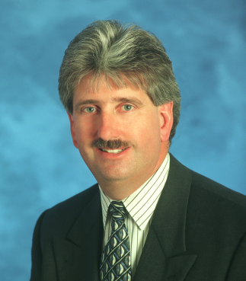

Romano (Rom) Mascetti, III
Deputy Assistant Secretary for Information Technology Resource Management
& Chief Financial Officer
Office of Information & Technology (OI&T)
Department of Veterans Affairs (VA)

Rom Mascetti has been the Deputy Assistant Secretary for Information Technology Resource Management (ITRM) and the Chief Financial Officer for the Office of Information & Technology since July 2008. He is the principal advisor on IT resource requirements as well as leading IT’s acquisition strategies, improving customer operational relationships, providing workforce development, multi-year programming, budget formulation, execution, cost accounting and capital asset management. He is charged with managing and ensuring the sound financial stewardship of VA’s IT resources that encompasses more than 8,000 employees and an annual budget $4.0 billion annually.

Prior to accepting this position, he served as VA’s Associate Deputy Assistant Secretary (ADAS) for Financial Policy. In this capacity, he was responsible for preparing VA’s consolidated financial statements and achieving its first clean audit opinion. He also provided policy development and oversight for VA in pay administration, budget execution, cost accounting, and debt management as well as internal controls management,. He was also the Department’s ADAS for Financial Operations which included management of VA’s Franchise Fund and VA’s Financial Services Center in Austin, Texas, and the Debt Management Center in St. Paul, Minnesota.

Before joining VA’s Office of Finance in February 1995, Mr. Mascetti was Executive Assistant to VA’s Assistant Secretary for Acquisition & Facilities. He served as principal advisor on many VA programs and policy issues, including acquisition, construction, materiel management, capital facilities, real property, enhanced use leasing, asset management, national security, emergency preparedness and environmental affairs. Early in his career, he held staff and project management positions within VA’s Office of Construction and Facilities Management.

Mr. Mascetti was also the Executive Director of VA’s Transition Planning Team to convert VA’s supply depot distribution network into a commercial “just in time” distribution system for pharmaceuticals, medical/surgical supplies and subsistence. With 40 years of dedicated and successful VA service, he has been involved in numerous programs and has been recognized with multiple awards.

A native of Washington, DC, he is a graduate of Cornell University where he earned his Bachelor of Science and Master’s degrees in Mechanical Engineering. He is married with two children and resides in Odenton, Maryland.

