Michael W. Feil
202-309-6861
Michael.feil2@va.gov

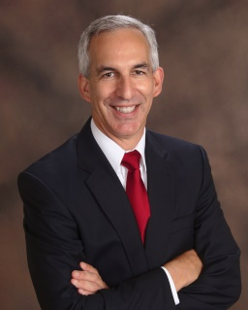

Michael leads the MyVA Task Force Program Support Office, which serves as the “nerve center” for the Department Veterans Affairs (VA) transformation effort. He reports the Executive Director of the MyVA Task Force. The Program Support Office guides and supports the activities of the MyVA priority initiatives in pursuit of the Task Force’s charter to:

Develop and guide required new initiatives;
Develop and incubate enabling capabilities to permanent organizations, and;
Fortify and integrate existing efforts.

The Program Support Office also acts as the Secretariat for the Secretary of Veterans Affairs regarding his oversight of transformation priorities. Prior to accepting his current position, Michael supported the VA’s Office of Small and Disadvantaged Business Utilization and the Transition Assistance Program.

Before joining the VA, Michael consulted for Booz Allen Hamilton, JPA Partners, Genesi-USA, and the Institute for Defense Analyses in the areas of operational assessments and technology integration. He has also served as the Director for Security Initiatives for MATT-Mexicans and Americans Working Together, and as the General Manager for Federal Services within the AAR Corporation.

Mike retired from the U.S. Army as an officer in 2010.

