VISITORS’ GUIDE
Fiscal Year - 2019

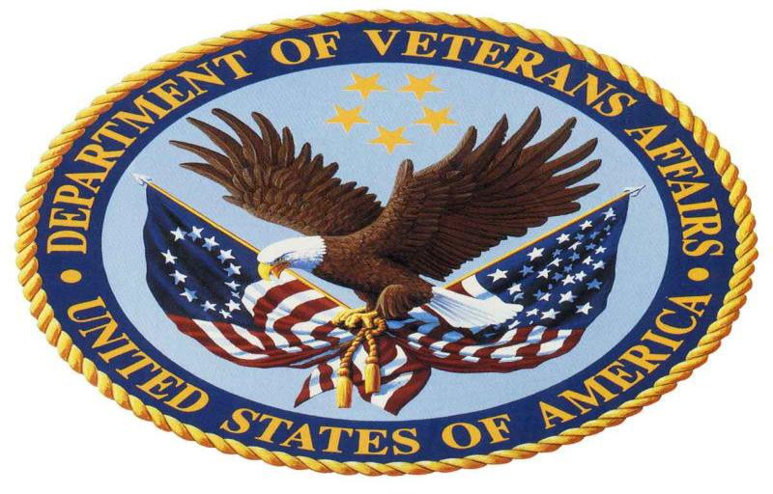

TECHNOLOGY ACQUISITION CENTER (TAC)
OFFICE OF PROCUREMENT, ACQUISITION AND
LOGISTICS (OPAL)
DEPARTMENT OF VETERANS AFFAIRS
EATONTOWN, NEW JERSEY

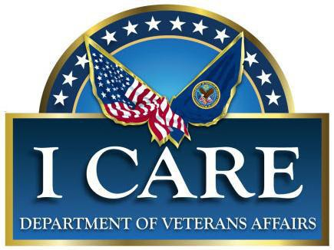

DEPARTMENT OF VETERANS AFFAIRS

MISSION STATEMENT

To fulfill President Lincoln’s promise

“To care for him who

shall have borne the battle, and

for his widow, and his orphan.”

TECHNOLOGY ACQUISITION CENTER (TAC)
OFFICE OF PROCUREMENT, ACQUISITION AND
LOGISTICS (OPAL)
DEPARTMENT OF VETERANS AFFAIRS
23 CHRISTOPHER WAY
EATONTOWN, NEW JERSEY 07724

Welcome to VA’s Technology Acquisition Center
Eatontown, New Jersey

The enclosed information is provided to help ensure that your visit with us is informative, productive, and enjoyable. This booklet includes the following information:

Table of Contents
GENERAL INFORMATION..................................................................4
DIRECTORY...............................................................................................5
DIRECTIONS TO VA TAC.....................................................................6-7
LOCAL RENTAL AGENCIES NEAR METRO-PARK......................8
LOCAL MAP TO VA TAC......................................................................9
LOCAL LODGING...................................................................................10
LOCAL LIMO / TAXI SERVICE ..........................................................11
ENTERTAINMENT / MOVIE THEATERS ……................................12
RESTAURANTS.........................................................................................13-15

SHOPPING...............................................................................................16-18 MEDICAL FACILITIES.........................................................................19

PHARMACIES / POST OFFICES..........................................................20

GENERAL INFORMATION

1. The Technology Acquisition Center (TAC) is accessible from the New Jersey Turnpike, Garden State Parkway, Metropark Train Station, and Newark Liberty International Airport.

2. The TAC Reception area is open to all visitors during normal business hours, Monday through Friday, 7:30 a.m. to 4:30 p.m. EST. The TAC is located in the METRO-Federal building. When you turn into the building parking lot, Visitor parking is available in the front of the building. The Main Entrance is located facing the Visitor parking lot. All Visitors must enter through the Main Entrance of the building.
To reach the TAC, please call the receptionist’s desk at (732) 795-1000. If arriving at the TAC prior to 7:30 a.m., please call your point of contact for assistance.

- All visitors to the TAC are required to sign in and out at the Receptionist’s desk and display the provided visitor badge in a noticeable location at all times. Visitors issued “Escort Required” badges need to remain with their escorts at all times.

- The TAC has been designated a non-smoking facility. The designated smoking areas are located near the entrances of the building. Please dispose of all trash in the proper receptacles.

- In case of inclement weather, please check the VA TAC Operating Status Hotline at: (732) 795-1002.

VA Technology Acquisition Center

Eatontown, New Jersey

DIRECTORY

Receptionist / Main Office......................... (732) 795-1000

VA Information Line..................................(732) 795-1199

Industry Visits.............................................(732) 795-1064

VA Fax Line................................................(732) 544-4031
or (732) 544-4030

VA Operation Status Hotline....................(732) 795-1002

WEBSITE:
http://www.va.gov/officeofacquisitionoperations/index.asp

DRIVING DIRECTIONS

VA Technology Acquisition Center

23 Christopher Way

Eatontown, New Jersey 07724

From: Newark Liberty International Airport – Newark, NJ
Drive northeast and take US-1-9 South ramp toward New Jersey Turnpike/I- 95/Elizabeth. Merge onto US-1 & 9 Express Lane/US-1-9 Express Lane South/US-9 Express Lane South/US-1 Express Lane South. Merge onto RT-81 South toward I-95/New Jersey Turnpike/Dowd Ave/North Ave/Eliz Seaport. (TOLL Road). Take I-95 South/Turnpike South ramp. Merge onto I-95 S/New Jersey Turnpike South toward Cars/Trucks-Buses.

On the NJ Turnpike, take Exit 11. Bear to the left of the tolls and follow signs for Garden State Parkway South/US-1/Woodbridge. Follow the Garden State Parkway South to Exit 105. At the first traffic light, turn right onto Hope Road. Follow Hope Road to Industrial Way (first light after crossing Wyckoff/Shafto Road). At Industrial Way, turn left. Follow Industrial Way to the first traffic light (Route 35). Proceed straight across Route 35 until you see Christopher Way on your right. Turn right onto Christopher Way. Proceed on Christopher Way to the cul de sac. 23 Christopher Way will be on your left. Turn left into the parking lot. The Main Entrance and Visitor parking are to your right. Additional parking is available on the sides of and in the rear of the building. A secondary entrance is located in the rear of the building.

From the Garden State Parkway – NORTH or SOUTH:

Follow the Garden State Parkway North or South to Exit 105. At the traffic light, turn right onto Hope Road. Follow Hope Road to Industrial Way (first light after crossing Wyckoff/Shafto Road). At Industrial Way, turn left. Follow Industrial Way to the first traffic light (Route 35). Proceed straight across Route 35 until you see Christopher Way on your right. Turn right onto Christopher Way. Proceed on Christopher Way to the cul de sac. 23 Christopher Way will be on your left. Turn left into the parking lot. The Main Entrance and Visitor parking are in the front of the building. A secondary entrance is located in the rear of the building.

From the New Jersey Turnpike – NORTH or SOUTH to Route 18:

If you are traveling from the North or South, use the NJ Turnpike and take Exit 7A (195 toward Shore Points). Follow 195 East, towards the Ocean, and shortly after 195 turns into Route 138 (approximately 35 miles), watch for Route 18 North (Eatontown). Take Route 18 North to Exit 13A (Wayside West/Wyckoff Road). At end of the ramp, bear left. At first traffic light (Hope Road), make a Left turn. At the next traffic light, turn left onto Industrial Way. Follow Industrial Way to the first traffic light (Route 35). Proceed straight across Route 35 until you see Christopher Way on your right. Turn right onto Christopher Way. Proceed on Christopher Way to the cul de sac. 23 Christopher Way will be on your left. Turn left into the parking lot. The Main Entrance and Visitor parking are in the front of the building. A secondary entrance is located in the rear of the building.

From: METROPARK Train Station - Iselin, NJ:

When exiting METROPARK Train Station, follow signs for the Garden State Park (GSP) SOUTH. Turn left out of the Station and proceed to GSP-South. Take the GSP-S to Exit 105. At the first traffic light, turn right onto Hope Road. Follow Hope Road to Industrial Way (first light after crossing Wyckoff/Shafto Road). At Industrial Way, turn left. Follow Industrial Way to the first traffic light (Route 35). Proceed straight across Route 35 until you see Christopher Way on your right. Turn right onto Christopher Way. Proceed on Christopher Way to the cul de sac. 23 Christopher Way will be on your left. Turn left into the parking lot. The Main Entrance and Visitor parking are in the front of the building. A secondary entrance is located in the rear of the building.

LOCAL RENTAL CAR AGENCIES

(NEAR METROPARK)

Avis Metro Park / North Edison Rental Cars
15 Wood Avenue / North Edison Metro Park
Edison, NJ, 08817 (across the street from Metropark) (908) 754-0584 (Pick up/drop off services & 24 hr. rentals)

Enterprise Rent-A-Car
1245 St. George’s Avenue
Colonia, NJ 07067 (2 miles from Metropark)
(732) 636-6800 (Pick up/drop off services & 24 hr. rentals)

Hertz Rental Car/Northbound side
370 US Highway # 9
Woodbridge, NJ 07095 (4 miles)
(732) 855-6924 (Pick up/drop off services)

LOCAL MAP to VA TAC

VA Technology Acquisition Center

23 Christopher Way

Eatontown, NJ 07724

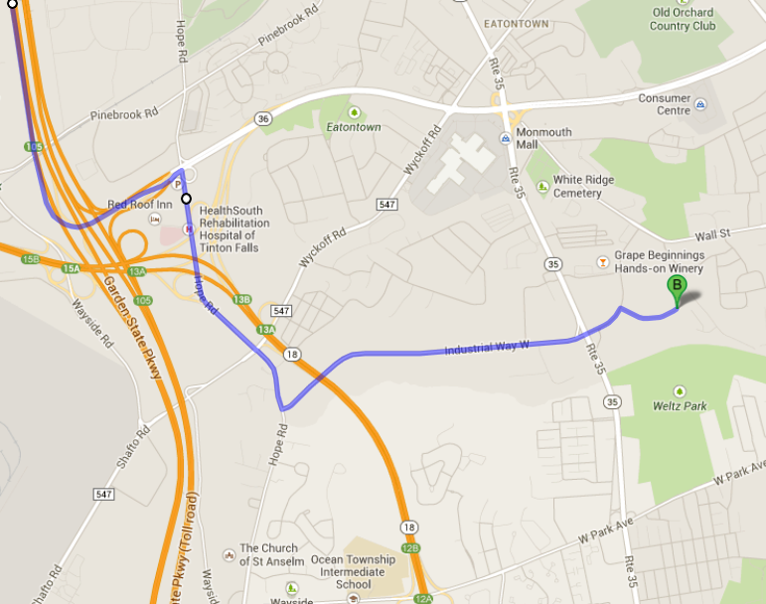

LOCAL LODGING

Courtyard Marriott of Red Bank
245 Half Mile Road
Red Bank, NJ 07701
(732) 530-5552

Courtyard Marriott of Tinton Falls 600 Hope Road
Tinton Falls, NJ 07724
(732) 389-2100

Double Tree Hotel
700 Hope Road
Tinton Falls, NJ 07724
(732) 544-9300

Residence Inn by Marriott Tinton Falls/Eatontown
90 Park Road
Tinton Falls, NJ 07724
(732) 389-8100

Residence Inn of Neptune
230 Jumping Brook Road
Neptune, NJ 07753
(732) 643-9350

Staybridge Suites – Eatontown/Tinton Falls
4 Industrial Way East
Eatontown, NJ 07724
(732) 389-9300

For your reassurance: Bed Bugs Reports
http://www.bedbugreports.com/

LIMOS / TAXI SERVICE

Above All Car Service
174 Main Street
Eatontown, NJ 07724
(732) 389-4409

Apple Taxi Inc.
174 Main Street
Eatontown, NJ 07724
(732) 542-3600

Arrow Limo
208 South Pearl Street,
Red Bank, NJ 07701
(732) 747-4844
1-800-882-7769

Eatontown Taxi & Limo
www.taxiandlimocarservice.com
(973) 206-9167

Omnitaxi
1 Main Street
Eatontown, NJ 07724
(732) 544-8999

ENTERTAINMENT

Count Basie Theatre
99 Monmouth Street,
Red Bank, NJ 07701
(732) 842-9000

Two River Theatre Company
21 Bridge Avenue,
Red Bank, NJ 07701
(732) 345-1400

MOVIE THEATERS

AMC Movie Theatre – Freehold Raceway Mall
101 Trotters Way
Freehold, NJ 07728-4820
(732) 294-7761

AMC Theatre – Monmouth Mall
180 State Route 35
Eatontown, NJ 07724-2023
(732) 935-0789

Clearview Cinemas
36 White Street
Red Bank, NJ 07701
(732) 747-0333

Clearview Middlebrook Galleria - Middlebrook Shopping Center
1502 Highway 35 South
Ocean Township, NJ 07712-0771
(732) 493-3800

RESTAURANTS

All Season’s Restaurant
176 Wyckoff Road
Eatontown, NJ 07724
(732) 542-9462 (1 mile)

Americana’s Diner & Restaurant
1160 Highway 35
Shrewsbury, NJ 07702
(732) 542-1658 (1 mile)

Applebee’s Restaurant
14 Park Road,
Tinton Falls, NJ 07724
(732) 935-1158

Back to Nature (Kosher) Average pp-$20-$30 Casual attire
312 Main Street (Between Corlies Ave & Allen Ave),
Allenhurst, NJ 07711 (3 miles)
(732) 663-2910

Bogart’s Bar & Grill
613 Hope Road,
Eatontown, NJ 07724
(732) 542-1836

Charley’s Ocean Grill (Seafood) Restaurant
29 Avenel Blvd
Long Branch, NJ 07740 (732) 222-4499

Chili’s Grill & Bar (Mexican) (Monmouth Mall)
182 State Route 35 South,
Eatontown, NJ 07724
(732) 389-7530

Chipotle Mexican Grill Restaurant
186 New Jersey 35,
Eatontown, NJ 07724
(732) 389-5041

Gaetano’s (Italian) Restaurant
10 Wallace Street,
Red Bank, NJ 07701
(732) 741-1321 (3 miles)

Illiano Café (Italian)
1 Corbett Way,
Eatontown, NJ 07724
(732) 542-2520

It’s Greek to Me Restaurant in Pier Village
44 Centennial Drive
Long Branch, NJ 07740
(732) 571-0222 (3 miles)

Kwong Fat Restaurant (Chinese Take-out)
613 Hope Road, Ste 1,
Eatontown, NJ 07724
(732) 389-8222

Maurizio’s Pizzeria (Italian)
613 Hope Road,
Eatontown, NJ 07724
(732) 578-9280

McLoone’s Pier House Restaurant
1 Ocean Ave
Long Branch, NJ 07740
(732) 923-1006 (1 mile)

The Olive Garden Restaurant
230 State Route 35,
Eatontown, NJ 07724
(732) 389-4585

Red Lobster Restaurant
2200 State Route 35,
Oakhurst, NJ 07755
(732) 493-2404

Rooney’s (For group reservations: ask for Daryl) Seafood
Private Party Coordinator / Laura
100 Ocean Ave North Long Branch, NJ 07740 (732) 870-1200

Ruby Tuesday (Monmouth Mall)
35 Wyckoff Road,
Eatontown, NJ 07724
(732) 542-4141

Ruffino’s Restaurant and Pizzeria
178 Highway 35
Eatontown, NJ 07724
(732) 542-0110 (1 mile)

Sirena Ristorante in Pier Village (Italian)
27 Ocean Ave
Long Branch, NJ 07740
(732) 222-1119

The Sitting Duck Restaurant
104 Myrtle Avenue Long Branch, NJ 07740 (732) 229-5566

TGI Friday’s (Monmouth Mall)
180 Route 35 South Ste 6000,
Eatontown, NJ 07724
(732) 542-2176

The Turning Point in Pier Village **Breakfast/Lunch closes at 3:00 p.m.
92 Ocean Ave
Long Branch, NJ 07740 (732) 923-1104

Village Long Branch Ocean view (www.piervillage.com)
Follow Route 36 East to Ocean Blvd, turn right onto Ocean Blvd and go through 3 traffic lights. At Garfield Ave/Laird St, make a left into Pier Village

SHOPPING

Monmouth Mall is one of central New Jersey’s leading shopping destinations. Minutes from Jersey Shore beaches, featuring: Boscov’s, JC Penney, Lord & Taylor, Macy’s and more than 120 places to shop and dine, including Abercrombie & Fitch, Aeropostale, Aldo, American Eagle Outfitters, Barnes & Noble, Bath and Body Works, The Children’s Place, Express, Forever 21, Gymboree Kids, H&M, Hollister, Justice, Modell’s Sporting Goods, New York & Company, Old Navy, Shi and Victoria’s Secret, as well as a 15-screen AMC/Loews Multiplex Theater. In addition to the Food Court, restaurants include Bobby’s Burger Place, Buffalo Wild Wings, Chili’s, Chipotle Mexican Grill, Firebirds Wood Fired Grill, Johnny Rockets, Ruby Tuesday, and TGI Friday’s.

Monmouth Mall has over 7,000 parking spaces, including a three-level parking deck, providing access to seven (7) mall entrances. Regular shopping hours are: Monday through Saturday: 10:00 a.m. - 9:30 p.m.
Sunday: 11:00 a.m. – 7:00 p.m.

Department stores, restaurants, cinema and holiday hours vary. Mall information is available 24 hours per day by calling The Shopping Line at (732) 542-0333.

Freehold Raceway Mall
3710 Route 9,
Freehold, NJ 07728
(732) 577-1144
Monday-Saturday: 10:00 a.m. - 9:30p.m. Sunday: 11:00 a.m. - 7:00 p.m.
Restaurant & Department Store Hours May Vary

The Grove at Shrewsbury
597 Route 35,
Shrewsbury, NJ 07702
732-530-1200 (1 mile)
Monday – Friday 10:00 a.m. - 8:00 p.m. Saturday 10:00 a.m. - 6:00 p.m.
Sunday 11:00 a.m. - 5:00 p.m.

Jersey Shore Premium Outlets
One Premium Outlets Blvd,
Tinton Falls, NJ 07753
(732) 918-1700 (2 miles)
Monday-Friday: 10:00 a.m. – 9:00 p.m.
Sunday: 10:00 a.m. – 7:00 p.m.
Restaurant & Department Store Hours May Vary

Pier Village Long Branch Oceanview Shopping (www.piervillage.com)
1 Chelsea Avenue,
Long Branch, NJ 07740
(732) 923-0100
Monday-Friday: 9:00 a.m. - 5:00 p.m.
Saturday-Sunday: 10:00 a.m. - 6:00 p.m. Restaurant & Department Store Hours May Vary
Follow Route 36 East to Ocean Blvd, turn right onto Ocean Blvd and go through 3 traffic lights. At Garfield Ave/Laird St, make a left into Pier Village

Seaview Square Shopping Center (Costco, Sears, Burlington Coat Factory and Target)
290 Seaview Square Mall, Route 66,
Ocean, NJ 07712
Mon-Sat: 10:00 a.m. - 9:30p.m.
Sun: 11:00 a.m. - 7:00 p.m.
Department Store Hours May Vary

120 Outlet Stores you will find impressive savings at: Adidas, Ann Taylor, Banana Republic, Brooks Brothers, Burberry, Calvin Klein, Carter's, Cole Haan, Elie Tahari, J.Crew, Juicy Couture, Gap Outlet, Kenneth Cole, Lacoste, Michael Kors, Theory, Tommy Hilfiger and many more.

From North Jersey:
Take the Garden State Parkway South to Exit 100A Stay left and follow signs to Route 66 East
Follow Premium Outlets Boulevard

From South Jersey:
Take Garden State Parkway North to Exit 100A (Route 66 East) Follow Route 66 East Premium Outlets Boulevard

From New Brunswick/Old Bridge/Freehold:
Take Route 18 South to Exit 15A (Garden State Parkway) (Follow directions above from North Jersey)

From Neptune/Wall Township:
Take Route 18 North to Exit 10B
Follow Route 66 West Premium Outlets Boulevard

MEDICAL FACILITIES

Jersey Shore University Medical Center
1945 Route 33,
Neptune, NJ 07753
(732) 775-5500 (4 miles)

Monmouth Medical Center
300 Second Avenue,
Long Branch, NJ 07740
(732) 222-5200 (3 miles)

Riverview Medical Center
1 Riverview Plaza,
Red Bank, NJ 07701
(732) 741-2700 (4 miles)

WALK-IN EMERGENCY CLINICS

Family First Urgent Care – Walk in
1910 Highway 35 South,
Oakhurst, NJ 07755
(732) 531-0100 (1 mile)
Monday - Thursday 9:00 a.m. – 8:00 p.m. Friday - 9:00 a.m. – 5:00 p.m.
Saturday - 9:00 a.m. – 3:00 p.m. Sunday - Closed

IMA Medical Care – Walk in
1048 Highway 35,
Shrewsbury, NJ 07702
(732) 542-0002 (1 mile)
Monday - Friday 8:00 a.m. – 8:00 p.m. Saturday & Sunday 8:00 – 6:00 p.m.

POST OFFICES

Eatontown, NJ Post Office
409 South Street
Eatontown, NJ 07724
(732) 542-0108

Red Bank, NJ Post Offices
104 Shrewsbury Avenue
Red Bank, NJ 07701
(732) 741-9342

171 Broad Street
Red Bank, NJ 07701
(732) 741-9200

PHARMACIES

CVS Pharmacy

180 Route 35

Eatontown, NJ 07724

(732) 542-7391

RITE AID Pharmacy

140 Water Street

Red Bank, NJ 07701

(732) 747-3727

