**Department of Veterans Affairs (VA), Office of Acquisition Operations (OAO)**

**Strategic Acquisition Center (SAC)**

**DVA Logo**

**Customer Ordering Guide**

**Enterprise Event Planning and Event Support Services**

**April 4, 2013**

**Ordering Guide**

**Enterprise Event Panning and Event Support Services**

**Blanket Purchase Agreement (BPA)**

**Executive Summary**

**Ordering Guide:** This Ordering Guide provides the Department of Veterans Affairs’ (VA) organizations and offices with a simple, straightforward process for ordering Event Planning and Event Support services. Within this Ordering Guide, the process and associated information are structured to maximize efficiencies and streamline ordering.

**Overview:** The five Blanket Purchase Agreements (BPAs) listed in Section 5.0 of this Ordering Guide provide all VA organizations and offices the ability to procure Event Planning and Event Support services using a standardized process. These BPAs satisfy the current strategic acquisition need, offering a consolidated and streamlined approach for enterprise-wide Event Planning and Event Support services.

**Scope:**  The BPAs listed in Section 5.0 of this Ordering Guide identify the BPA awardees that are capable of providing the broad range of Event Planning and Event Support services required throughout the VA.

**Customer Assistance:** Per individual Event Planning and Event Support services requirement, the Requiring Office will designate a BPA Ordering Officer who is also a warranted Contracting Officer (CO). The BPA Ordering CO will be responsible for the award and administration of specific BPA Order(s). The VOA CAP contains valuable information and samples that will assist the Requiring Office in developing the Ordering Request Package (ORP). In order to obtain VOA access or request technical assistance with the Virtual Office of Acquisition (VOA) Customer Acquisition Portal (CAP), contact the VOA Customer Portal help desk at [voahelp@va.gov](mailto:voahelp@va.gov) or 937-281-1740.

Assistance with ORP development will be provided on a per call basis by the designated BPA Ordering CO. When submitting an initial request for assistance, include the following information: (1) Customer focal point name, telephone/mobile number, and email address; (2) name of Customer’s organization; (3) a brief description of the requirement; and, (4) the projected need-by date.

**Customer Ordering Guide**

**Enterprise Event Planning and Event Support Services**

**Blanket Purchase Agreement (BPA)**

**Table of Contents**

1.0 PURPOSE 5

2.0 BACKGROUND 5

3.0 BPA SUMMARY 5

4.0 COMPETITION 5

5.0 CONTRACTORS 6

6.0 TASK AREAS & LABOR CATEGORIES 7

7.0 ORDER REQUEST PACKAGE (ORP) COMPONENTS 9

7.1 Performance Work Statement (PWS) 10

7.2 Independent Government Cost Estimate (IGCE) 10

7.3 VA Form 90-2237 10

7.4 Contracting Officer’s Representative (COR) 10

7.5 Government-Furnished Equipment (if applicable) 10

7.6 Determination and Findings (D&F) (if applicable) 10

7.7 Special Sourcing Considerations (If applicable) 11

8.0 ORDERING PROCESS 12

8.1 Ordering Preparation Steps 12

8.2 Within Scope Determination 15

8.3 Receipt and Refinement of ORP 15

8.4 Request for Quotation (RFQ) 15

8.5 Contractors’ Response to Quote 15

8.6 Evaluation of Quotes 15

8.7 Award: 15

8.8 Award Notification: 15

9.0 BPA ROLES AND RESPONSIBILITIES 15

9.1 SAC Contracting Officer 15

9.2 BPA Ordering Contracting Officer 15

9.3 Requiring Office 16

9.4 Contracting Officer’s Representative (COR) 16

9.5 Fiscal Office 16

10.0 POST AWARD ACTIVITIES 16

11.0 ACRONYMS AND ABBREVIATIONS 16

APPENDIX A: TECHNICAL INFORMATION FOR CORs 18

A1 Management of BPA Orders 18

A2 Fair Opportunity for Consideration and Proposal Evaluations 18

A3 Solicitation Procedures, Standard Form (SF) 1449 19

A4 Substitution of Key Personnel 19

A5 Performance 20

APPENDIX B: FUNDING 20

B1 Important Definitions: 20

B2 Invoicing Process 20

B3 Service Level Agreement 20

**Ordering Guide**

**Enterprise Event Planning and Event Support Services**

**Blanket Purchase Agreement (BPA)**

# 1.0 PURPOSE

The purpose of this Ordering Guide is to assist VA’s Requiring Offices in the preparation of all documentation required when ordering Event Planning and Event Support services (i.e., place BPA Orders) against the established BPAs described herein. This Guide outlines the process and lists the documents required to place BPA Orders and defines roles and responsibilities of the major parties involved in the ordering process. BPA Orders will be placed in accordance with Federal Acquisition Regulations (FAR) section 8.405-2, Ordering procedures for services requiring a Performance Work Statement (PWS).

# 2.0 BACKGROUND

VA is responsible for providing high quality and timely commodities and services for our Veterans and their families. As the complexity of those items and services increases, program and team involvement will, likewise, become more complicated. These VA enterprise-wide BPAs are placed against a General Services Administration (GSA) schedule and serve to standardize and streamline the acquisition of Event Planning and Event Support services using a decentralized process. These BPAs, in total, provide a $60 million ceiling over the next five years (not to exceed $12 million per year) for enterprise-wide Event Planning and Event Support services described herein.

# 3.0 BPA SUMMARY

The Event Planning and Event Support services BPAs are summarized as follows:

**Who:** Event Planning and Event Support services BPAs are available for use by all VA organizations and offices, regardless of geographic location.

**What:** Event Planning and Event Support services - When a Customer requests placement of a BPA Order for Event Planning and Event Support services, that Order is competed among the BPA Holders to secure the best value for the Government. The resulting award(s) may be made on a Firm-Fixed-Price, Time and Materials, or Labor Hour basis.

**When:** BPAs listed in Section 5.0 were established on May 31, 2013 and are available for BPA Orders for 60 months from the established date of May 31, 2013.

**Why:** Developed to standardize and streamline the acquisition of Event Planning and Event Support services throughout VA. Ordering is decentralized and offers an efficient means to quickly award BPA Orders, while reducing the time and saving costs for VA as a whole.

**How:**  Event Planning and Event Support services requirements will be fulfilled through the use of BPA Orders. The Requiring Office will prepare an ORP in accordance with Section 7.0 of this document.

# 4.0 COMPETITION

BPA Orders will normally be competed among those vendors awarded BPAs listed in Section 5.0 of this document. VA officials and employees must **not** have conversations with Contractors or other vendors, including incumbents, about pending requirements before obtaining express written approval to do so from the BPA Ordering CO, via the Contracting Officer’s Representative (COR). This measure is to ensure that no vendor is provided unfair advantage in a competition. If a bona fide business need exists to discuss requirements with vendors in advance, all BPA Holders listed in Section 5.1 shall be provided the opportunity to participate in the discussion. The BPA Ordering CO shall provide official points of contact to arrange and facilitate such discussions, and shall ensure all awardees are provided a fair opportunity to be considered for any Order in excess of $3,000.

# 5.0 CONTRACTORS

The following BPAs have been awarded for this effort. The following includes the BPA number, the Prime Contractor’s name, email address and any subcontractors or teaming partners for each BPA.

1. VA798S-13-A-0022

Pothos, Inc.

2260 El Cajon Blvd, #474

San Diego, CA 92104-1192

Phone: (619) 546-0621

Fax: (413) 723-7838

Website: http://www.pothos.us

Contract Administrator: Michael Patton

E-mail: michael@pothos.us

robin@pothos.us

Cage Code 3F7G9

DUNS # 117929963

Federal Tax Id # 61-1543928

GSA Contract Holder # GS-07F-0524U

1. VA798S-13-A-0023

American Small Business Alliance, Inc. dba ASBA

9030 Red Branch Road STE 190

Columbia, MD 21045-2012

Phone: (301) 596-6031

Fax: (410) 715-2595

Mobile: (410) 961-7476

Web address: www.asballiance.com

Contract Administrator: Mr. Tariq Shane

E-mail: shane@asballiance.com

Cage Code 3G6N7

DUNS # 128598013

GSA Contract Holder # GS-07F-0595X

1. VA798S-13-A-0024

National Conferencing, Inc. (NCI)

dba/FederalConference.Com

3912 Lansing Court | Dumfries, VA 22026

Phone number: 703.232.5792

Fax number: 886-204-1828

Web address: www.federalconference.com

Contract Administrator: Paul Trapp

E-mail: paul@nationalconference.com

Cage Code 4PLL6

DUNS # 784819810

GSA Contract Holder # GS-07F-0434W

1. VA798-S-13-A-0025

TCG Consulting, Inc.

2221 Peachtree Rd., Ste. X22

Atlanta, GA 30309

Telephone: 888-824-8920

Fax: (404) 934-5196

Web address: www.tcgconsultinginc.com

Contract Administrator: Shawn Cooper

E-mail: shawn@tcgconsultinginc.com

Cage Code 46V76

DUNS # 135273816

GSA Contract Holder # GS-07F-0115V

1. VA119-13-A-0011

Ian, Evan & Alexander Corporation

44335 Premier Plaza, Suite 200

Ashburn, VA 20147

Office: (703) 209-6275

Fax: (703) 935-1063

Email: jcochran@iea-corp.com

Website: www.iea-corp.com

Contract Administrator: John Cochran

Cage Code 1XCZ1

DUNS # 102242844

GSA Contract Holder # GS-23F-0072R

# 6.0 TASK AREAS & LABOR CATEGORIES

Table 1 provides a breakout of the GSA Task Areas (listed below) along with the associated labor categories, descriptions, education and experience requirements included in these BPAs.

**Table 1. Task Areas and Labor Categories**

| **Labor Category Title** | **Description** | **Education/Experience Requirements** |
| --- | --- | --- |
| **Senior Meeting Planner – CMP/Senior Project Manager/Director** | **Senior Project Director responsible for planning and coordinating day to day (tactical) management of program, coordination of meetings, conventions and work performance on one or more projects. Holds primary responsibility for planning, managing, and overseeing work efforts of project team personnel, determining and monitoring project schedules and budgets, and/or ensuring compliance with all contract and project requirements and quality standards. Serves as primary interface with Customer. Demonstrates skills in the scope of work encompassed by the project, provides technical guidance to the project team in performance of the work, and provides quality review of all work products.** | **BA/BS in related field/ Education may be substituted for 5 - 10 years professional project management experience.** |
| **Graphic/Web Designer** | **Graphic Designer responsible for concept and design for project’s graphic and web applications, designing printed materials to include graphics, logos, advertisements, brochures, marketing and promotional material, etc. The graphic designer works closely with the project manager in order to produce information that promotes the intended message or image.** | **AA/AS in related field / Education may be substituted for 3 years Graphic Design experience.** |
| **Event Planner II/Senior Research Analyst** | **Senior Event Planner (II) responsible for logistics planning (event and facility point-of-contact, catering functions, meeting requirements and layouts, etc.), oversee the design/publishing/printing of event agenda/program guide, develop and produce audio advertising, oversee registration preparation, advertising/promotional campaigns, handling phone inquiries, meetings/telephone correspondence with sponsors/clients, progress updates, oversee printing of promotional campaign materials, post-event follow-up, event set-up, on-site event management, oversee event evaluations, designs research studies. An event manager may review invoices, assist to coordinate website developments and updates, handle logistical planning (catering, directions, on-site visits, etc.), and prepare registration materials and premiums under supervision of senior event manager or project manager and may, at times, be assigned a specific area to manage (e.g., Speaker Manager, Room Director, etc.).** | **AA/AS in related field; Education may be substituted for 3 years event planning experience. Certified Meeting Planner (CMP) designation may also be substituted for education/experience requirements.** |
| **Event/Meeting Coordinator/Market Analyst** | **This position provides expert support to the Event Planner II/Senior Research Analyst by assisting with the logistical elements of conferences, meetings and special events, administering studies and conducting data analysis. The ideal candidate must provide service for internal and external clients.** | **1-2 years prior experience.** |
| **Administrative Assistant** | **Performs administrative and office support activities in support of meeting planning and management. Duties may include fielding telephone calls, receiving and directing visitors, word processing, filing, and faxing.** | **HS Diploma/GED; One (1) year Customer Service Experience; valid driver’s license.** |
| **Data Base Manager** | **Data Base Manager to act as support personnel for meeting activities. Duties may include such activities as: management of database, processing of registrations, and contact with participants regarding conference details and any related issues. Preparing name badges, tents, certificates, etc. for speakers, presenters and participants; duplicating and distributing event materials; implementing meeting evaluation procedures; and aiding in the completion of documentation of participant attendance. Preparation of financial documentation for all conference related revenues and expenses. Acts as support personnel for meeting activities. Provides travel coordination to meeting attendees. Contacts traveler, makes travel arrangements, issues itinerary, processes travel requests and reimbursements.** | **AA/AS in related field; Education may be substituted for 3 years data base management experience.** |
| **Event Support Staff** | **Support staff for on-site delivery / typically provides administrative, clerical or logistical services under close supervision. Such duties include processing registrations and follow-up, data entry, handling phone inquiries, vehicle driver, event management, on-site event management, assembling of promotions and on-site distributions.** | **HS Diploma/GED; One (1) year Customer Service Experience; valid driver’s license.** |

# 7.0 ORDER REQUEST PACKAGE (ORP) COMPONENTS

The Requiring Office is responsible for preparing an Order Request Package (ORP). As a means of assisting the Requiring Office, samples of ORP documents including are provided in the VOA CAP Template Library.

The required documents are identified below:

## 7.1 Performance Work Statement (PWS)

The PWS is a detailed description of what the Government intends to buy. The "detailed description” must be within scope of the overarching PWS in the overarching BPA. Follow the sample PWS notes and instructions located in VOA CAP (link provided in Section 7.0) to prepare the PWS.

## 7.2 Independent Government Cost Estimate (IGCE)

The Independent Government Cost Estimate (IGCE) is the Government’s estimate of the resources required and the other projected costs (such as travel or materials) that would be incurred by the Contractor during performance of a specific BPA Order. The rates will be based on the average proposed labor rates among the BPA Contractors for a specified labor category. A sample IGCE is provided in the VOA CAP Template Library (referenced in Section 7.0).

## 7.3 VA Form 90-2237

VA Form 90-2237 represents a VA Purchase Request to identify commitment of funds in an amount equal to the IGCE for the specified period of performance. The funding document number as well as a copy of the 2237 should be included with the ORP.

## **7.4 Contracting Officer’s Representative (COR)**

The Requiring Activity will provide a signed nomination letter for a trained and qualified COR. The nomination letter will identify the name(s) of the designee (with contact information) and include the signatures from the Customer’s nominating official and the COR. The COR’s Training Completion Certificate must also be provided with the ORP. All training certificates must be no more than three years old, and must not expire during the performance of the BPA Order.

*See Appendix A of this Ordering Guide for technical information deemed important to the COR functions and responsibilities.*

## 7.5 Government-Furnished Equipment (if applicable)

List of all applicable Government-Furnished Equipment (GFE), Government-Furnished Information (GFI) and Government-Furnished Facilities (GFF) must be provided. The list must include the identified need, the expected need date, and the source from which the need will be provided. The GFE data will become part of the PWS or contract attachments as needed.

## 7.6 Determination and Findings (D&F) (if applicable)

A signed Determination and Findings (D&F) is required only if a labor hour contract is preferred, vice a Firm-Fixed-Price contract.

In accordance with FAR 8.404(h)(3)(i): a time-and-materials or labor-hour order may be used for the acquisition of commercial services only when it is not possible at the time of placing the order to estimate accurately the extent or duration of the work or to anticipate costs with any reasonable degree of confidence.

(ii) Prior to the issuance of a time-and-materials or labor-hour order, the BPA Ordering CO shall—

(A) Execute a D&F for the order, in accordance with paragraph (h)(3)(iii) of this section that a fixed-price order is not suitable;

(B) Include a ceiling price in the order that the contractor exceeds at its own risk; and

(C) When the total performance period, including options, is more than three years, the D&F prepared in accordance with this paragraph shall be signed by the contracting officer and approved by the head of the contracting activity prior to the execution of the base period.

(iii) The D&F required by paragraph (h)(3)(ii)(A) of this section shall contain sufficient facts and rationale to justify that a fixed-price order is not suitable. At a minimum, the D&F shall—

(A) Include a description of the market research conducted (see 8.404(c) and 10.002(e));

(B) Establish that it is not possible at the time of placing the order to accurately estimate the extent or duration of the work or anticipate costs with any reasonable degree of confidence;

(C) Establish that the current requirement has been structured to maximize the use of fixed-price orders (e.g., by limiting the value or length of the time-and-materials/labor-hour order; or, establishing fixed prices for portions of the requirement) on future acquisitions for the same or similar requirements; and

(D) Describe actions to maximize the use of fixed-price orders on future acquisitions for the same requirements.

(iv) The BPA Ordering CO shall authorize any subsequent change in the order ceiling price only upon a determination, documented in the order file, that it is in the best interest of the ordering activity to change the ceiling price.

## 7.7 Special Sourcing Considerations (If applicable)

Identify any special sourcing considerations. An example would be a request to continue work in progress with the incumbent vendor. This “logical follow-on work” would need to be accompanied by a signed Limited Source Justification (LSJ).

**Note**: If the requirement is exempt from competition, please complete an LSJ form. Exemptions from competition include:

1. the agency’s need for services is of such urgency that providing such an opportunity would result in unacceptable delays;
2. only one awardee is capable of providing the services required at the level of quality required, because the services ordered are unique or highly specialized; or
3. In the interest of economy and efficiency, the new work is a logical follow-on to an original Federal Supply Schedule order provided that the original order was placed in accordance with the applicable Federal Supply Schedule ordering procedures. The original order or BPA must not have been previously issued under sole-source or limited-source procedures.

# 8.0 ORDERING PROCESS

Administration offices, staff offices and/or other key officials wishing to utilize the services identified in the overarching BPA PWS and described in this Ordering Guide shall assemble an ORP.

## 8.1 Ordering Preparation Steps

The BPA Ordering CO may place orders by following the eCMS procedures provided below:

Step I 1. Complete the normal eCMS process for your Purchase request, Solicitation, and any amendments.

Step II 1. When it is time for award, click on the Solicitation (FSS-RFQ) action process coach, and then select “create a delivery/task order action.”

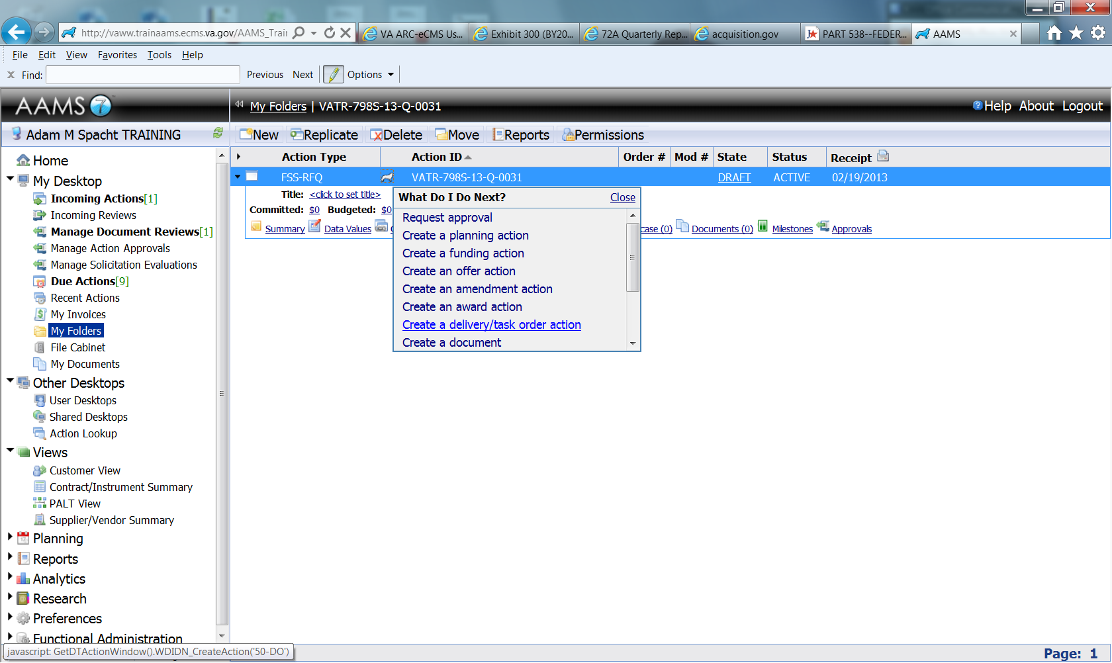

1. Select

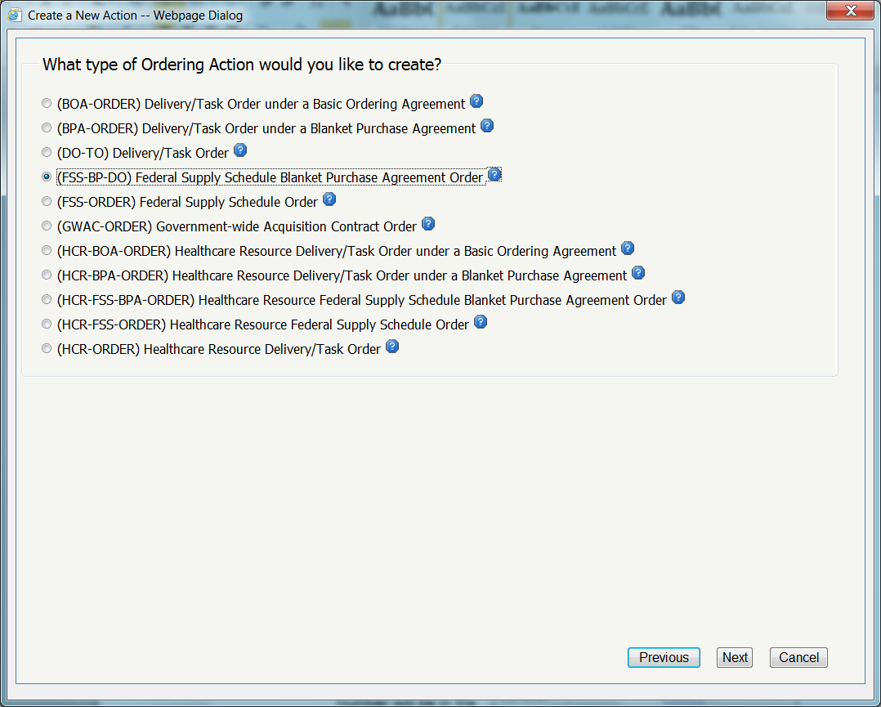

2. 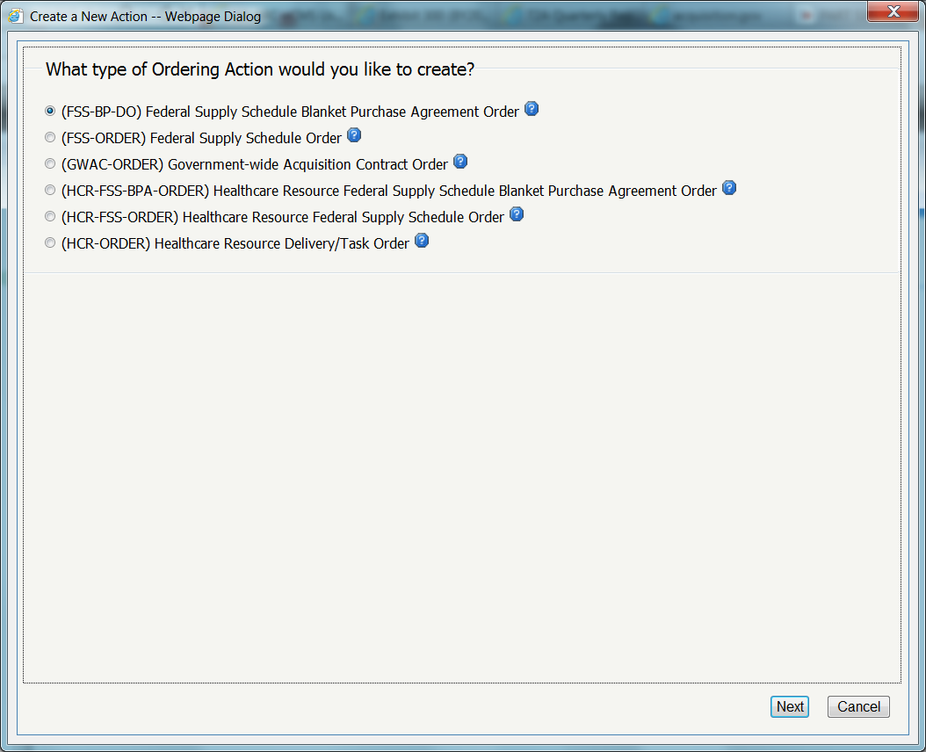

3. Click **Next** .

1. Determine whether to create a new folder or use an existing folder.
2. Either enter the exact BPA number or use the "Lookup” feature to locate the appropriate BPA (see BPA numbers above).
3. Click “Generate” to create the Order Number.
4. From the Type Code popup, choose the “J” code, and click OK.
5. Click Ordering Process Steps. 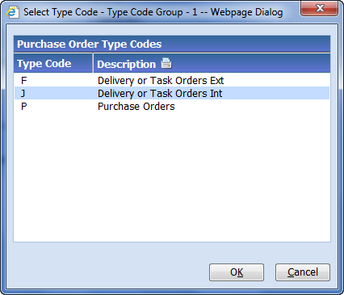

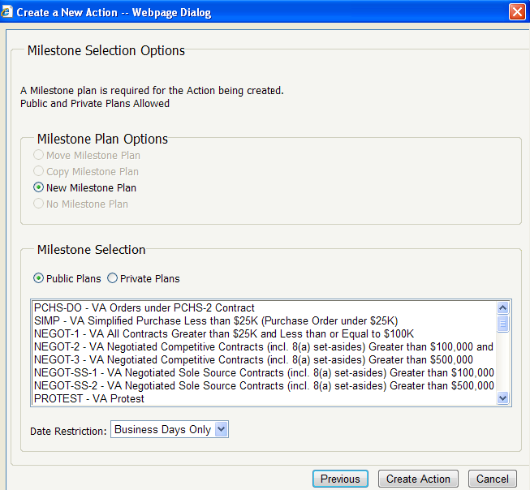

1. The Milestone Plan radio button will be selected.
2. Select a Public Plan or Private Plan.
3. Select the appropriate Date restriction menu item.
4. Select the appropriate line item(s), if appropriate.
5. Click ***Create Action***
6. Click ***FINISH*** to access the new action.

1. Open the order action to the **Summary** tab. Update the title, from the copied action, as needed. Add comments if desired.

1. Navigate to the **Data Values** tab and complete the data values.

1. Navigate to the **Items** tab and add **Add a Line Item** items as necessary.

1. Navigate to the **Briefcase** tab and **Add** files as necessary.

2. NOTE: You may elect to attach an electronic copy of your IFCAP Purchase Order to the briefcase.

1. Navigate to the **FPDS** tab and report the order to FPDS.

2. NOTE: For additional assistance with reporting to FPDS, please refer to your FPDS Reporting User’s Guide.

. Step XII 1. Navigate to the **Data Values** tab and award the order in eCMS.

2. NOTE: For additional assistance with awarding, please refer to your FPDS Reporting User’s Guide.

## 8.2 Within Scope Determination

Upon receipt of the ORP, the BPA Ordering CO will determine if the specific request is within the scope of the BPA. Please note that the data entered should be sufficient to determine if the work requested is within the scope of the BPA. Close attention to the PWS sample and this document will assist the BPA Ordering CO in making that determination.

## **8.3 Receipt and Refinement of ORP**

After a “within scope determination” has been made by the BPA Ordering CO, the Contract Specialist will work with the Requesting Office to ensure that the ORP is complete.

## **8.4 Request for Quotation (RFQ)**

The BPA Ordering CO, having reviewed the ORP for completeness, will issue a Request for Quotation (RFQ) to all BPA Holders.

## **8.5 Contractors’ Response to Quote**

Each RFQ will specify its corresponding response time for either a quote or a “No Response” statement from Contractors.

## **8.6 Evaluation of Quotes**

The BPA Ordering CO and Customer will work to assemble an evaluation team (as required and instructed by the BPA Ordering CO). The BPA Ordering CO, Requiring Office, COR, and Technical Personnel will evaluate all quotes within twelve (12) working days of receipt (unless otherwise specified by the Ordering CO) and ultimately select the BPA Order awardee based upon best value methodology.

## **8.7 Award**:

The BPA Ordering CO is responsible for awarding each BPA Order on a per Order basis.

## **8.8 Award Notification**:

The BPA Ordering CO is responsible for notifying the Contractor, the Requiring Office and the SAC CO of any/all awards.

# 9.0 BPA ROLES AND RESPONSIBILITIES

## **9.1 SAC Contracting Officer**

The SAC CO has overarching responsibility for all established BPAs and competing follow-on agreements beyond the full five (5) year period of performance covered by respective BPAs.

## BPA Ordering Contracting Officer

The BPA Ordering CO is responsible for ensuring all awardees are provided an opportunity for Order consideration in accordance with FAR 8.405-3(c)(2) which outlines competitive thresholds above and below the simplified acquisition threshold. The Contract Specialist assists the BPA Ordering CO with award of BPA Orders, administration, and competing follow-on agreements and works with the COR to assist with administration of the BPA Order through completion.

## 9.3 Requiring Office

The Requiring Office is responsible for the initiation of a requirement, which include development of a PWS and an IGCE. The Requiring Office is also responsible for identifying a COR and providing a COR nomination letter, ensuring that the COR has completed all requisite training, and ensuring that the COR training certificates are sent with the ORP. In addition, the Requiring Office is responsible for funding the requirement.

## 9.4 Contracting Officer’s Representative (COR)

The COR duties will be delineated in the COR designation/appointment letter. In general, the COR responsibilities are to assist in the technical monitoring and/or administration of respective BPA Orders. The COR will review all invoices/document expenditures and forward expenditures along with the respective invoice to the cognizant Fiscal Office for billing.

## 9.5 Fiscal Office

The Fiscal Office will create a billing document that references the Customer’s BPA Order. The Contractor is paid the invoiced amount from the responsible payment office. The vendor sends the Customer/COR the invoice as noted in the award document. The BPA Ordering CO receives the invoice from the Customer/COR and certifies vendor invoices. The BPA Ordering CO will work with the COR to verify that all work and deliverables cited on invoices have been accomplished and charged in accordance with the terms and conditions of the contract. The BPA Ordering CO will forward copies of all certified invoices to the SAC CO.

# 10.0 POST AWARD ACTIVITIES

The Requiring Office and the assigned COR will be responsible for evaluating the services performed under each BPA Order (refer to the COR Appointment Letter for additional responsibilities).

Examples of Post Award activities include:

1. Within Scope Changes
2. Modifications
3. Changes to Delivery Locations or Dates
4. Performance Monitoring
5. Ensuring Timely Monthly Reporting
6. Metric Monitoring
7. Ensuring COR reporting

A Contract Specialist will work with the COR to assist in administering the BPA Order through completion.

# 11.0 ACRONYMS AND ABBREVIATIONS

BPA Blanket Purchase Agreement

CO Contracting Officer

COR Contracting Officer’s Representative

CAP Customer Acquisition Portal (CAP)

D&F Determination and Findings (D&F)

GSA General Services Administration

LSJ Limited Source Justification

IGCE Independent Government Cost Estimate

OAO Office of Acquisition Operations

ORP Order Request Package

PWS Performance Work Statement

QASP Quality Assurance Surveillance Plan

SAC Strategic Acquisition Center

VA Veterans Affairs; also Department of Veterans Affairs

VOA Virtual Office of Acquisition

# APPENDIX A: TECHNICAL INFORMATION FOR CORs

## A1 Management of BPA Orders

The COR shall utilize the Quality Assurance Surveillance Plan (QASP) to ensure the Contractor institutes and maintains a management process (i.e., Quality Control Plan or QCP) that effectively manages all Contractor personnel and financial resources used to perform the services delineated in specific BPA Orders.

As part of the management process described above, the COR will ensure that the Contractor:

* Employs a management approach that is consistent with project management best practices.
* Clearly identifies all staff involved in the management and performance of the contract and clearly defines their roles, responsibilities and interaction with the Government.
* Ensures that all services are compliant with applicable Federal regulations and guidelines.
* Adheres to security regulations, policies, and procedures described in BPA Order RFQ.

For each BPA Order, ensure that the Contractor designates a BPA Order Manager who shall be the Contractor’s primary interface with the requiring VA organization and COR. Ensure that any tasks or work products requested by the Government are submitted to the BPA Order Manager. Ensure that the BPA Order Manager directs the activities of all BPA Order personnel to meet contract requirements. Ensure that the Contractor’s BPA Order Manager is proactive and responsive to managing Contractor resources and meeting VA requirements.

Ensure that any costs associated with the BPA Order Manager are considered to be included in the Contractor’s labor rates, as no separate BPA Orders or funding will be provided for BPA Order Managers.

## A2 Fair Opportunity for Consideration and Proposal Evaluations

Fair Opportunity for Consideration:

1. One or more BPA Orders will be issued during the specified performance period. The BPA Ordering CO will provide all awardees fair opportunity for consideration in accordance with FAR 8.405-3(c)(2), unless one of the conditions in paragraph 2, below, applies.
2. Exceptions to Fair Opportunity for Consideration: awardees will not be given an opportunity to be considered for BPA Orders which are expected to exceed $3,000 when the BPA Ordering CO determines one of the following conditions apply:
3. the agency’s need for services is of such urgency that providing such an opportunity would result in delays;
4. In the interest of economy and efficiency the Order should be issued on a sole-source basis as a logical follow-on to a BPA Order already issued under the overarching BPA, provided that all awardees were given fair opportunity to be considered for the original Order. For the purposes of this RFQ, the BPA Ordering CO may negotiate a sole source logical follow-on Order with the current Contractor providing previously competed services. In the event an increase in the amount of previously competed services is required by the Government, the BPA Ordering CO may negotiate a sole source logical follow-on BPA Order with the current Contractor provided the required additional services do not represent more than one full time equivalent position or 20% of the total competed labor hours on the entire BPA Order, whichever is greater. When deciding whether to negotiate a sole source logical follow-on task order with the current Contractor, consideration will be given to the Contractor's past performance, continuity of services, and price.
5. Quote Evaluation
6. The BPA Ordering CO has broad discretion in determining which awardee shall receive a BPA Order. Each BPA Order award decision will include an evaluation plan developed by the BPA Ordering CO and detailed in each BPA Order RFQ (i.e., Standard Form (SF) 1449). In general, BPA Order quotes will be evaluated by analysis of the Technical Approach, Management Plan, Past Performance, and Price. Other factors may be used to evaluate proposals (for example, low price technically acceptable), if deemed appropriate by the BPA Ordering CO. Such factors will be made known to the Contractors via evaluation instructions provided per specific BPA Order RFQs.

## A3 Solicitation Procedures, Standard Form (SF) 1449

The BPA Ordering CO will issue a written RFQ Standard Form (SF) 1449, and will forward it to all awardees unless one of the exceptions to the fair opportunity for consideration listed above in (a)(2) applies.

The SF 1449 will be issued as either a “Standard” 1449 or “Rapid Response” 1449. A “Standard” 1449 will generally allow 10-30 calendar days for proposal submission, and once awarded, work shall begin in approximately 30 calendar days, unless otherwise specified by the BPA Ordering CO. A “Rapid Response” 1449 requires a shorter suspense period for proposal submission, generally less than 10 calendar days (unless otherwise specified by the BPA Ordering CO), and commencement of work, less than 30 calendar days from award.

## A4 Substitution of Key Personnel

Key personnel shall not be removed, diverted, or replaced from work without approval of the BPA Ordering CO and COR.

Any personnel the Contractor offers in substitution shall possess abilities and qualifications equal to or better than the key personnel being replaced. Requests to substitute personnel must be approved by the COR and the BPA Ordering CO. All requests for approval of substitutions in key personnel shall be submitted to the COR and the BPA Ordering CO **immediately** after receiving knowledge that an employee will be leaving his/her position. The request shall be written and provide a detailed explanation of the circumstances necessitating the proposed substitution. The Contractor shall submit a complete resume for the proposed substitute, and any other information requested by the BPA Ordering CO needed to approve or disapprove the proposed substitution. The BPA Ordering CO will evaluate such requests and promptly notify the Contractor of approval or disapproval thereof in writing.

## A5 Performance

BPAs will be performance-based to the maximum extent practicable in accordance with FAR 37.102. Contractor performance within Contractor Performance Assessment Reports System will be assessed annually. Utilizing the QASP, BPA Order performance will be assessed by the COR and Requiring Office for each invoicing period (e.g., monthly). The COR is responsible for reviewing and accepting the work performed for each invoice.

# APPENDIX B: FUNDING

## B1 Important Definitions:

**VA Form 90-2237** – Sometimes referred to as “2237”. Request, Turn-in and Receipt for Property or Services; used to request goods and services.

## B2 Invoicing Process

The vendor sends the Customer/COR the invoice as noted in the award document. The BPA Ordering CO receives the invoice from the Customer/COR and certifies vendor invoices. The BPA Ordering CO will work with the Customer/COR to verify that all work and deliverables cited on invoices have been accomplished and charged in accordance with the terms and conditions of the contract. The BPA Ordering CO will electronically forward copies of all certified invoices to the SAC CO at [Zachary.wilcox@va.gov](mailto:Zachary.wilcox@va.gov).

## B3 Service Level Agreement

Like GSA, the SAC is a fee-for-service organization. If your organization has a Service Level Agreement (SLA) with the Office of Acquisition Operations (OAO), the fee will be assessed on a quarterly basis through the Supply Fund office. For BPAs created against Federal Supply Schedules, the SAC charges a nominal fee of one-half of one-percent (0.5%) on obligations for all orders placed against these BPAs. The Event Planning Event Support BPAs’ savings between 1.2% to 22.4% off of the BPA holders’ GSA pricing offset the cost of the fee; however, it is important to budget for this fee.