**CAPABILITY STATEMENT** 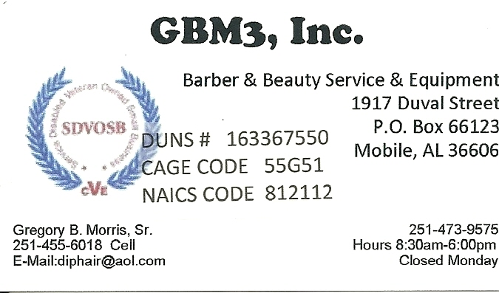

Barber & Beauty Service Supply & Equiptment

* Let Us Help You Build The Salon of Your Dreams.
* Barbering Serevices, Shave, Men’s Hair Cutting, Mustaches and Beards.
* Cosmetology Services, Cutting and Styling, Shampooing and Rinsing, Perms, Relaxers.
* Color Bar Services, Hair Coloring.
* Manicure Services, Nails and Feet.
* Pedicure Services, Feet and Legs.
* Skin Care Services, Facial.
* Massage Services, Scalp, Shoulder, Back and Full Body.
* Tanning Services.
* Salon Chairs, Styling Chairs, All Purpose, Shampoos Chair, Dryer Chairs, Kiddie Chair, Cutting Stools.
* Cabinetry, Styling Station, Wet Station, Reception Desks & Chairs, Retail Display.
* Bar Bar, Shampoo Bulkhears, Backwashes, Bowels, Chairs, Dryers and Processors.
* Salon Essentials, Stylist Mats, Trolleys, Service Trays, Sanitation, Parts, Return Policy.

We are a new establishment at present we have no past performance as of today.

What make us different is that we are a minoity on full service beauty supplier with services along with equiptment. Which gives you an in house structure, that’s keeping tax dollars and creating jobs for our economy and that’s good business for all its citizens. By my company receiving this contract this would give us the oppurtunity to increse our staff and help reduce the high unemployment rate in our community.

**Our purpose is to improve your self-esteem!**

* DUNS# 163367550
* CAGE Code 55G51
* NAICS Code 812112, 812111
* SDVOSB
* Accept Credit and Purchase Cards

**GBM3, Inc. 1917 Duval Street Mobile, Alabama 36606 251-473-9575 251-455-6018 Diphair@aol.com**