Screenshots for the Readers Room to introduce current reporting tools:

SCDIO Toolbox Splash Page

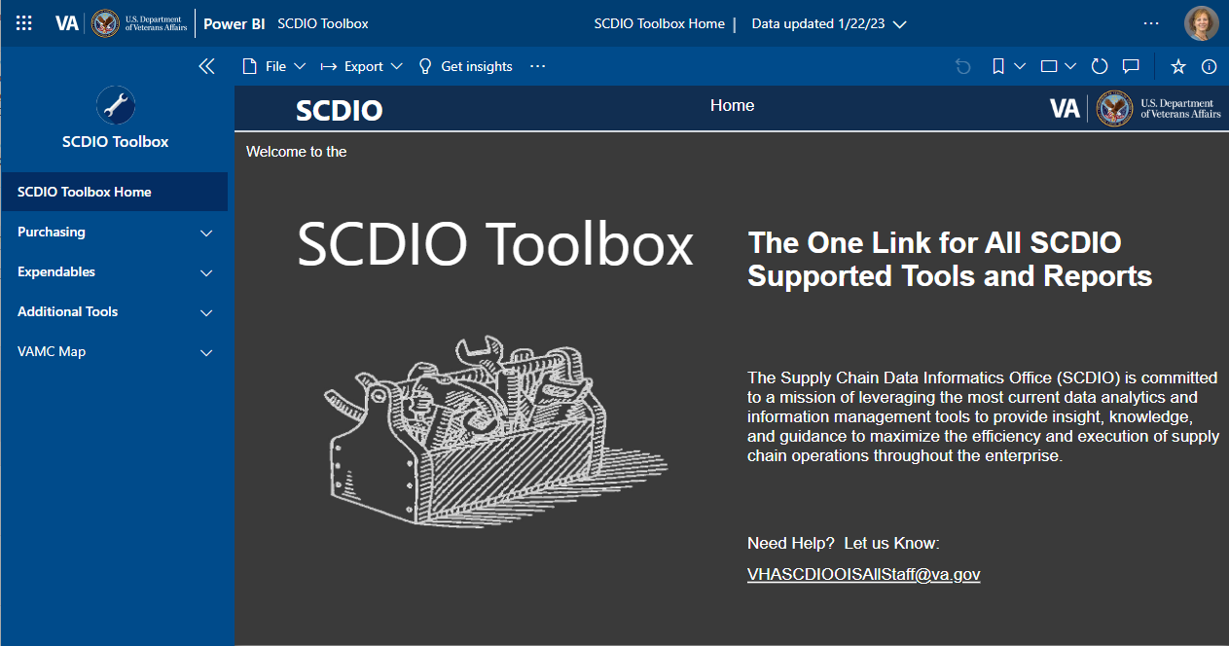

SCDIO Toolbox Example Report

PAR Image of a sample Enterprise Primary Stock Report that allows filtering on VISN, Facility, Inventory Point, IMF, MedPDB Key, Manufacturer, Manufacturer Part # and Status.  
The top part of the data shows Inventory Item Status by VISN and Station.  Column headers are 'AT RISK', 'NEG QOH', 'NO USAGE', 'NOT AT RISK', 'PAR LEVEL 0', 'STOCK OUT' and 'Total'.  
The lower half of the report shows VISN and Facilities with column headings of 'Inventory Point', 'IMF', 'MedPDB Description', and 'GIP Description'.

SCCOP Production Dashboard example

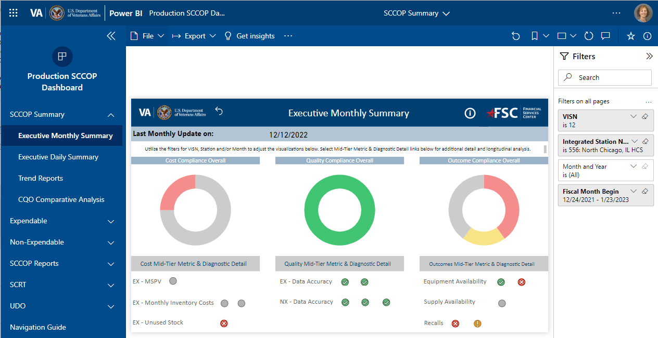

SCCOP Expendable Metrics Splash Page

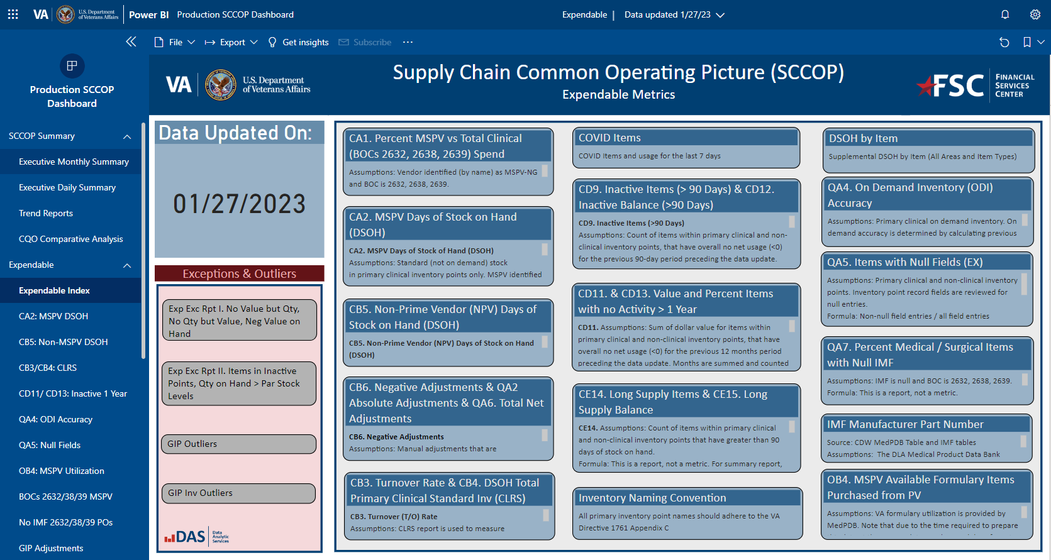

Purchase Card Analytics Splash Page

Purchase Card Analytics dashboard splash page.  It contains a text message saying "Overview:  This report is produced by the Financial Services Center using data obtained directly from US Bank without revisions which may or may not have been made in FMS.  The results are intended to inform and guide users as they seek cases which may be worth further investigation.  Included in this report are all transactions for the previous 25 months, updated each business day, with a lag of about 2 days."
The report selections on the left side of the screen are: Landing, High Level Overview Spending, Category Spending, High-Risk Categories, High-Risk Purchases, High-Risk Merchants, Over Limit, Potential Split Purchases, Shipping & Item Detail, IFCAP Overview, IFCAP Items and IFCAP Exc.

CPRC Metrics Dashboard

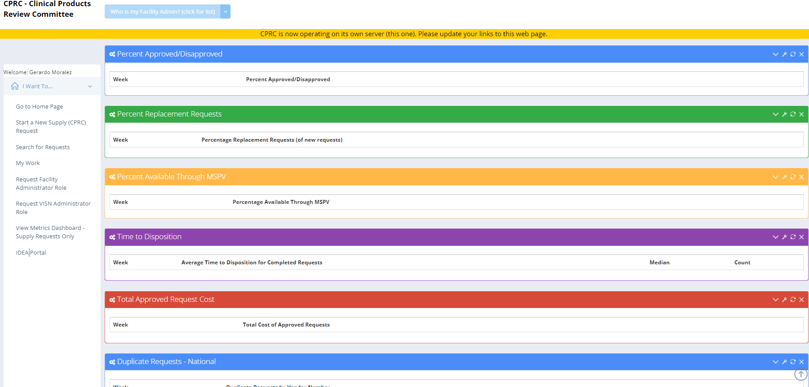

SEPG-EER Dashboard

SEPG/EER dashboard.  On the left side are categories and sub-categories of:
Inventory Review - Equip Drill-through, Equip by site, Equip by replacement year, Plan Development - FY 2024 through FY2028 with a Plan Archive selection, Equipment Request - Requests Search and Request Archive.
The right of the links shows six charts, four donut charts and two horizontal bar charts.  They represent Cost by Justification, Cost by VISN, Cost by equipment category, Planned vs Requested Qty, Planned vs Requested Cost and Plan Items by Status.  

HTM KPI Dashboard

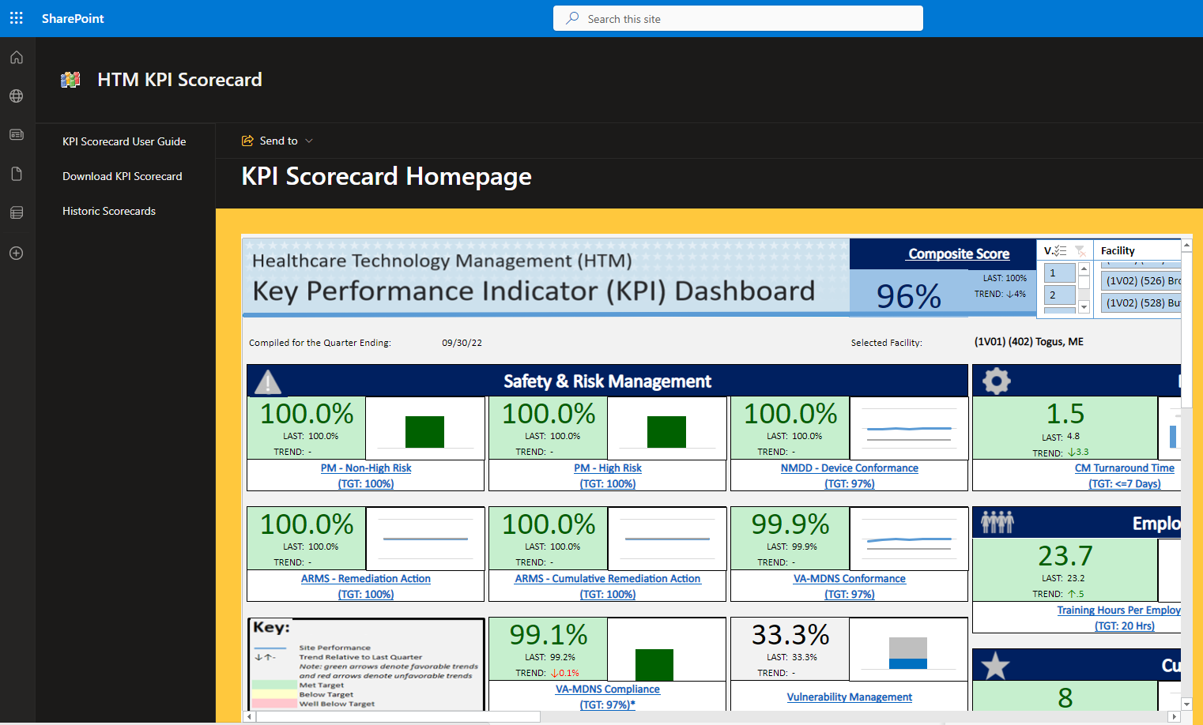

HTM KPI Dashboard Example Reports

