 | York & Whiting Consulting, LLC  “Driving Innovative Improvements, Efficiencies, and Value” | 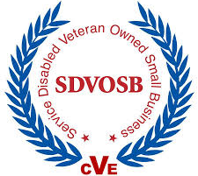
Kenneth M. Lang  Ph.D., MBA  CEO/Managing Member  - USAF Lt. Colonel (Retired)  - Program Management Professional (PMP) Certified  - Class A Construction License (pending) | WHY WE’RE DIFFERENT:  - Experts In Capital Investment: Planning, Installation, and Management  - Design-Build/Repair, Restoration, and Alteration  - Building and Property Specialty Trades (e.g., roofing, siding, electrical, foundation, structure, finishing)  - Information Technology, Telecommunications  - 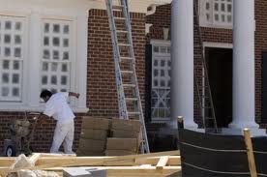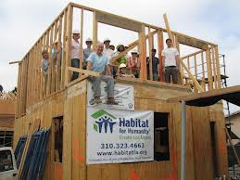Certified Veteran Enterprise (CVE)
Primary NAICS Codes  541330 Engineering Services  236210 Industrial Building Construction  236220 Commercial and Industrial Building Construction  238120 Structural Steel and Precast Concrete  238130 Framing  238140 Masonry  238160 Roofing  238170 Siding  238190 Other Foundation, Structure, and Building Exterior  238310 Drywall and Insulation  238320 Painting and Wall Covering  238330 Flooring  561210 Facilities Support Services  541350 Building Inspection Services  541512 Computer Systems Integration Consulting  541611 General Management Consulting Services  541618 Other Management Consulting Services  541519 Other Computer Related Services  541712 Research and Development in the Physical, Engineering, and Life Sciences  541990 All Other Professional, Scientific and Technical  DUNS: 066787386  CAGE Code: 6H8G5  Clearances: Top Secret (TS) Sensitive Compartmented Information (SCI) | Core Competencies  - Architecture, Engineering, and Construction  - Information Technology Systems Integration and Interoperability  - Concepts and Solutions Development, Requirements Engineering, Strategic Planning and Support  - Project/Program Management  Areas of Expertise  - General Construction  - Design-Build/Repair and Alteration Services  - Architectural, Structural, Civil, Geotechnical, Mechanical,  and Electrical Engineering  - Security Planning/Design  - Roofing, Framing, Siding, and Foundation Construction  - Inspection Services  - Historic Preservation and Restoration  - Project/Program Management (PM), Planning  - Information Technology Support Services  - Engineering  Corporate Experience  Building 10620, Fort Lee, Virginia: furnish all labor, supervision, and material to remove existing floor covering and install new vinyl composition tile (VCT). $21,000 THR Enterprises Eddie O’Brien, (757) 625-4592  Building CEP 76, NEXCOM Mini Mart, Naval Station, Norfolk: modify existing mechanical system for dehumidification and install energy recovery unit, dampers, and mini split system. $24,770 THR Enterprises Eddie O’Brien, (757) 625-4592  Building 9621 Shore Drive, Norfolk, Virginia: erect 4,100 sf structure including installation of windows, doors, and exterior trim. $26,727 Vista Construction Li Shen, (757) 531-7187  Building 2808, Norfolk, Virginia: revitalize 5,000 sf structure. Install new windows, door, brick pointing, and lighting. Frame interior walls. Install insulation and wall boards. Trim, paint. $77,500 Starburst Construction Hugh DeLauney, (757) 635-4917  Herron Hall, Langley AFB, Virginia: Demolish 3-foot thick masonry wall. Install structural steel for installation of new mechanical system. $6,600 THR Enterprises Eddie O’Brien, (757) 625-4592  Air Combat Command A8, Langley AFB, Virginia: analyze Integrated Missile Defense System requirements/subsystems. $164,000 FA8750-09-D-0017 A. Perkins, (757) 214-8539
York & Whiting Consulting, LLC www.yorkandwhiting.com
205 Coinjock Run, Yorktown, VA 23693 www.yorkandwhiting.com (877) 875-6229

