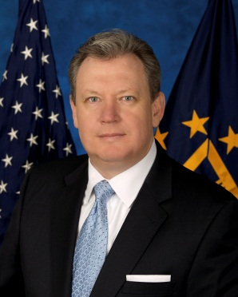

Stanley F. Lowe Leadership Bio
Deputy Assistant Secretary, VA Office of Information Security

Stanley F. Lowe is the U.S. Department of Veterans Affairs (VA) Deputy Assistant Secretary (DAS) for Information Security. Mr. Lowe manages information security and privacy across VA’s vast network of more than 450,000 devices, serving more than 400,000 VA system users. Under Mr. Lowe’s direction, the VA Office of Information Security (OIS) works to prevent and mitigate the impact of any impending threats to VA’s IT infrastructure. Mr. Lowe oversees the management of VA’s Information Security Officers (ISOs), Cyber Security Program, Privacy Program, incident management and response capabilities, security operations, and business continuity efforts.

Prior to becoming the Deputy Assistant Secretary for OIS, Mr. Lowe was the Deputy Director of the Department of Defense (DoD)/VA Interagency Program Office (IPO). In his time working for the IPO, Mr. Lowe worked with the IPO Director to lead the DoD and VA in the development and implementation of Electronic Health Records and the Virtual Lifetime Electronic Record (VLER) Health systems, capabilities, and initiatives, which allow for full information interoperability between the departments to better serve Servicemembers, Veterans, and other eligible beneficiaries. In concurrence with his role with the IPO, Mr. Lowe also served as the Senior Advisor to the Assistant Secretary for Information and Technology at VA.

Before joining VA, Mr. Lowe served as Chief Information Officer of the Federal Trade Commission (FTC), joining as Deputy CIO for Management in 2006. Mr. Lowe’s public service record extends to the US Department of Interior in the Bureau of Land Management as Chief of the Information Security Policy and Training Branch (BLM). Prior to BLM, he served as the Security Director for the Inspector General of the U.S. Postal Service and held executive positions in several private companies. Mr. Lowe is a Navy Veteran, having served 10 years on active duty on various ships and stations around the world.
Mr. Lowe holds a Bachelors of Science from Strayer University and is currently pursuing a Masters in Public Administration from George Mason University. He has a Master’s Certificate in Management from the George Washington University in Washington, D.C

