VETERAN HEALTH ADMINISTRATION (VHA)
MEDICAL APPOINTMENT SCHEDULING SOLUTION (MASS)
Business Blueprint

May 2014
V 0.4

VERSION HISTORY
Version # | Revision  Date | Reason | Author
0.1 | March 21, 2014 | Initial draft, derived from 09/2012 Business Blueprint | ACAP
0.3 | May 16, 2014 | Updated for release with industry day announcement | ACAP

Table of Contents
1 Introduction 1
2 Blueprint Structure 1
3 Background 2
3.1 Finding from Current Environment 6
3.2 Assumption and Constraints 8
3.3 Risk Assessment 9
3.4 Problem/Opportunity Statement 12
4 Framework 13
4.1 National Perspective 15
4.2 Medical Application Scheduling System Setup 17
4.3 Veteran Information Management 31
4.3.1 Process Overview for Veteran 31
4.4 Request Management 40
4.5 Manage Appointment 49
4.6 Coordinate Associated and Occasions of Services 63
4.7 Manage Encounter of Care 74
4.8 Report Management 84
4.9 Master Data and Functional Integration Points in VistA 93
5 Supporting Materials 96
5.1 Acronyms 96
5.2 Descriptions of Terms 99
5.3 National Services 110
6.1 References 111

Table of Tables
Table 1 Pain Points 7
Table 2 Assumptions and Constraints 9
Table 3 Risks 12
Table 4 - Problem Opportunity Statement 12
Table 5 National Unique/High Priority Business Needs 16
Table 6 Setup Unique/High Priority Business Needs 18
Table 7 Setup Sub-Capabilities 20
Table 8 MASS Scheduling Master Records 22
Table 9 MASS Resource Master Records 23
Table 10 MASS Veteran Master Records 23
Table 11 MASS Scheduling Templates 23
Table 12 MASS Master Alerts and Workflow 24
Table 13 Manage Veteran Information Unique/High Priority Business Needs 32
Table 14 Veteran Information Management Sub-Capabilities 34
Table 15 Common Veteran Information Management Situations 35
Table 16 Request Management 41
Table 17 Request Management Sub-Capabilities 43
Table 18 Common Request Management Situations 44
Table 19 Appointment Management 51
Table 20 Appointment Management Sub-Capabilities 52
Table 21 Common Appointment Management Situations 57
Table 22 Coordinate Associated and Occasions of Service Unique/High Priority Business Needs 64
Table 23 - Coordinate Associated and Occasions of Services Sub-Capabilities 65
Table 24 Common Associated and Occasions of Service Situations 67
Table 25 Manage Encounter of Care 75
Table 26 Manage Encounter of Care Sub-Capabilities 77
Table 27 Common Encounter of Care Situations 78
Table 28 Report Management Unique/High Priority Business Needs 85
Table 29 Report Management Sub-Capabilities 87
Table 30 Common Reports Generated During Report Management 90
Table 31 Functional Integration Points to VistA 95
Table 32 Acronyms 98
Table 33 Descriptions of Terms 109

Table of Figures
Figure 1 Framework Structure 13
Figure 2: MASS Framework 14
Figure 3 - Setup (Framework View) 19
Figure 4 - Setup and Maintain Resource Availability Process Flow 26
Figure 5 - Setup Maintain Scheduling Care Coordination Agreements Process Flow 27
Figure 6 - Setup and Maintain Scheduling Notification Templates Process Flow 28
Figure 7 - Setup and Maintain Scheduling Business Rules, Alerts and Workflow Process Flow 29
Figure 8 - Setup and Maintain Scheduling System Access Process Flow 30
Figure 9 - Veteran Information Management (Framework View) 33
Figure 10 – Assess VA/VHA Veteran Enrollment and Benefits Process Flow (2A) 37
Figure 11 - View/Maintain Existing Veteran Information Process Flow (2B) 38
Figure 12 - Create/Maintain Veteran Preference and Special Needs Process Flow (2C) 39
Figure 13 - Request Management (Framework View) 42
Figure 14 - Process Request Process Flow 46
Figure 15 – Process Request List Process Flow (3B) 47
Figure 16 - Perform Request Oversight Activities Process Flow (3C) 48
Figure 17 - Appointment Management (Framework View) 51
Figure 18 - Make Appointment Process Flow (4A) 59
Figure 19 - Process Appointment Reschedules and Cancellations Process Flow (4B) 60
Figure 20 - Process Notifications Process Flow (4C) 61
Figure 21 – Perform Appointment Oversight Activities Process Flow (4D) 62
Figure 22 - Coordinate Associated and Occasions of Service (Framework View) 64
Figure 23 - Coordinate Other VA Health Care Services Process Flow 69
Figure 24 - Coordinate External Health Care Services Process Flow 70
Figure 25 - Coordinate Occasions of Service (Ancillary) Process Flow 71
Figure 26 - Coordinate Alternate Means of Delivering Care Process Flow 72
Figure 27 - Coordinate Medical Records Process Flow 73
Figure 28 - Encounter Management (Framework View) 75
Figure 29 – Perform Check-in Process Flow (6A) 80
Figure 30 - Capture Encounter Events Process Flow (6B) 81
Figure 31 - Perform Check-out Activities Process Flow (6C) 82
Figure 32 - Perform Encounter of Care Oversight Activities Process Flow (6D) 83
Figure 33 - Reporting (Framework View) 86

Introduction
The VHA Medical Appointment Scheduling System (MASS) project will replace the legacy outpatient scheduling system to provide more efficient access to care for Veterans. Outpatient scheduling is complex in that it requires coordination across medical services while enforcing clinical delivery business rules. VistA Scheduling was built in the early 80’s as an inpatient care scheduling system with few embedded clinical delivery business rules. Today’s VHA care delivery is dramatically different from the past with the majority of appointments scheduled for outpatient care. Recent movements towards home healthcare, telehealth and Veteran self-scheduling has illuminated the limitations of VistA Scheduling. In FY2010 approximately 8.4 million of the 23.1 million living veterans in the nation were enrolled in the VA health care system. VHA’s 50,000 users schedule over 85 million appointments a year for this Veteran population. Serving this volume requires state of the art capacity management tools and a solution that provides for efficient scheduling to meet Veteran demands.
VHA is developing products, including this Business Blueprint, to illustrate the complexity of the current state and present a future state describing scheduling-essential capabilities. This is designed as a reference document to capture - relevant future state medical scheduling information for a comprehensive upgrade of medical scheduling capabilities.

Blueprint Structure
This blueprint is organized into three main sections: Background, Framework and Scheduling Capability Descriptions and supporting sections: Acronyms, Descriptions, National Services and References. Background section provides the organizational context of outpatient scheduling in VHA, how it impacts performance measures and a general sense of the scope of the business processes. The second section includes the Framework and Scheduling Capability Descriptions sections depict the overall capabilities desired for a new scheduling solution by defining the functional areas illustrated in the framework, leading with the National perspective. Each capability consists of several sub-capabilities which are described in detail. Additional supporting detail is provided in the final sections.

Background
Access to VHA services is at the center of the VHA mission to provide exceptional healthcare that improves the Veterans’ health and well-being. To accomplish its mission, VHA needs to ensure that there is consistency and expediency in providing needed services to our Veterans: timely access to care where and when needed, equity across VHA in the number and types of services available, and consistency in access to those services. The mission has become even more of a challenge as demand for VA healthcare services has increased.
In order to consistently and reliably meet access commitments, VHA will need to ensure standardization of operational policies for clinic management related to patient scheduling and wait times. This will require updating the current scheduling system and modernizing operations, as well as consistently managing workload demand and consult request and tracking across the enterprise. More importantly, VHA will be enabling transition from a face-to-face appointment model to a sustained relationship model using multiple forms of access and engagement.
There is no single VHA entity responsible for these activities, therefore VHA’s Office of the Deputy Under Secretary for Health Operations and Management (DUSHOM) established a program office to define, standardize and coordinate system-wide administrative clinic operations and management. This program is designated as the Access and Clinic Administration Program (ACAP). The scope of ACAP will include outpatient access standards and workload capacity alignment; with the highest order being Primary Care and Mental Health, and call center operations to include triage, queuing and standard operating procedures. Specialty Care clinic access will include the aforementioned plus consult management, including establishment of tracking and monitoring standards. The ACAP will also serve as VHA’s business owner and manager in collaboration with the VA Office of Information Technology (OIT) in matters regarding appointment scheduling. Additionally, the ACAP will bridge the gaps and disconnects between policy and operations necessary to comprehensively define and coordinate the transformation of clinic operations which will require standardization through policies that are consistently implemented, performance measures that are reliable and actionable and reporting structures that facilitate accountability. These initiatives will result in fundamental business processes that will ensure standardization of clinic practices across VA Healthcare systems and proactively and strategically focus on systemic improvements to Veterans’ access to care.
In February 1998, the GAO issued a report entitled VA Health Care Status of Efforts to Improve Efficiency and Access (Report No. GAO/HEHS-98-48). In this report, GAO noted VA’s unprecedented changes to its health care system. Introducing practices inspired by managed care, VA was shifting the emphasis of its medical care delivery system from extensive inpatient services to outpatient care. Implementing these changes was intended to improve the efficiency of their operations, while improving Veterans’ access to their services.
In April 1998, the GAO issued a report entitled VA Hospitals – Issues and Challenges for the Future (Report No. GAO/HEHS-98-32). The main focus of the report was to provide Congress and the administration with sufficient information for properly assessing the potential effects of VA’s health care system changes on all stakeholders. Specifically, those related to decreased use of VA services due to medical advances, declining numbers of Veterans, and the potential for improved health care options available to Veterans through Medicare and other insurance at the time of this report. Upon review, the GAO stated that one of the most crucial decisions facing the Congress and the administration as they planned for the future of the Veterans’ health care system is the extent of effort that should be spent to preserve VA’s direct delivery infrastructure and the process that should be followed to effect change.
In May 2000, the GAO issued a report to the Ranking Democratic Member, Committee on Veterans Affairs, House of Representatives entitled VA Needs Better Data on Extent and Causes of Waiting Times (Report HEHS-00-90). Although the VA had initiated two separate efforts for gathering comprehensive outpatient waiting time data from its facilities with plans to spend additional monies to make improvements in the timeliness of service and access to clinical information, it still lacked reliable national waiting time data to assess whether its proposed expenditures would reduce waiting times. The GAO recommended that VA take actions to identify the extent and causes of waiting time problems.
In January 2001, the GAO issued Major Management Challenges and Program Risks – Department of Veterans Affairs (Report No. GAO-01-255) in its Performance and Accountability Series. This analysis addressed the major performance and accountability challenges facing the VA. It includes a summary of actions that VA has taken and that are under way to address these challenges and outlines further actions that VA believes are needed.
In July 2005, the GAO issued Audit of the Veterans Health Administration’s Outpatient Scheduling Procedures (Report No. 04-02887) and concluded that schedulers were not following outpatient scheduling procedures, resulting in inaccurate waiting times and incomplete waiting lists.
As a follow-up to the 2005 GAO report, the GAO issued Audit of the Veterans Health Administration’s Outpatient Waiting Times (Report No. 07-00616-199) in September 2007. Again, the conclusion was that schedulers were not following established procedures for making outpatient appointments, causing VHA’s reported performance on waiting times and waiting lists to be unreliable for Congressional and VA decision making.
In December 2008, VA’s OIG issued Audit of Veterans Health Administration’s Efforts to Reduce Unused Outpatient Appointments (Report No. 08-00870-36). The objectives were to determine if VHA has an effective method to accurately track and report unused outpatient appointments, whether VA medical facilities implemented effective processes for reducing the number of patient no-shows, and whether unused appointments could be used for patients who are waiting for care. VHA failed to meet any of these objectives and OIG recommended the Under Secretary of Health establish procedures and measures to remedy these deficiencies.
In June 2009, VA’s OIG issued Review of Interagency Agreement between the Department of Veterans Affairs and Department of Navy, Space Naval and Warfare Systems Center (SPAWAR) (Report No. 09-01213-142). Essentially, an interagency agreement (IAA) was entered to provide government employee and contractor technical support for analysis, planning, program review and engineering services for information management/information technology initiatives. OIG found that the IAA was entered into without an adequate analysis to determine the “use of an interagency acquisition is in the best interest of the Government”. Neither entity complied with the terms nor conditions of the IAA and both were deficient in the management of various tasks/responsibilities. One of the projects under this IAA was the Replacement Scheduling Activity – Enrollment System Application (RSA-ESR). OIG suggested that VA take steps to re-evaluate the IAA and determine whether it is in the best interests of VA to continue obtaining services through this type of agreement.
In August 2009, VA’s OIG issued Review of the Award and Administration of Task Orders Issued by the Department of Veterans Affairs for the Replacement Scheduling Application Development Program (RSA) (Report No. 09-01926-207). OIG was asked to conduct a review of the VA RSA Development Program. Specifically, OIG was to determine why there was not adequate internal oversight to prevent continued investment in what was ultimately a failed project. Upon review, OIG ultimately determined the failure of the RSA project was linked to larger systemic problems relating to the management and implementation of IT projects within VA. It suggested that VA both develop effective oversight systems and develop in-house staff that has the expertise to fully support, manage and execute complex integrated IT programs.
In May 2010, GAO issued Information Technology – Management Improvements Are Essential to VA’s Second Effort to Replace Its Outpatient Scheduling System (Report No. GAO-10-579). They found that after spending an estimated $127 million over 9 years on its outpatient scheduling system project, VA has not implemented any of the planned system’s capabilities and is essentially starting over. Upon review, the GAO recommended that VA implement measures that prevent the types of management weaknesses that plagued its earlier efforts. Failure to do this would result in incurring similar weaknesses in its latest scheduling replacement effort, which could again prevent VA from delivering this important capability for serving the health care needs of Veterans and their families.
The Department of Veterans Affairs (VA) policy states that facilities are expected to be able to see patients within 14 calendar days of the appointment date requested. VHA is currently utilizing several data extracts to assess clinic appointment waiting; however, due to a lack of standardization across VHA facilities, this measurement is not accurate for National Wait Time reporting. Challenges with wait time estimates include, but are not limited to: the inability to distinguish between new and follow-up visits, inconsistent use of Decision Support Services (DSS) Identifiers (used for wait time extracts), inability to document a patient or provider’s desired date for a future appointment, and the inability to calculate the total time interval between the request and when the appointment was actually made or has been rescheduled several times.
The current VHA Medical Scheduling system is outdated and outmoded. VHA’s current scheduling processes do not meet the needs of patients, providers and the VHA scheduling staff. Modernization of the system across the enterprise is required in order to meet ambulatory and patient appointment needs of VHA today. In the current state clinic grids are inflexible, productivity is not measurable, there is no method for scheduling resources (staff, rooms, equipment), and there are no links between scheduled appointments and ancillary appointments, i.e. lab and radiology. These broken links cause unnecessary bookings and rebooking as well as increased travel costs and patient dissatisfaction with VHA scheduling practices.

Finding from Current Environment
The following are findings identified as pain points and impacts to patients, providers and VHA’s operational environment.
Pain Points
Pain Point ID | Pain Point Description
PP1 | Scheduling solution not up to date for regarding emergent needs
PP2 | Information sharing between clinic stakeholders is often inefficient
PP3 | Veteran preferences and special needs often are not accommodated or require multiple entry points
PP4 | Data exchange with other systems, both internal and external are often performed manually
PP5 | Responsibilities not efficiently distributed among schedulers/staff
PP6 | Lack of visibility into provider availability
PP7 | Quality assurance and auditing require data which are not readily available
PP8 | Scheduling is inflexible due to clinic profile construct, resulting in multiple, manual work-arounds
PP9 | Reporting is labor intensive and often problematic
PP10 | Current system does not provide role level access
PP11 | Linking appointments is problematic and usually results in manual processes
PP12 | Notification process is non-standard, confusing to Veterans, paper-based and inconsistent across the VA
PP13 | Inability to perform predictive reporting
Table 1 Pain Points
EXTENSIVENESS OF SCHEDULING
VHA scheduling is high volume with approximately 85 million appointments scheduled per year, 50,000 staff schedule appointments across 150+ Medical Centers and 700+ Community Based Outpatient Centers (CBOCs).
ACCESS TO PROVIDER AVAILABILITY
The inability to view provider availability impedes efficient use of resources and understates available supply for patient services.
INABILITY TO COLLECT METRICS
Significant time and resources are spent identifying and collecting data required for quality assurance and auditing purposes. Reporting capabilities require excessive cycle time, the process is manual and labor-intensive and the output is often incomplete an inaccurate due to quality and the availability of the data.
INABILITY TO PERFORM PREDICTIVE DATA ANALYSIS
There is a lack of visibility into data that could provide trending and forecasting capabilities. This prevents VHA from realizing opportunities to increase efficiencies in patient scheduling and resource utilization.
INFORMATION AND DATA SHARING
There is inadequate information and data exchange between clinic stakeholders and other systems (internal and external) to VHA, therefore visibility to the full picture of medical care is limited.
NOTIFICATIONS PROCESS
Notifications are not performed in a consistently automated process, resulting in missed appointments, or available appointment time slots that could be filled.
CUSTOMER SATISFACTION
The current system is unable to provide Veterans with the highest level of customer satisfaction. Veterans’ scheduling needs and preferences are not captured and communicated effectively.
INABILITY TO LINK AND ASSOCIATE APPOINTMENT
The processes for linking and associating appointments are manual and inconsistent, opportunities for more efficient care are lost.
ROLE BASED ACCESS
Current scheduling system lacks role-level access, managing access rights is very labor intensive.
WORKLOAD PRIORITIZATION
There are inadequate integral business rules to efficiently distribute scheduling responsibilities among schedulers and staff and to manage resources in accordance with demand.

Assumption and Constraints
For the purposes of upgrading medical scheduling capability through the MASS project, it was necessary to identify specific assumptions and constraints to establish a common baseline understanding of the business need. These items shown in Figure 3 include a sample set of assumptions and constraints.
Assumptions
- An IT solution for Medical Appointment Scheduling System (MASS) will be implemented
- VHA schedules 85,000,000 appointments a year
- VA OIG estimates 3.1 million no-shows a year in its 2008 audit
- The average cost of an appointment is $182, according to 2008 VA OIG estimates
- There are approximately 50,000 VA staff that schedule appointments, and 10% of those are scheduling managers
- Existing policies may require changes to accommodate the future scheduling operating model
Constraints
- Funding for this effort will be phased over 3-5 years
- The solution cannot force extensive changes to other business processes dependent on scheduling data
- The approach must be able to deliver significant benefit without the need to aggregate VistA instance data at the national level
- A 3-year lead time for changes to congressional reporting must be considered during requirements and transition planning
- VHA deployment support is largely staffed from existing resources
- VHA appointment scheduling will continue throughout any transition period
- The existing VHA skill base for scheduling will remain unchanged
- No impact to current union agreements
Table 2 Assumptions and Constraints

Risk Assessment
The VHA conducted a risk assessment, incorporating existing documentation from previous efforts related to scheduling. The following risks displayed below were identified as the pertinent risks for VHA and include associated action plans to mitigate these risks at the enterprise level:
Business Risk | Mitigation
Enterprise Architecture
- If the interfaces to other systems are not fully understood by the scheduling solution providers, there may be substantial rework required, resulting in cost overruns or degraded performance. | Close coordination between the scheduling and VistA Evolution activities.
Scheduling Solution and COTS Products
- Because business operations of the VA are governed by congressional bodies, mandates that push system requirements beyond the capabilities of the commercial off the shelf scheduling solutions may lead to failed implementation or deployment. | All deviations from an “out-of the-box” solution will be closely monitored and explicitly approved by the CMIO.
Standardization and Local Autonomy
- If VHA does not implement a commonly accepted strategy for data standardization, efforts to achieve broad-scale data standardization may have false starts or fail to achieve the needed result. | VHA will establish a data standardization working group prior to contract award.
- Because the present operating environment allows for a great degree of autonomy at each facility, if the scheduling solution requires too much standardization, there will be resistance to change – threatening successful deployment. | VHA will trade the needs of national standardization against local facility needs in a solution adoption plan that will be approved by the Governance Board.
- Because local implementations that support scheduling today vary so much, if the new functionality requires a great level of localization at each site, then the effort to successfully deploy the capability at each site may be cost-prohibitive. | (same as #4)
Organizational Capacity and Relationships
- Because of the diversity of production environments throughout the VA, if the requirements gathering activity does not have sufficient broad-based participation, it may not be possible to identify all business needs to be fulfilled by the solution purchased by the VA – which may lead to failure during deployment. | Coordinate with the VistA Evolution Executive Program Office to ensure staffing and resource needs are available.
Governance
- If the VA is not configured to support timely solution development trades, then the cost of implementing a COTS-based system will become prohibitive. | A VA governance board of stakeholders who can enforce a decision will be established.
Testing
- Because of the diversity of IT Production Environments supported by VistA throughout the VA, if sufficient information is not provided to test the implementation and deployment of scheduling software, integration testing will be time-consuming, expensive and difficult to plan. | A test plan will be developed that will be approved by the Governance Board.
- Because of the diversity of production environments throughout the VA, if a centralized testing environment is not established, it will be infeasible to achieve economies of scope by allocating test cases to be tested in a centralized environment – leading each and every test case to be a focus of testing at each and every deployment. | (same as #8)
Adoption
- Because scheduling functionality may represent a more substantial change to some users than to others, seemingly minor mismatches in expectations (e.g., sequence of work steps or required data fields) may inhibit adoption, leading to a failed deployment. | VHA will develop and communicate a concept of operations that addresses mismatches among user needs and expectations that will be adjudicated by the governance board.
Deployment
- Because of the complex nature of this project, if the strategy for broad-scale deployment is not understood, local sites may be unable to begin the process of setting expectations – leading to potentially unpleasant surprises, and risk of failed deployment at the local level. | A deployment plan will be approved by the Governance Board.
Sustainment
- If the total cost of ownership is not well understood until late in development, then deployment may be delayed or the effort abandoned. | Independent cost assessment will address costs across the life of the solution.
Table 3 Risks

Problem/Opportunity Statement
Problem/Opportunity statement(s): | - VHA’s current scheduling processes do not meet the needs of patients, providers and VHA’s scheduling staff. The processes are unable to meet the supply and demand and the current medical scheduling system is outdated and outmoded.
Affects: | Veterans and other healthcare beneficiaries (spouses and dependents), providers and VHA.
The impact of which is: | - Financial: costly and resource intensive  - Operational: excessive cycle time, waiting time is non-value added, inability to respond to supply and demand, poor visibility which impairs management and improvement of workflow processes and scheduling activities.  - Patient Care: scheduling is not patient (Veteran) centric
A successful solution would: | - Provide patient centered scheduling services (Veteran centric)  - Centralized scheduling services  - Improve scheduling processes and oversight  - Reduce administrative costs  - Improve waiting time and overall cycle time of scheduling patients  - Provide an audit trail of scheduling activities  - Increase visibility for management and control of supply and demand  - Standardize data collection  - Enforced VHA policies, i.e. Business rules  - Allow information sharing and data exchanges both internal and external to VHA  - Meet Congressional and other external stakeholder reporting requirements
Table 4 - Problem Opportunity Statement

Framework
Outpatient scheduling is complex, in part, because of all the processes scheduling interacts with. In order to define scheduling business needs, the initial step was to create a framework that established a common definition for scheduling.
The framework is a graphical representation defining VHA outpatient scheduling functions. The framework draws a boundary around scheduling and clusters similar capabilities and their sub-capabilities.
The framework represents the scheduling operation, core capabilities, and business functions at four levels. Figure 1: Framework Structure illustrates the framework structure.
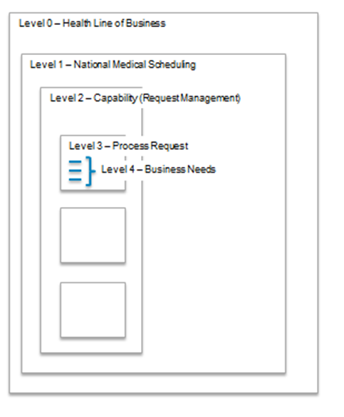
Figure 1 Framework Structure
- Level 0: Represented by the Health Care Line of Business. The Health Care Line of Business identifies the operational model within VA that is related to providing health care specifically. Other lines of business might be the Financial Line of Business or The Burial and Cemetery line of Business.
- Level 1: Represented as the VHA’s vision of the scheduling operation, that encompass outpatient scheduling.
- Level 2: Represented by the business’ core capabilities for the specific grouping of activities and functions, for example, “Manage Appointment”. In our framework, we have identified the following core capabilities:

- Medical Appointment Scheduling System (MASS) Setup (Configuration)
- Veteran Information Management
- Request Management (Demand)
- Appointment Management (Services and Delivery)
- Coordinate Associated and Occasion of Services (Delivery and Services)
- Encounter of Care Management (Episode of Care)
- Report Management
- Level 3: Represented by a group of core functions for each capability. For example, Manage Appointment has four core functions and each has a set of business needs.
- Level 4: Represents the end to end scheduling process activities, integration between the capabilities, and flow of information.
The framework serves as VHA’s highest level artifact is used as a guide to identify high-priority and VHA-unique characteristics of scheduling. Figure 2: MASS Framework illustrates the Operational Capability Model for scheduling.
Figure 2: MASS Framework

National Perspective

Vision Statement
Medical care is changing and there is an increasing need for Telehealth, rural healthcare, home healthcare and electronic access. VHA seeks the opportunity to establish new patient expectations and move toward patient centered healthcare. To meet these needs and expectations, an enterprise scheduling solution is needed to provide consistent, seamless, timely and high-quality scheduling interactions for patients, providers and VHA scheduling staff. The solution must also support standardization of scheduling data and business practices with full transparency across VHA. Additionally, the enterprise solution must be flexible and extensible so that VHA can deliver scheduling solutions with agility and the capability of continuous process improvement as healthcare changes.

Scope
The scope of an enterprise scheduling solution must provide the following:
- Seamless patient centered scheduling services
- Balance the supply and demands through resource based scheduling
- Standardized data collection and business rules
- Centralized scheduling services based on standardized scheduling policies
  - Geographic coverage to include call centers and tele-health methods
- Automation
  - Increase efficiency for patient scheduling and resource utilization
  - Reduce scheduling errors
- Increase visibility for management and control of supply and demand
- Information sharing and data exchanges both internal and external to VHA
- Meet Congressional reporting requirements
  - Address concerns of Government Accounting Office (GAO), the Office of Inspector General (OIG), and other external stakeholder requirements

Unique/High Priority Business Needs
National Level
Feature or Characteristic | Measure of success
Current VistA reporting and DSS coding must continue to support non-scheduling business processes as it currently does today | All scheduling data extracts continue to support other non-scheduling processes without disruption
Timestamps to capture Veteran cycle of care and episode of care, starting from first contact with VA | Any veteran contact date / wait time or care cycle can be tracked by type of services received, time to complete requested service or segment of services received from the initial request presented by the patient
Capture of desired date | Changes to desired date are reportable
Proactive resource management-based scheduling that schedules staff, facilities, equipment | Ability to coordinate necessary resources at the time the appointment is made, based on predetermined configuration information
Patient-scheduling | Patients are able to easily request and schedule routine appointments themselves through multiple avenues, such as mobile applications and web.
Single view of the patient | Patients do not encounter delays and administrative tasks when they need to be seen away from their local center
Efficient, effective user interface that enables error-free scheduling of resources | Total actions for scheduler to create appointment in the solution requiring minimal navigation and training
Efficient, effective user interface that enables error-free scheduling of resources | Appointments are scheduled efficiently and error free
Table 5 National Unique/High Priority Business Needs

Medical Application Scheduling System Setup

Process Overview for Medical Appointment Scheduling System Setup
The Medical Appointment Scheduling System Setup capability establishes system operating parameters, such as: provider, facility, and equipment, care coordination agreements, notification templates, business rules, alerts, workflow, and system access. While facility, provider and business rules are established at the national level, other parameters such as workflow, alerts and templates may be tailored at VISN and facility levels per security and policy constraints yet still meet national standards to ensure accurate data exchanges and consistent reporting results. These configuration items are generally referred to as “scheduling master records”. Master records are the backbone of most organizations and contain the information required to create and maintain a nation-wide "system of record" for core business entities to capture business transactions and measure results for these entities. Data considered for master data management varies, but generally is categorized along the lines of customer, product, employee and vendor. For the VHA, this translates to Veteran, service, provider, facility, appointment, request, encounter, Veteran health record.
There are five sub-capabilities within the Setup capability:
- Setup and Maintain Resource Availability
- Setup and Maintain Care Coordination Agreements
- Setup and Maintain Scheduling Notification Templates
- Setup and Maintain Scheduling Business Rules,
- Alerts and Workflow
- Setup and Maintain Scheduling System Access
Each is described with the high level activities described and lays the groundwork to identify more detailed processes.

Unique/High Priority Business Needs
Medical Application Scheduling System Setup
Feature or Characteristic | Measure of success
Current VistA reporting and DSS coding must continue to support non-scheduling business processes as it currently does today | All scheduling data extracts continue to support other non-scheduling processes without disruption
Resources, such as provider, support staff, equipment and facilities, can be configured for availability and services | When scheduling appointments, those resources required to fulfill the appointment that are available and appropriate are presented.
 | Scheduling is simplified because business rules are captured during setup and used when scheduling appointments
 | Errors in scheduling are reduced because the solution prompts, warns or otherwise enforces the configured business rules
Ability to create system level configurable business rules that are leveraged throughout the scheduling process | Automation of business rules throughout the process
Access to schedule resources must be role-based, allowing for various levels of access. | Different user groups may be granted differing levels of access throughout the system, at the functional level (view vs schedule) and at the data level (one facility vs another)
Development and sharing of templates to ease implementation | Templates for facility or service configurations can be created and shared, allowing for easy propagation of common configuration of business rules
Configuration must mirror the multi-level construct of VHA, national, VISN, Health System, Facility, Outpatient clinics, allowing for cascading of policy via business rule enforcement | A policy established at any level of the hierarchy is automatically enforced (soft enforcement with a warning, hard enforcement with a prohibition of capability) downstream
Table 6 Setup Unique/High Priority Business Needs

Setup Sub-Capability Descriptions
The five Setup sub-capabilities are instrumental to the scheduling solution as these foundational configuration components determine system efficiency and effectiveness. Table 1- Setup Sub-Capabilities provides detailed descriptions of the five Setup sub-capabilities. These descriptions define the importance of each sub-capability and how these sub-capabilities contribute to the overall Setup capability.
Figure 3 - Setup (Framework View)
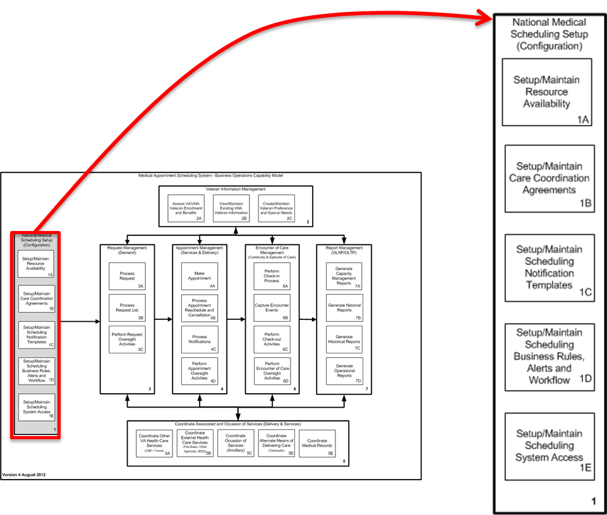

Medical Appointment Scheduling System (MASS) setup SUB-CAPABILITIES
The Medical Appointment Scheduling System Setup capability establishes system operating parameters, such as: provider, facility, and equipment, care coordination agreements, notification templates, business rules, alerts, workflow, and system access. While facility, provider and business rules are established at the national level, other parameters such as workflow, alerts and templates may be tailored at VISN and facility levels per security and policy constraints yet still meet national standards to ensure accurate data exchanges and consistent reporting results.
1A | Setup and Maintain Resource Availability | Setup and Maintain Resource Availability sub-capability determines, creates, and maintains the type of resources to be used throughout the scheduling process. Resources consist of elements such as facility, room, equipment and provider. The creation and maintenance of configurable components (e.g., service lines, modes of delivery, appointment durations, etc.) are required for the scheduling process. Defined resources comprise a critical aspect that ties not only to scheduling Veterans, workforce utilization, but also sustaining VistA systems such as the Decision Support System (DSS).
1B | Setup and Maintain Care Coordination Agreements | The Setup and Maintain Scheduling Care Coordination Agreement sub-capability provides a means to enter and maintain work flow rules between any two or more services that send work to one another. A care coordination agreement establishes a protocol to use resources according to provider or service line guidelines; this work aid will guide schedulers throughout the scheduling process. A framework of agreements may be created at a National level, but VISNs and facilities require a certain level of flexibility to tailor them to meet unique needs and goals.
1C | Setup and Maintain Scheduling Notification Templates | The Setup and Maintain Scheduling Notification Templates sub-capability establishes and maintains a library of standardized template types for all outbound communication between VHA and Veterans. This sub-capability also integrates with various delivery types such as mobile applications, secure messaging, USPS, and personal phone calls with Veterans.
1D | Setup and Maintain Scheduling Business Rules, Alerts and Workflow | The Setup and Maintain Scheduling Business Rules, Alerts and Workflow sub-capability establishes overarching parameters which to ensure consistent scheduling practices by controlling the configuration of business rules, alerts, and workflow.
1E | Setup and Maintain Scheduling System Access | The Setup and Maintain Scheduling System Access sub-capability establishes user access roles and rules at a national level. The flexible assignment of system access roles to users supporting the scheduling process should disseminate to the VISN or facility levels.
Table 7 Setup Sub-Capabilities

Components of Setup
Medical Appointment Scheduling System Master Records define more specific scheduling elements including scheduling resources, care coordination agreements, scheduling templates, alerts and workflow, and scheduling system access. Each must be identified and defined not only in regard to making appointments, but also whether it is used by other downstream systems.
 | Medical Appointment Scheduling System (MASS) master Records
Request Types |  | In order to capture the origin of an appointment, requests (source of input) need to be tracked. VHA can then determine where demand is generated, control workflow routing, and reduce backlog. Request types will allow VHA to determine where resources should be allocated (toward internet resources or for additional schedulers).  Some request types include:  - Consults  - MyHealtheVet  - Telephone  - Secure Message  - In-person
Appointment Types |  | The VHA’s governance structure will determine and define the actual type of appointments to assign and track.  Appointment types currently tied to clinic profiles include:  - Compensation & Pension (C&P)  - Mental Health Clinic  - Primary Care Clinic  - New Appointment  - Follow-up Appointment  - Pre-operative Appointment  - Post-operative Appointment  Facilities will select a subset of the appointment types or be able to add additional ones as long as they meet naming conventions and other standards.
Service Types |  | Service types will be defined and made available to the VISNs and facilities. Service types currently tied to clinic profiles include:  - National Service  - Ambulatory Care Services  - Anesthesia Service  - Blind Rehabilitation  - Chaplains Service  - Dental Service  - Dermatology Service  - Dialysis Service  - Domiciliary Service  - Geriatric Extended Care Service  - Laboratory Service  - MASS Veteran Contact Service  - Medicine Service  - Neurology Service  - Nuclear Medicine Service  - Nursing Service  - Nutrition Service  - Optometry/Ophthalmology Service  - Pharmacy Service  - Podiatry Service  - Prosthetics Service  - Psychiatry (PSI) Service  - Psychology (PSO) Service  - Radiation Therapy Service  - Radiology Service  - Recreational Therapy Service  - Rehab Medicine Service  - Social Work Service  - Speech Pathology/Audiology Service  - Spinal Cord Injury Service  - Surgery Service  Facilities will determine what the values are for service types they offer. These may vary greatly from facility to facility and a facility will need to eliminate service types from their view if they do not perform those services.  Facilities will be able to add additional ones as long as they meet naming conventions and other standards.
Table 8 MASS Scheduling Master Records
Resource master Records
Facility Types | Initial system setup will have a group of basic facility types. These are a generic listing and may expand to include entities such as Veteran home.  A partial list include:  - VAMC  - Veteran Center  - Outpatient Clinic  - CBOCs  Facility types are a relatively small data set. At the VISN or facility level, those venues may have additional values to add to the national definitions as long as they meet naming conventions and other standards.
Equipment Types | Equipment types where scheduling is involved are:  - MRI  - Portable X-Ray  - EKG  Facilities will select and add other types as the facility desires as long as they meet naming conventions and other standards.
Room Types | Facilities will add to the list as the facility dictates depending on unique facility attributes.  For example:  - General treatment room  - Dental room  - OB/GYM room
Health care Delivery Types | Health care Delivery Types describe how the service is delivered. Most of the health care delivery types will be available and facilities can choose the entities that apply to them. The facilities may also contribute additional types as long as they meet naming conventions and other standards. Health care Delivery Types include:  - TeleHealth  - Home-Care  - Outpatient  - Internet Secure Messaging  - Phone
Types of Providers | Provider Types include:  - Cardiologist  - Dermatologist  - Physical Therapist  - LPN  - Primary Care Physician  Facilities will select a subset of the type of provider and be able to add additional ones as long as they meet naming conventions and other standards.
Table 9 MASS Resource Master Records
Veteran master Records
Veteran Types | Veteran types establish and categorize the Veteran. Veteran types are strongly linked to policy and reporting. Veteran types define Veterans such as OEF/OIF, WWII, etc. It is anticipated that facilities will have very few additions to this category but would be able to add Veteran types as long as they meet naming conventions and other standards.
Table 10 MASS Veteran Master Records
Master Scheduling Templates
Master Templates/Letters/Forms Notifications | Establishes consistent and standard ways to communicate to the Veteran. The communication methods should be standardized throughout all VA facilities.  For example:  - No-Show Letter  - Pre-Appointment Letter  - Clinic Cancellation Letter  - Appt. Cancellation Letter  These communication tools may be tailored to meet unique facility operations and preferences. As long as facilities meet VHA standards they may elect to send notifications farther in advance, or send an additional follow-up reminder, or to include the facility name and map, etc.
Table 11 MASS Scheduling Templates
Master Alerts and Workflow
Alerts | Determine core sets of alerts and subsequent action required by scheduling personnel. For example, one alert at the national level is that scheduling personnel must verify Veteran demographics at certain times in the scheduling and encounter processes and use a specific protocol. An example of a facility level alert is a message to scheduling personnel to remind Veterans that the bus stop moved recently.  Examples of other alerts are:  - Inform clinicians when a Veteran is due to receive clinical activity  - Determine appropriate follow-up activities  - Allow clinicians to resolve reminders through CPRS
Workflow | Uses an automated series of events to enhance efficiency and assist decision-making. While basic alerts and workflow are established nationally, facilities have individual ways to process Veterans through scheduling and the encounter. Workflow should meet the strengths of each facility and enable the Veteran a smooth path from scheduling to completion of care.  Examples of workflow:  - Target the clinicians who can manage and resolve the clinical activity most appropriately  - Provide aggregate reports that assist clinicians in managing their entire Veteran caseload  - Support national clinical practice guidelines  Facilities may wish to tailor their workflow based on physical layout of the facility. In some instances, check-in and check-out might be in the same area while at other facilities, they may be in different areas.
Table 12 MASS Master Alerts and Workflow

Medical Appointment Scheduling System (MASS) MASS Setup Process Flows and Business Needs (1)
The business requires the ability to maintain a high-level partnership agreement with integrated VistA modules to ensure consistent system operability with scheduling and non-scheduling systems. The business requires the ability to configure and maintain system operating parameters to ensure standards at a national level, and the ability to tailor at VISN, facility and service line levels.

Setup and Maintain Resource Availability 1A
Figure 4 - Setup and Maintain Resource Availability Process Flow
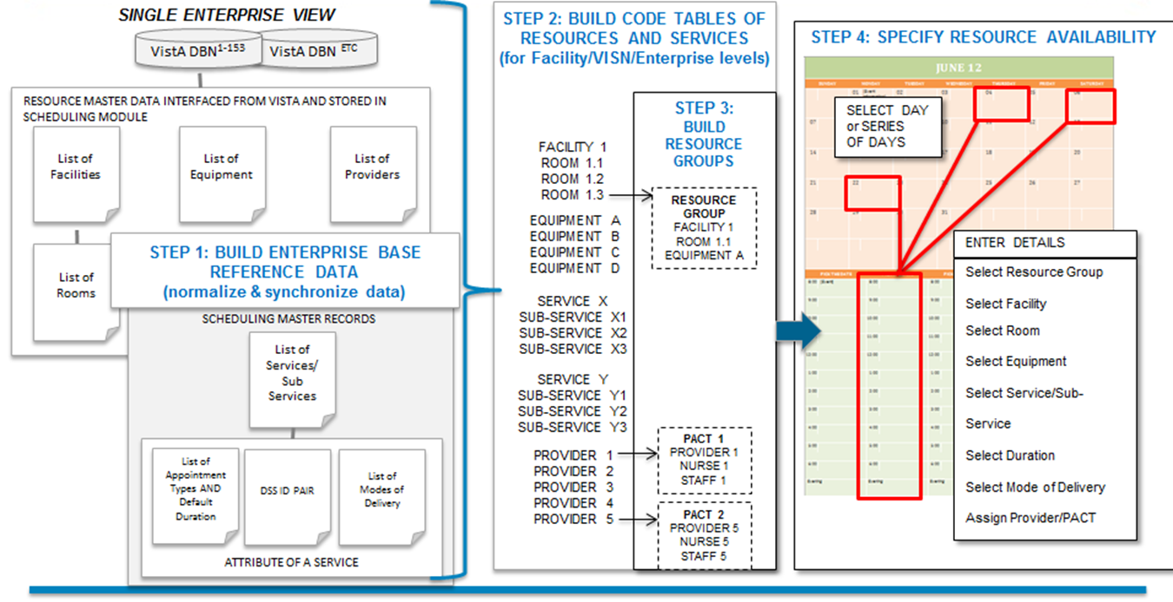
The business requires the ability to determine, create and maintain resources such as facility, room, equipment and provider to be used throughout the scheduling process. The business requires the ability to create and maintain configurable components (e.g., service lines, modes of delivery, appointment durations, etc.) necessary for the scheduling process. The business requires the ability to define resources that comprise critical aspect that tie not only to scheduling Veterans, workforce utilization, but also to sustaining VistA systems such as the Decision Support System (DSS).

Setup Maintain Scheduling Care Coordination Agreements (1B)
Figure 5 - Setup Maintain Scheduling Care Coordination Agreements Process Flow
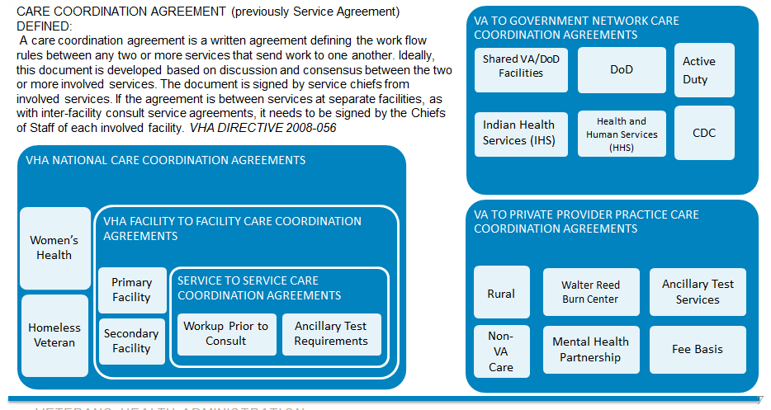
The business requires the capability to create a national framework of care coordination agreements to support the establishment of protocols to use resources according to provider or service guidelines; and to serve as a work aid for schedulers throughout the scheduling process. VISNs and facilities require a certain level of flexibility to tailor agreements to meet unique informational goals.

Setup and Maintain Scheduling Notification Templates (1C)
Figure 6 - Setup and Maintain Scheduling Notification Templates Process Flow
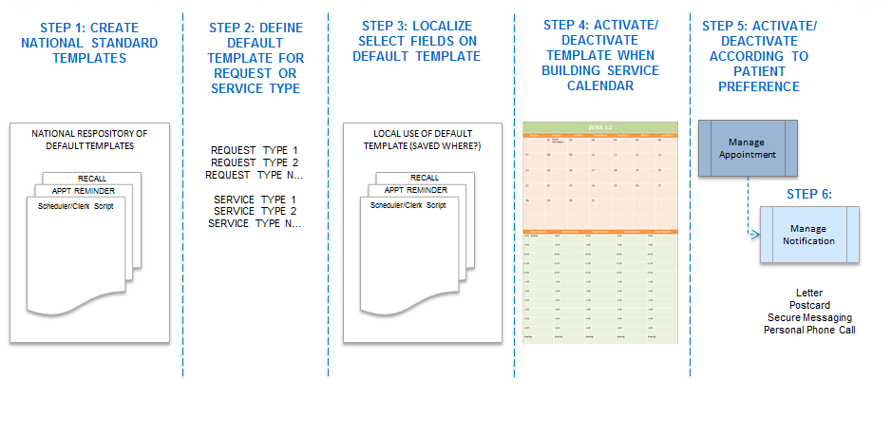
The business requires the ability to use clear, accurate, consistent, and targeted messages by standardizing notification templates to be used for outbound communications between VHA, healthcare stakeholders, and Veterans with various delivery types such as mobile applications, secure messaging, USPS, and personal phone calls with Veterans.

Setup and Maintain Scheduling Business Rules, Alerts and Workflow (1D)
Figure 7 - Setup and Maintain Scheduling Business Rules, Alerts and Workflow Process Flow
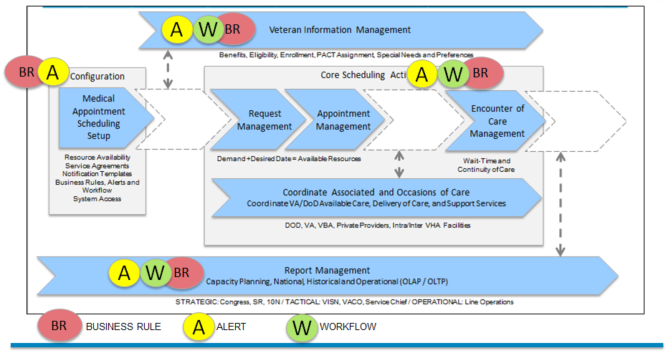
The business requires the capability to establish overarching parameters to ensure consistent scheduling practices by controlling the configuration of business rules, alerts, and workflow.

Setup Maintain Scheduling System Access (1E)
Figure 8 - Setup and Maintain Scheduling System Access Process Flow
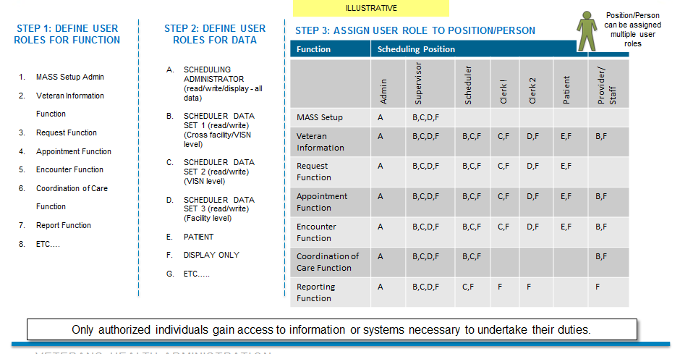

The business requires the ability to establish user access roles and rules at a national level, and the flexibility to assign/unassign users performing scheduling transactions to established security roles.

Veteran Information Management

Process Overview for Veteran Information Management
The Veteran Information Management capability provides access to a common set of Veteran-related information (such as benefits, and eligibility). The capability accommodates integration with other business units or organizations inside VA/VHA, with geographically dispersed health care location across VA regions, between VA and community based partners, and with other government partners. Veteran special needs and preferences shall be accessible and able to be updated. There are many situations throughout the end to end scheduling process where Veteran information is accessed and modified. Verifying identity, eligibility and enrollment while fielding requests for care, scheduling appointments and during the encounter are among the most frequent, and require current information from authoritative sources throughout the scheduling process. Authorized persons must be able to update information. Additionally, this information must be available to external partner organizations as permitted by policy and security regulations.
VHA envisions a ‘Single View of the Veteran’ to ensure continuity of care and capture encounter of care by treatment protocols. The scheduling capability needs to provide consistent and automated access to near real-time Veteran data across independent 128+ VistA instances (stand-alone versions of the scheduling system) to provide visibility and scheduling at any location from any other location in accordance to the business rules and security policy.
The Austin Information Technology Center (AITC) controls the Master Veteran Index (MVI) where the majority of Veteran information is stored. Local VistA instances synchronize data to the MVI through various background processes. However, these processes are not run simultaneously when a change is made, therefore if a Veteran updates demographic information in a facility, other systems may not know about the update. One result of delayed updates can be that if a Veteran goes to another facility, the demographic data may be incomplete - resulting in potential gaps in medical care information.

Unique/High Priority Business Needs
Manage Veteran Information
Feature or Characteristic | Measure of success
Current VistA reporting and DSS coding must continue to support non-scheduling business processes as it currently does today | All scheduling data extracts continue to support other non-scheduling processes without disruption
The scheduling solution shall capture special needs and preferences for each patient | Schedulers can easily identify patients with special needs and preferences
Patient information must be consistent with other VA data about the patient | The same patient data update does not have to occur more than once because the initial update was not propagated
Patient information is shared with any facility where the patient will be seen | Patients scheduled in a facility that is not their preferred facility will have the patient information at the time of service
VHA eligibility and enrollment data must be integrated into scheduling process | Scheduling process takes into consideration the eligibility of the patient throughout the scheduling process
The scheduling solution shall allow patients to schedule appointments at any facility based upon permissions of the patient and medical service | The patient can access their personal information and applicable lists of available appointments for any facility
 | The patients can schedule an appointment at any facility
New, easily accessible reporting capability allowing for broader analysis (across VHA) and deeper analysis (category of patient, condition, era, etc.) of scheduling performance | Easily accessible data for trend analysis across the VA (broad analysis) as well as deep analysis for specific conditions or populations
Table 13 Manage Veteran Information Unique/High Priority Business Needs

Capability Model Description
Veteran Information Management contains three sub-capabilities described in Table 7 - Veteran Information Management Sub-Capabilities which outlines how they contribute to the overall Veteran Information Management concept.
Figure 9 - Veteran Information Management (Framework View)
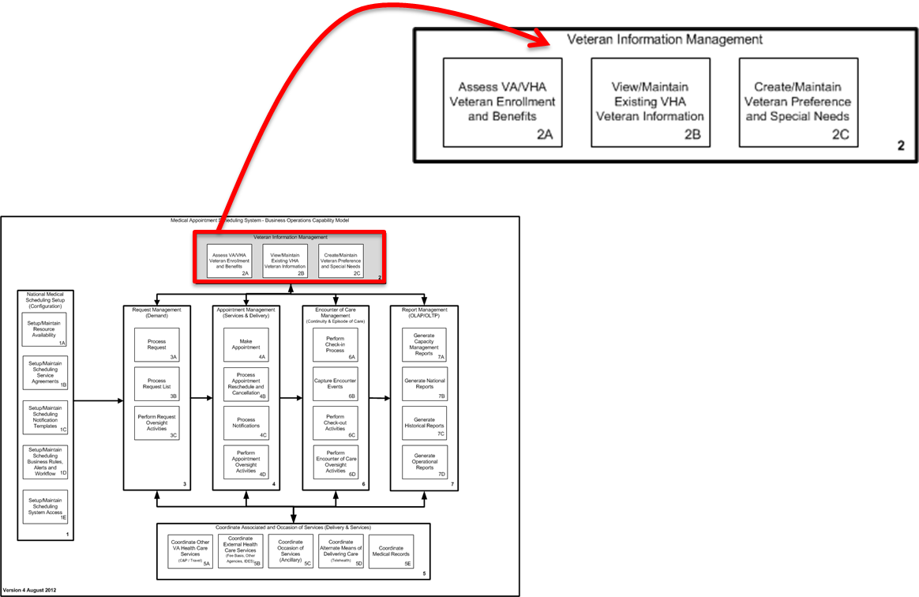
VETERAN INFORMATION MANAGEMENT SUB-CAPABILITIES
The Veteran Information Management capability provides access to a common set of Veteran-related information (such as enrollment, eligibility, benefits, and registration). The capability accommodates integration with other business units or organizations inside VA/VHA, with geographically dispersed health care location across VA regions, between VA and community based partners, and with other government partners. Veteran special needs and preferences shall be accessible and able to be updated.to be updated.
2A | Assess VA/VHA Veteran Enrollment and Benefits | The Assess VA/VHA Veteran Enrollment and Benefits sub-capability enables access to view conditions concerning a Veteran's level of care or eligibility determination provided by the VBA (such as eligibility, benefits, service connected, means test score, insurance, and travel benefits) from a single authoritative source.
2B | View/Maintain Existing VHA Veteran Information | The View and Maintain Existing Veteran Assignments sub-capability provides the ability to view, establish and maintain existing Veteran assignments (such as one or more facilities within or outside of VA, service lines, and PACT) to include user alerts when information is incomplete or out of date (such as demographics) from a single data entry screen within security and standards constraints.
2C | Create/Maintain Veteran Preference and Special Needs | The Create and Maintain Veteran Preference and Special Needs sub-capability provides the ability to capture, store and access critical patient healthcare preference (such as appointment date and time, preferred provider, and language assistance) and special needs (such as transportation, escort services, and handicap assistance) to include alerts when the need to coordinate additional services is required.
Table 14 Veteran Information Management Sub-Capabilities

Examples of Common Veteran Information Situations
Managing Veteran Information is shown in a variety of situations as illustrated in Table 8 - Common Veteran Information Management.
Examples of Common Veteran Information Situations
DoD/VA Collaboration:
Transitioning from active duty to Veteran status, scheduling should accommodate the interaction between DoD and the VA to enable a smooth transition.
Veteran Transitions from Active Duty | Veteran data should be accessible between DoD and the receiving VA facility where care will be administered.
Active Duty Veteran Requests VHA Services | Active duty person may be physically closer to a VHA facility or ill and need immediate care. The VHA facility needs to be able to easily accommodate the person and have access to demographic and medical records.
View/Maintain Existing VHA Veteran Information:
It is VHA policy that Veterans enroll once into VA’s health care system and are continuously enrolled. Enrolled Veterans may seek care at any VA facility without being required or requested to reestablish eligibility for VA health care enrollment purposes.
New to VHA | Outside of the scheduling application, the VA eligibility center enacts processes to establish (enroll) a Veteran. Part of enrollment includes eligibility criteria and includes the Means Test (income and geographic determiners). The output from that eligibility process goes to the Health Eligibility Center Systems, and to the Master Veteran Index which assigns a unique ID system number used by scheduling and other systems. This information must be available to the scheduling solution upon initiation of scheduling.  If the Veteran information is not available, the process needs to accommodate adding a Veteran in a temporary manner and then associate data to an enrolled Veteran later.
Updating Veteran Demographics | Demographic data is verified per policy and security practices throughout Veteran interaction with VHA. When a Veteran updates demographics, the updates should be processed real time and made available. The Veteran should not be required to continually update the same demographic information throughout the same encounter/visit event.
Deceased Veteran | When a Veteran is deceased, yet still has appointments for care, those appointments must be cancelled. The Manage Veteran Information process will receive the update to the Veteran’s status from the authoritative source, and could send an alert via workflow to scheduling staff to process the appointment cancellation(s). The scheduling solution could then flag the status of the Veteran and prevent any future accidental appointment scheduling.
Register Veteran with New Facility | Veteran information must be available across the entire VHA to allow for seamless scheduling of Veterans without the need to engage the Veteran to provide repetitive registration information at each facility.
Create/Maintain Primary Care Provider Assignment:
Create/Modify Primary Care Assignment | A single primary care provider (or PACT) must be established for each Veteran. Additional primary care providers may be established for each facility in which the Veteran receives care.
Create/Maintain Veteran Preference and Special Needs:
Create/Modify Preferences and Special Needs | Preferences or special needs may be different for a Veteran at different facilities. For example at one facility, a Veteran may need assistance finding parking in busy lots. The preferences and specials needs should be searchable and sortable, and have ranking by priority. That same Veteran may not need the same accommodation at another facility. The ability to keep preferences and special needs current and visible will help provide a more Veteran-centered experience for the Veteran.
Table 15 Common Veteran Information Management Situations

Veteran Information Management Process Flows and Business Needs (2)
The business requires access to a common set of Veteran-related information (such as enrollment, eligibility, benefits, and registration). The business requires integration with other business units or organizations inside VA/VHA, with geographically dispersed health care location across VA regions, between VA and community based partners, and with other government partners. The business requires the ability to access and update Veteran special needs and preferences.

Assess VA/VHA Veteran Enrollment and Benefits (2A)
Figure 10 – Assess VA/VHA Veteran Enrollment and Benefits Process Flow (2A)
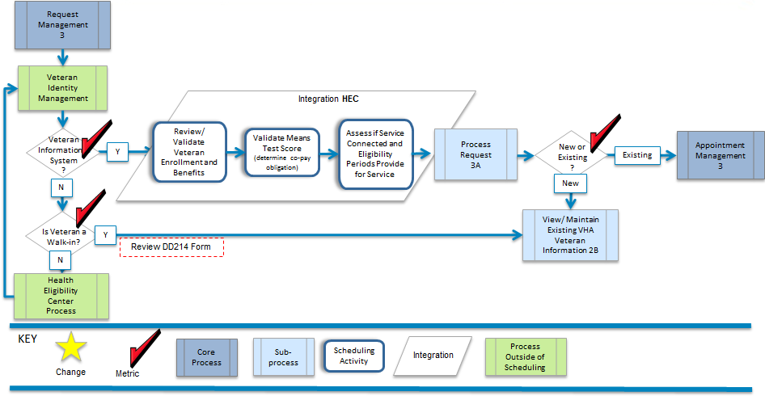
The business requires the ability to view conditions concerning a Veteran's level of care or eligibility determination provided by the VBA (such as eligibility, enrollment benefits, service connected, means test score, insurance, and travel benefits) from a single authoritative source.

View/Maintain Existing Veteran Information (2B)
Figure 11 - View/Maintain Existing Veteran Information Process Flow (2B)
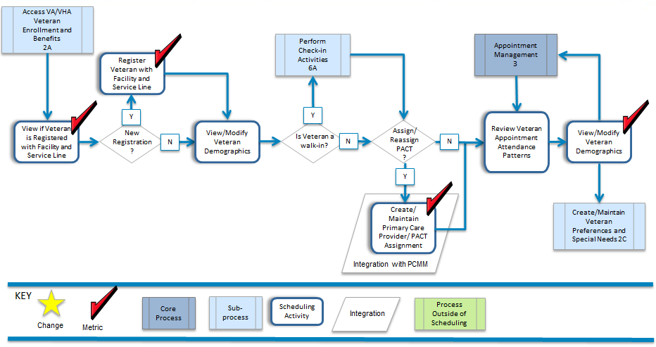
The business requires the ability to view, establish and maintain existing Veteran assignments (such as one or more facilities within or outside of VA, service lines, and PACT) to include user alerts when information is incomplete or out of date (such as demographics) from a single data entry screen within security and standards constraints.

Create/Maintain Veteran Preference and Special Needs (2C)
Figure 12 - Create/Maintain Veteran Preference and Special Needs Process Flow (2C)
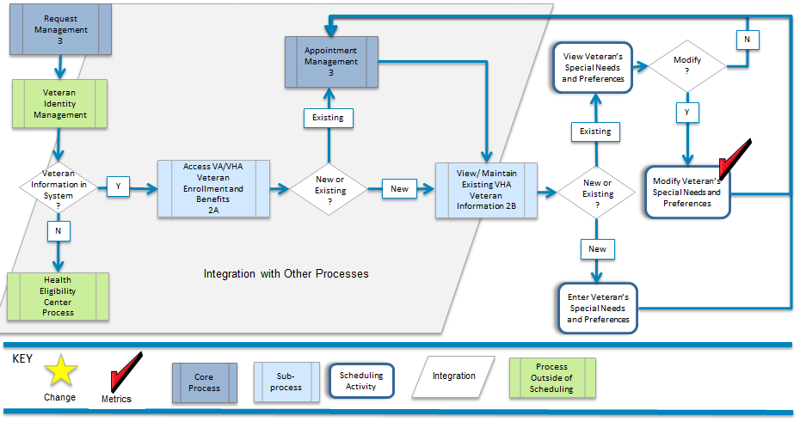
The business requires the ability to capture, maintain, and access patient healthcare preferences (such as appointment date and time, preferred provider, and language assistance) and special needs (such as transportation, escort services, and handicap assistance) when scheduling an appointment to include user alerts when the need to coordinate additional services is required.

Request Management

Process Overview for Request Management
The Request Management capability triggers the scheduling process with a request for care from a Veteran, or a provider on behalf of a Veteran. The date a request is submitted and the Veteran's desired date represent some of the key components to be captured during the request process. Requests are entered from a variety of input sources (such as web, mobile, email, phone, and other communication modes) creating a standard view of information to be processed, tracked and reported.
Requests are routed differently at each facility, yet the basic process is relatively the same. Requests are received, assessed, and routed. How they are received, criteria for assessment, routing rules and practices, and workflow are all driven by business rules and practices unique to a facility.
Part of the Request Management capability is Process Request List. VHA envisions a consolidated list to contain what are now several non-integrated lists. It is anticipated that having more efficient processes to match patient medical needs with available resources will reduce patient wait times (how long the Veteran must wait for care calculated from their desired date.)
The Perform Request Oversight Activities sub-capability encompasses a variety of management tools and techniques to report operational efficiencies or deficiencies in near real-time (such as time to process new requests, accuracy of capturing desired date, etc.)
The goal of this capability is to capture and track the demand for access to care, track how the VHA is meeting the Veteran’s desired date and use those metrics to diminish the amount of time Veterans wait for care.

Unique/High Priority Business Needs
Request Management
Feature or Characteristic | Measure of success
Current VistA reporting and DSS coding must continue to support non-scheduling business processes as it currently does today | All scheduling data extracts continue to support other non-scheduling processes without disruption
Able to capture requests for service from multiple sources, to include NEAR, EWL, Recall | All current list purposes are captured and maintained
Patients are able to request appointments using different modes such as email, web access, mobile applications, etc. | Patients can request appointments via different modes such as email, web access, mobile applications, etc.
 | Routine or follow up appointments are easily scheduled without error by patients without the aid of a VA scheduler
Robust capability to manage multiple sources of requests to achieve appointment fulfillment rate standards | Schedulers can create appointments directly from the list to improve efficiency rates, reduce data and scheduling errors, provide traceability and ensure accountability of all list entries
Able to track all dates associated with any services from VA. Dates/times should be system-protected and not changed, reportable, auditable | When VA can track all patient interactions with VA services from first contact to the end of provided care. Dates/times should be system-protected and not changed
Table 16 Request Management

Capability Model Description
Request Management is comprised of four sub-capabilities. Each defined below in Table 9 - Request Management Sub-Capabilities.
Figure 13 - Request Management (Framework View)
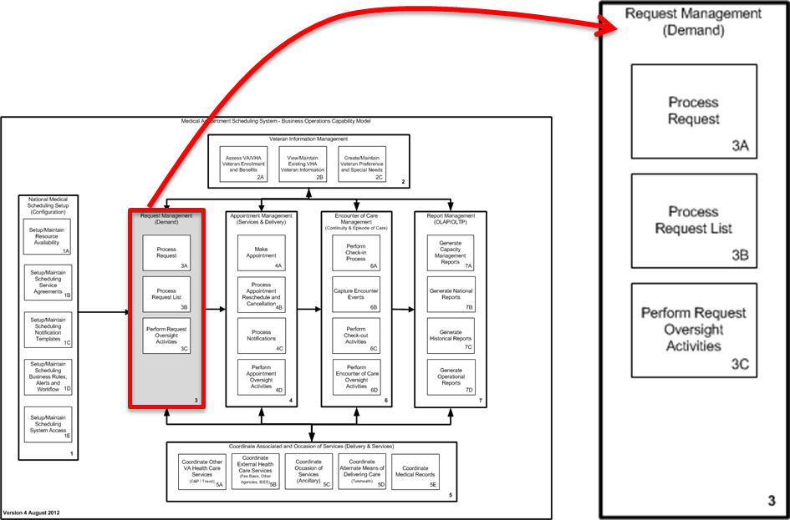
Request Management SUB-CAPABILITiES
The Request Management capability triggers the scheduling process with a request for care from a Veteran, or a provider on behalf of a Veteran. The Veteran's desired date is one of the key components to be captured during the request process. Requests are entered from a variety of input sources (such as web, mobile, email, phone, and other communication modes) creating a standard view of information to be processed, tracked and reported.
3A | Process Request | The Process Request sub-capability provides users the ability to enter requests for care and desired date from a variety of input sources (such as web, mobile, email, phone, and other communication modes) in a standard format. The request is then processed to determine which service is initially required, with what priority, and in accordance with desired date.
3B | Process Request List | The Process Request List sub-capability involves the generation and management of an all-inclusive list of patients that have yet to be scheduled into an appointment for care and the reason from a standard format. Managing one standard, consolidated, sortable, searchable list by patient or by service streamlines the process of matching patient medical needs with available resources.
3C | Perform Request Oversight Activities | The Perform Request Oversight Activities sub-capability encompasses a variety of proactive management tools and techniques to monitor the request processes and capability to report operational efficiencies or deficiencies in near real-time from service-line to national level.
Table 17 Request Management Sub-Capabilities

Examples of Common Request Management Situations
Table 10 - Common Request Management Situations illustrates how request management occurs in the course of outpatient scheduling.
Examples of Common Request Management Situations
Request Management:
The Request Management capability triggers the scheduling process with a request for care from a Veteran, a designate on behalf of a Veteran, or a provider on behalf of a Veteran. VHA needs the ability to track and report the origin of requests. This capability tackles weaknesses in the current process, particularly the existence of multiple lists, requiring manual and error-prone processes to manage. The ability to manage one list will allow VHA to more accurately track demand to supply and better manage capacity.
Urgent Request for Care | Supports a scheduler facing an urgent request from a Veteran in order to determine if or how an appointment should be routed. Sorting or screening of Veterans seeking care to determine which service is the initial activity, followed by determining the priority and action to schedule the requested care.
Non-urgent Request for care | Receive requests from several sources (Veterans, providers, other VistA data sources, and via on-line mechanisms) and allow the scheduler to assess the request and take the appropriate action to validate, prioritize, and act upon according to current service line business rules.
Request Entered into Appointment Request List | Capture and access an all-inclusive list of Veterans that have requested an appointment but have not been scheduled. The goal is to consolidate all situations where Veteran and medical needs have not been matched and the reason(s) for an unfulfilled appointment request.
Manage Appointment Request Lists:
VHA needs a consolidated view of requests for care. The consolidated list needs to be sortable, searchable and able to be updated. The consolidated list will be used for decision making, capacity planning and for performance measurement reporting. The consolidated list will need to incorporate the lists below.
New Enrollee Appointment Request (NEAR) Call List | The NEAR Call List is a tool used by enrollment staff to communicate to primary care management coordinators or schedulers at the Veteran’s designated preferred location that a newly enrolled Veteran has requested an appointment during the enrollment process.
Electronic Wait List (EWL) | The EWL is the official VHA wait list used to track and manage Veterans waiting to be scheduled, which consists of newly registered, Newly enrolled, new consult requests for Veteran waiting for their first scheduled appointment, or waiting for a panel assignment. In general, the EWL is used to keep track of Veterans with whom the clinic does not yet have an established relationship and cannot be scheduled in target timeframe.
CPRS and PCMM | Requests may also be received from VistA Applications (e.g. CPRS and PCMM). CPRS is the GUI into VistA where requests for Consults and Service Orders are entered and received
Recall/Reminder | The recall/reminder software application is used for Veterans with whom the service has an established relationship. Typically used when the requested follow-up appointment date is greater than 3 to 4 months into the future.
Perform Request Oversight Activities
Oversight activities are envisioned to be tasks performed by personnel responsible for keeping the outpatient scheduling processes running smoothly. Activities will include running reports regarding capacity management to determine if there are open appointment slots that could be filled from someone on a list, or a walk-in, and expedient processing of request in backlog.
Activities |  | A supervisor wants to check the status of the facility and how quickly new requests are being processed, run daily reports to show how well the facility provides an appointment by the desired date.
Table 18 Common Request Management Situations

Request Management Process Flows and Business Needs (3)
The business requires that a request (includes create date for each new episode of care and desired date for existing patient care) for future care from a Veteran, or a provider on behalf of a Veteran be captured on a standard form. The information gathered (such as Veteran information and desired service) should be captured from a variety of input sources (such as web, mobile, email, phone, and other communication modes) and viewed from a single screen or generated in a list for processing and reporting. The business requires that activity components of request and request lists processing be captured and date/time stamped to support operational oversight reporting.

Process Request Process Flow (3A)
Figure 14 - Process Request Process Flow
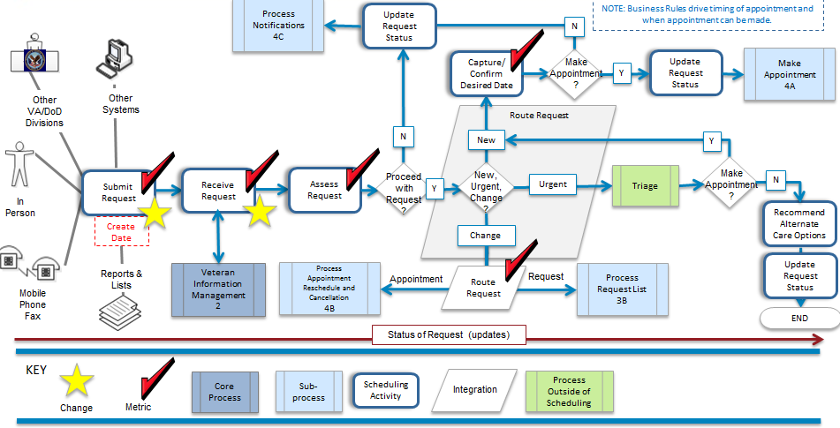
The business requires the ability to capture the creation date of a request and demand for services in accordance to a Veteran’s desired date for care from a variety of input sources (such as web, mobile, email, phone, and other communication modes) in a standard format, while tracking the request status until an appointment is fulfilled. Processing request activities and attributes will be tracked and date/time stamped for auditing and reporting.

Process Flow for Process Request List (3B)
Figure 15 – Process Request List Process Flow (3B)
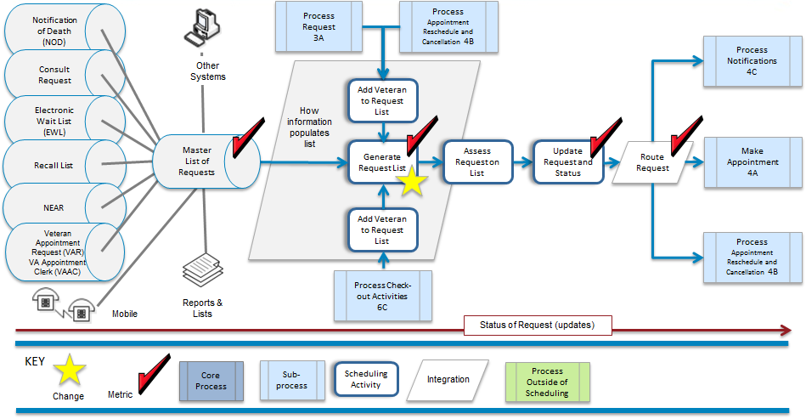
The business requires an all-inclusive master list designated for active requests, waiting for available appointments, recalls or other terms to be consolidated in a standard format and accessible for daily request processing and appointment management. Processing request list activities will be tracked and date/time stamped.

Perform Request Oversight Activities (3C)
Figure 16 - Perform Request Oversight Activities Process Flow (3C)
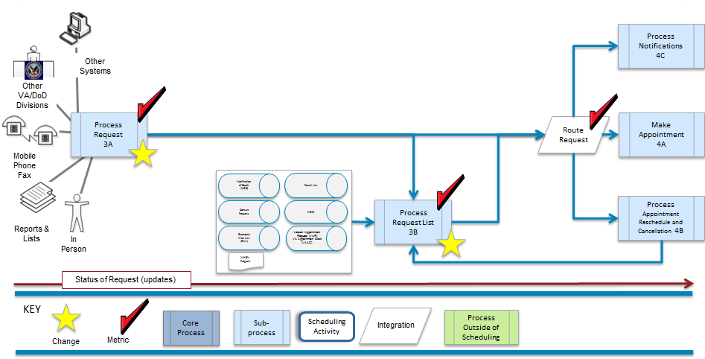
The business requires that processing request activities be tracked and date/time stamped to support oversight and reporting (structured, user defined, and ad-hoc) operational efficiencies or deficiencies in near-real-time.

Manage Appointment

Process Overview for Appointment Management
The Manage Appointment capability highlights the need to view the availability of all resources and services across facilities, time zones and scheduling horizons from a single graphical representation screen in order to instantly schedule an appointment within the Veteran's desired date. This capability allows for flexibility to cancel and reschedule appointments, and also includes standardizing the notifications process to issue messages to Veterans, their families, and other stakeholders.
Meeting the desired date is one of the driving factors in the scheduling process, and the ability to audit and monitor compliance to meeting desired date is a significant requirement of VHA policy. Reporting the reasons that appointments are made outside the desired date is vital to meet expectations of Veterans and meet Congressional mandates.
While making an appointment is often straightforward for primary and specialty care; there are situations where coordinating multiple same day appointments, prerequisite testing, medications, and transportation become hurdles that may cause difficulties for schedulers. For this reason, the Coordinate Services and Occasions of Service capability is closely integrated with this process.
Notifications are outbound messages in the form of postcards, personal calls, letters, emails, etc. to Veterans. Examples include sending a letter to a Veteran with preparatory instructions prior to an appointment, a postcard notification to a Veteran to schedule a follow-up appointment, or contacting a Veteran for failure to show up for their appointment. The goal of the notification sub-capability is to standardize the type, form and format of Veteran interaction and streamline the activities and resources required to complete each notification.
Perform Appointment Oversight Activities encompasses a variety of proactive management tools and techniques to ensure the productive use of resources. Oversight tasks are driven by observation and indicators critical to ensure efficient process performance. Indicators illuminate entities such as resource management, capacity planning, scheduler performance, and notification management.

Unique/High Priority Business Needs
Appointment Management
Feature or Characteristic | Measure of success
Current VistA reporting and DSS coding must continue to support non-scheduling business processes as it currently does today | All scheduling data extracts continue to support other non-scheduling processes without disruption
Appropriately capture desired date for each appointment created | When desired date is captured indicating the source of the desired date (patient, provider, other) for each individual appointment
Automated implementation of business rules as configured (setup) when searching for resources and creating appointments | Scheduler training requirements are decreased since majority of business rules are automated
 | Reduction in scheduling errors because of automated business rules
 | Visibility to scheduler when scheduling outside of policy, guidance or business rules
Flexibility to substitute appropriate resources assigned to appointment | Reduced cancellations due to short term unavailability of resource
Improve notification process through capture of patient preference for notification, configurable and enforceable notification templates | Patients consistently receive notifications in their preferred method (phone, email, USPS) in a timely and accurate manner
Ability to coordinate multiple resource sets at multiple locations for a single appointment (telehealth) | Telehealth appointments are coordinated seamlessly between the provider(s), equipment, facilities and patients with on time delivery of care, no lost time due to poorly coordinated appointments
Ability to link dependent appointments | Schedulers able to view, coordinate and link multiple appointments (series or multiple same-day)
Create appointment for any service at any facility and delivery type based upon role-based access as defined in setup | Patients can schedule services as they desire
Ability to coordinate multiple appointments for a patient | Patients have an itinerary of appointments that suits their needs, with appointments coordinated in an efficient manner
Use scheduling preferences when scheduling appointment (van riders) | Patients preferences are automatically considered when creating appointments
Coordinate special needs throughout scheduling process | Staff are aware of and prepared for patients with special needs when they are being scheduled and when they present for care
Current VistA reporting and DSS coding must continue to support non-scheduling business processes as it currently does today | All scheduling data extracts continue to support other non-scheduling processes without disruption
Table 19 Appointment Management

Capability Model Description
There are four sub-capabilities to describe the activities in Appointment Management. They are described in Table 11 - Appointment Management Sub-Capabilities.
Figure 17 - Appointment Management (Framework View)
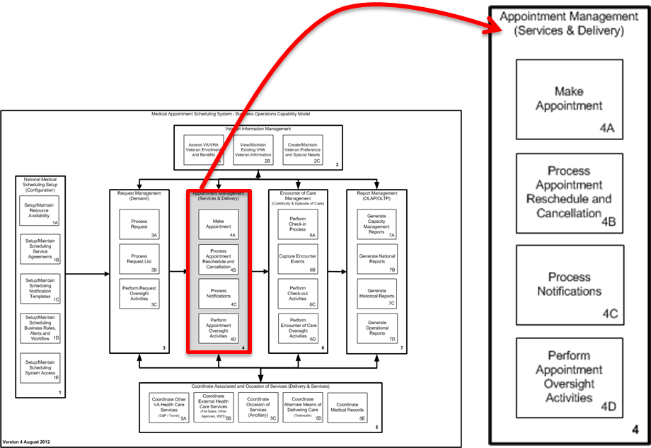
Appointment Management SUB-CAPABILITES
The Manage Appointment capability highlights the need to view the availability of all resources and services across facilities, time zones and scheduling horizons from a single graphical representation screen in order to instantly schedule an appointment within the Veteran's desired date. This capability allows for flexibility to cancel and reschedule appointments, and also includes standardizing the notifications process to issue messages to Veterans and their families, and other stakeholders.
4A | Make Appointment | The Make Appointment sub-capability provides the ability to search all available healthcare resources and instantly schedule an appointment to reserve resources to meet the Veteran's needs in accordance with desired date from a single screen within a graphical user interface (GUI).
4B | Process Appointment Reschedules and Cancellations | The Process Reschedule and Cancellation sub-capability provides the ability to assess the impact of care due to a cancellations request initiated by a patient, a provider, or in cases where equipment is inoperable and expeditiously resolve either by rescheduling, backfilling resources, or providing alternate modes of healthcare delivery options.
4C | Process Notifications | The Process Notifications sub-capability emphasizes the need to provide clear, accurate, consistent, and targeted messages to Veterans and their families, and other stakeholders. A standardized notification process uses common forms that allow the ability to customize, and select a mode of delivery to accommodate Veteran and stakeholder preferences.
4D | Perform Appointment Oversight Activities | The Perform Appointment Oversight Activities sub-capability encompasses a variety of proactive management tools and techniques to monitor and report operational efficiencies or deficiencies in near real-time from service-line to national level
Table 20 Appointment Management Sub-Capabilities

Examples of Common Appointment Situations
Appointment Management is probably the most visible and frequent activity for outpatient scheduling. A list of common situations is presented in Table 12 - Common Appointment Management Situations.
Examples of Common Appointment MANAGEMENT Situations
Appointment with Primary Care:
Providing Primary Care makes available to Veterans the full continuum of care that VHA offers. Primary Care addresses the daily, routine medical needs (i.e., initial diagnoses, annual exams and continual treatment of illness and preventive care). Through Primary Care, Veterans are encouraged to promote their health and well-being, prevent disease; receive treatment for existing acute illnesses; recover function to its highest level and utilize the long-term care when it is needed.
Initial | Scenario in which a scheduled appointment is made at the request of a new or established Veteran. “New” can be described as: new enrollee with VHA, newly registered to the facility, or one not seen by a qualifying provider type within a defined stop code or stop code group at that facility within the past 24 months.
Primary Care Follow-up | This scenario is initiated by the provider when a follow-up appointment is required for the Veteran. The request can be carried out by either the provider on behalf of the Veteran or by the Veteran following through with the provider’s recommendation for a follow-up appointment. A follow-up appointment could be the result of an emergent or urgent care encounter, or to close the loop on a consultation request.
Appointment with Specialty Care (Consult):
Specialty care consists of two types: Consultative Care and Highly Specialized Care. Consults are used regularly to request specialist care, evaluation and treatment for a Veteran. A consult is a document which facilitates and communicates consultative and non-consultative service requests and subsequent activities.
Clinical Consultative Care | Consultative care assists the primary care provider with the diagnosis or initiation or alteration of treatment strategies. A clinical consultation is provided by a physician or other health care provider in response to a request seeking opinion, advice, or expertise regarding evaluation or management of a specific Veteran problem )e.g. consult to Dermatology for rash). A clinical consultation request is initiated by a physician or appropriate source with the clear expectation that a reply will be provided in a timely manner. (VHA Directive 2088-056)  The major triggers of consultative care involve:  - Primary to Specialty  - Specialty to Specialty  - Mental Health
Specialized Care | Highly specialized care is provided to Veterans with illnesses that are too uncommon or complex for the primary care provider to maintain competence in their management. (VHA Directive 2088-056).
Specialty Care Follow-up | This scenario is initiated by the provider when a follow-up appointment is required for the Veteran. The request can be carried out by either the provider on behalf of the Veteran or by the Veteran following through with the provider’s recommendation for a follow-up appointment. A follow-up appointment could be the result of an emergent or urgent care encounter.
Non-Clinical Consultation | A non-consultative service request is used for all other non-clinical activities. Currently these requests are sent using the CPRS consult functionality for a purpose other than a clinical consultation, e.g. a request to Dermatology for a non-formulary approval or request to schedule a no-show.
Care Coordination Agreement | Care coordination is an agreement or understanding between any two or more services, one of which sends work to the other(s), defining the work flow rules. The agreements may exist within one facility or between two or more facilities. Typically this a written document that is developed based on discussion and consensus between the involved services and facilities. Some examples where service agreements may exist include agreements between:  - Primary to Specialty  - Specialty to Specialty  - Primary/Specialty to Mental Health (vice versa)  - Primary to Specialty to Surgery with follow-up with Specialty and closing the encounter of care with a Primary follow-up.  Care coordination may include orders to coordinate with associated and occasion of services (ancillary test). These enhancements will be discussed in more detail in the capability section #4: Coordinate Associated and Occasions of Service.
Emergent or Urgent Care
Care for an acute medical or psychiatric illness or for minor injuries for which there is a pressing need for treatment to manage pain or to prevent deterioration of a condition where delay might impair recovery. [VHA Directive 2010-027]
Urgent | An example of urgent care includes the follow-up appointment for a Veteran discharged from a Department of Veterans Affairs (VA) medical facility if the discharging physician directs the Veteran to return on a specified day for the appointment.
Emergency | Emergency care is the resuscitative or stabilizing treatment needed for any acute medical or psychiatric illness or condition that poses a threat of serious jeopardy to life, serious impairment of bodily functions, or serious dysfunction of any bodily organ or part.
Triage | Initial triage evaluations are required within 24 hours for all Veterans either self-requesting or being referred for mental health and substance abuse treatment. Additionally, when follow-up is needed, it must include a full diagnostic and treatment evaluation with 14 days.
Veteran Notifications (output notifications):
Notifications to Veterans are handled differently in each facility and by each type of service. An anticipated area of efficiency gain is in the form, format, and type of communication being sent to Veterans. Some standardization has begun with the inception of the Recall List and the introduction of the Appointment Card project. Similar discussions and pilots have emerged to automate communications.
There are three main scenarios involving Veteran notifications. They include: Veteran preparation, Veteran reminders, and Veteran follow-up. Whether the mode of delivery is a personal call, a letter, or a post card, the workload should be organized, prioritized, monitored and tracked for efficiency. Notifications should be standardized so the process is the same for each Veteran regardless of the location or service being provided.
Veteran Preparation | This scenario is first triggered when the Veteran is confirming an appointment or a series of appointments. The notification could include:  - Preparation instructions prior to arriving for an appointment such as required preliminary test and x-rays; or of special instructions (e.g. not eating 12 hours prior to the visit).  - An itinerary of times, providers’ names and locations for multiple same day appointments along with confirmation regarding a Veteran’s special needs and/or requests (e.g. escort services for handicapped Veterans).  - Coordination of services would be indicated where transportation and other types of assistance is required.
Veteran Reminders | Three main types of Veteran reminders currently exist including:  - Veteran reminder of existing appointment  - Veteran reminder to call for an appointment  - No-show notification to reschedule appointment  The purpose of the Recall List is to alert Veterans with a reminder to call and make an appointment as requested by their provider when the desire date is out three to four months from the original appointment. Veterans that fail to appear for their appointment may receive a call immediately by the service or are added to a Veteran reminder list.
Veteran Follow-up | This scenario is the result of an encounter. As a courtesy to Veterans by some services, a post appointment follow-up call is carried out. A second type of follow-up scenario involves the results of tests that were performed. In some cases a follow-up for test results could result in a request to make an additional appointment with the provider.  - Post appointment follow-up call  - Notification of test results
Notification of cancelations | The request to cancel is triggered in the Request Management and Make Appointment process; however, when a provider requests to cancel scheduled appointments with the proper advanced notice, the activities to support this scenario take place in the Manage Made Appointment process.
Cancel and Reschedule Appointments:
Cancellations where the availability of resources is limited by the provider or the facility should be avoided whenever possible. In cases where a cancellation is initiated by either the provider or the Veteran fails to appear for the schedule appointment, the medical records need to be reviewed to ensure that urgent medical problems are addresses in a timely fashion. Provisions need to be made for necessary medication renewals and Veterans need to be rescheduled as soon as possible, if clinically appropriate. (VHA Directive 1020-027)
Cancellation/Reschedule by Veteran | The Veteran scenario involving a cancellation or a reschedule may be made in advance of the appointment date or the same day of the appointment. Consideration of other coordinated services, occasions of service, linked appointments, or same day appointments should be rectified for any cancellation or reschedule request regardless of when the cancellation/reschedule was received.  Same day cancellations may be backfilled with walk-in Veterans, over booked appointments, or reverted to administrative time.  In all cases, the reason and resolution for the cancellation and or reschedule should be captured and tracked.
Cancellation/Reschedule by Provider | The provider scenario involves the limitation of a resource and becomes a more complicated scenario than when a Veteran cancels or reschedules. As with the Veteran scenario, consideration of other coordinated services, occasions of service, linked appointments, or same day appointments should be rectified for any cancellation request regardless of when the cancellation was received.  Same day provider cancellations may be backfilled with other PACT resources, and broken equipment may be resolved by a reciprocating facility with open slots.  In all cases, the reason and resolution for the cancellation and or reschedule should be captured and tracked.
Cancellation/Veteran status/test values not available/incomplete | The most common cause of a cancellation is when the appointment has required prerequisites for coordinated services and occasions of service of which is found to be incomplete or not available at the time of the appointment. The integration of all associated and coordinated services and the relationship to a specific appointment should be established and the status of each should be tracked to prevent unnecessary cancelations. In cases where the Veteran’s status causes a cancellation is rare and unusual yet none the less should have provisions to handle such situations.
No-show Reschedule | When a Veteran fails to appear for the scheduled appointment, the responsible provider, surrogate, or designated team representative needs to review the Veteran’s medical record, including any consult or procedure request received or associated with the appointment and then determined and initiates appropriate follow-up action. (VHA Directive 1020-027 (k)).
Consultation Process:
The policies defined for managing the clinical consultation process are described in VHA Directive 2008-056. It states that the consultation process is a relationship between a sending and receiving Health care service where defined workflow rules exist. Effective use of care coordination agreements establishes clear processes and reduces the need for inspection and rework, and improves the relationship between practices. The policy and actions required request that clinical consultations be clinically completed with results consistent with VHA timeliness standards and is efficiently resolved while taking into account an individual’s health care needs. A consult is a specific document which facilitates and communicates consultative and non-consultative service requests and subsequent activities.
Clinical Consultation | A clinical consultation is a request by a physician or other health care provider to seek an opinion, advice, or expertise regarding evaluation or management of a specific health issue. Most often, a consult is generated electronically and is intended to facilitate and communicate requests for service with an expectation that a reply is provided within a timely manner. Currently, the CPRS functionality in VistA is the mechanism used to initiate, manage, and communicate clinical consultations.  - Consultations can be resolved without a face-to-face encounter yet should be captured and documented for tracking purposes  - All other clinical consultations must be acted on by scheduling an appointment within VA’s established timeframe. In cases where a consult cannot be scheduled within the established timeframe, a reason for the deviation must be captured.  - The ideal process is direct scheduling of consult appointments without clinical review by the receiving service, and performed by the referring provider’s team before the Veteran leaves.  - When a Veteran fails to keep a scheduled consultation, the receiving service must reassess the need for service and either reschedule the appointment or cancel the consult request, as appropriate.  - A consultation is considered a ‘count’ encounter which refers to workloads that meet the definition of on encounter. An encounter is a professional contact between a Veteran and a provider vested with the responsibility for diagnosing, evaluating, and treating the Veteran’s condition. Some Occasion of Services can be considered as ‘count’ encounters.
Non-count encounters | An appointment for occasion of services, such as laboratory work-ups and imaging services, are considered non-count encounters. A non-count encounter is one where diagnosing, evaluating, and treating a Veteran’s condition does not take place. There are two scenarios why an encounter is designated as ‘non-count’, One, if the encounter is administrative in nature and the Veteran care is not provided; and two, in cases where the workload associated with the occasion of service has already been captured during a count encounter.  - Requests for laboratory and imaging services are made via provider orders.  - Orders transmit directly to the lab or radiology software applications.  - Work performed in response to such orders triggers transmission of encounter data via VHA Veteran Care Encounter (PCE) software application.
Consult Tracking | To ensure a balanced level of oversight and autonomy by Systems Redesign, VISN Directors and Facility Directors, the consult process should be standardized to the extent possible while maintaining the flexibility to accommodate care coordination agreement requirements.  - Procedures are established to track and process clinical consultation requests that are without action within 7 days of the request.  - Appropriate checks and balances are in place before the consult request (VA and Non-VA) are closed out to ensure the clinical documentation is complete and accurately associated to the Veteran’s medical record.  - Both clinical consultation and non-consultative service requests will be tracked. Each is designated as a type of consult and used to ensure workflow and that the Veteran’s medical needs have been fully satisfied, and within acceptable timelines.
Table 21 Common Appointment Management Situations

Appointment Management Process Flows and Business Needs (4)
The business requires an integrated graphical view of all available resources and services across facilities, time zones and scheduling horizons (daily, weekly, monthly) in order to locate and schedule the appropriate resources within the Veteran's desired date. The business requires the flexibility to cancel and reschedule appointments, and standardize the notification process that issues messages to Veterans, their families, and other stakeholders. The business requires that appointment activities be tracked and date/time stamped to support operational oversight reporting.

Make Appointment Process Flow (4A)
Figure 18 - Make Appointment Process Flow (4A)
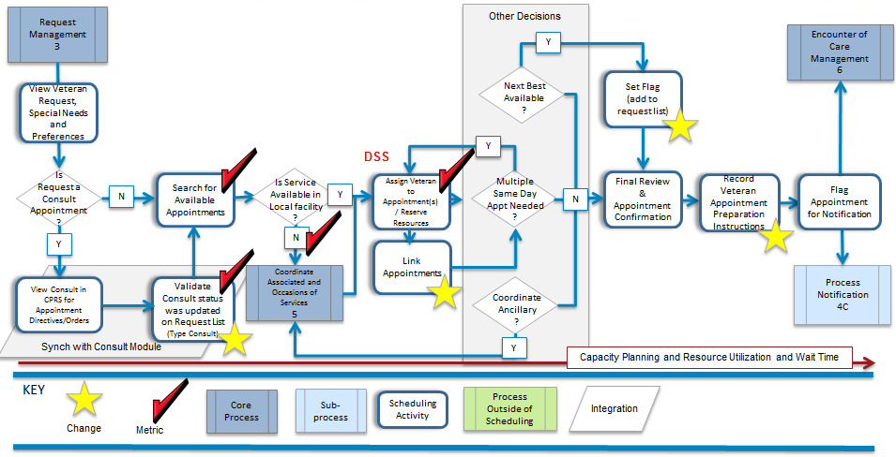
The business requires the ability to search all available healthcare resources and instantly schedule an appointment to reserve resources to meet the Veteran's needs in accordance with stated desired date for care from a single integrated view. Processing make appointment activities will be tracked and date/time stamped.

Process Appointment Reschedules and Cancellations Process Flow (4B)
Figure 19 - Process Appointment Reschedules and Cancellations Process Flow (4B)
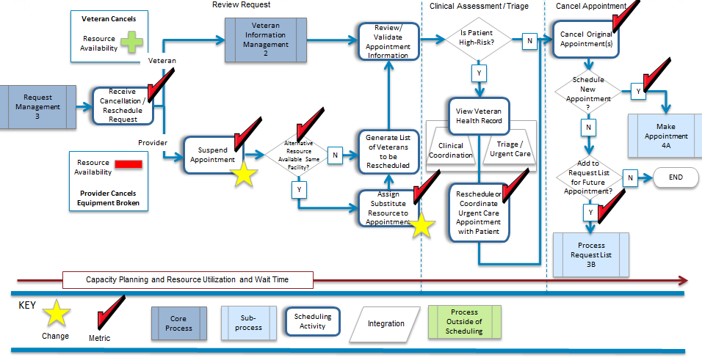
The business requires the ability to assess the impact of care (due to a cancellations request initiated by a patient, a provider, or in cases where equipment is inoperable) and resolve (by either rescheduling, backfilling resources, providing alternate modes of healthcare delivery options, or cancelling the appointment). Processing appointment reschedules and cancellation activities will be tracked and date/time stamped.

Process Notifications Process Flow (4C)
Figure 20 - Process Notifications Process Flow (4C)
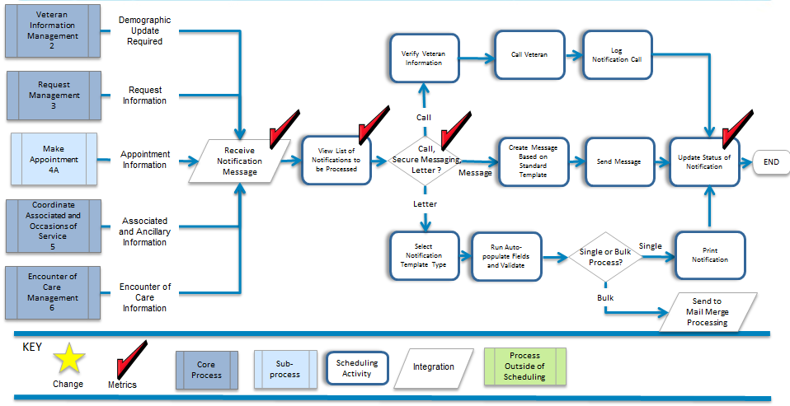
The business requires the ability to streamline the notification process by providing an auto-populated, standard set of templates (for letters, post cards, emails, or one-on-one phone calls) for all types of communication and all modes of delivery with the Veteran and their family, and other stakeholders based on specified personal preferences and business rules established at the national level. Processing notifications will be tracked and date/time stamped.

Perform Appointment Oversight Activities Process Flow (4D)
Figure 21 – Perform Appointment Oversight Activities Process Flow (4D)
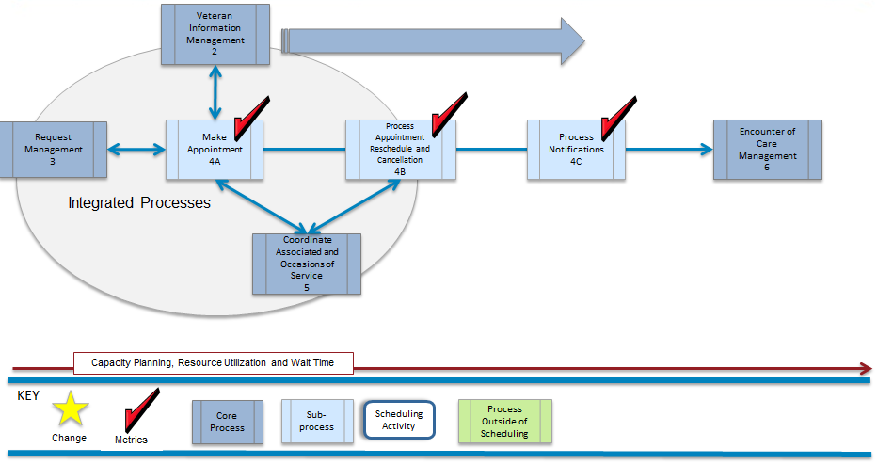
The business requires the ability to monitor the appointment, cancellation, reschedule, and notification processes for rapid decision making and issue resolution, as well as, the ability to report (structured, user defined, and ad-hoc) operational efficiencies or deficiencies in near-real time. Processing appointment activities will be tracked and date/time stamped.

Coordinate Associated and Occasions of Services

Process Overview for Coordinate Associated and Occasions of Services
The Coordinate Associated and Occasion of Services capability fosters open access between VistA instances with other VHA and VA facilities and outside VA to promote effective information sharing between stakeholders. The ability to view available enterprise resources allows for the coordination and fulfillment of requests (such as C&P process, telehealth, fee basis, IDES, ancillary, travel and medical records). The ability to coordinate care and communicate with other government partners such as DoD, CDC, and NIH will provide more options, and track care across agencies.
Occasion of Service, as defined in VHA Directive 2010-027 section (14) ‘Occasion of Service’ identifies ancillary service, as an “occasion of service” which is a specified identifiable instance of an act of technical and administrative service involved in the care of a Veteran or consumer, which is not an encounter and does not require independent clinical judgment in the overall diagnosing, evaluating, and treating the Veteran's condition(s).
(a) Occasions of service are the result of an encounter. Clinical laboratory tests, radiological studies, physical medicine interventions, medication administration, and vital sign monitoring are all examples of occasions of service.
(b) Some occasions of service, such as clinical laboratory and radiology studies and tests, are automatically loaded to the Veteran Care Encounter (PCE) database from other VistA packages.’
As VHA strives to meet the needs of an increasingly mobile Veteran population, offer expanded service mechanisms, providing schedulers the ability to coordinate across organizational boundaries and occasions of service will mean a more efficient experience for the Veteran.

Unique/High Priority Business Needs
Coordinate Associated and Occasions of Service
Feature or Characteristic | Measure of success
Current VistA reporting and DSS coding must continue to support non-scheduling business processes as it currently does today | All scheduling data extracts continue to support other non-scheduling processes without disruption
Need to make travel reimbursement data available to the travel determination process | Travel pay is consistent with patient schedules
Request scheduling data from non-VA healthcare delivery sources including DoD | Patient's pending appointments include all care delivery, to include delivery from non-VA healthcare delivery sources, including DoD
Coordinate consults and resultant appointments across service lines to reduce waiting time | Wait times for consults are reduced, data is not lost, easily able to report on consults and resultant appointments
 | Seamless integration of data from consults to scheduled appointments
Schedule health care delivery modes including home based healthcare, telehealth & phone/email/web services | Appointments can be scheduled for telehealth, home health, email, phone and other care delivery options
Table 22 Coordinate Associated and Occasions of Service Unique/High Priority Business Needs

Capability Mode Description
Table 13 - Coordinate Associated and Occasions of Services Sub-Capabilities describes the sub-capabilities which define this process.
Figure 22 - Coordinate Associated and Occasions of Service (Framework View)
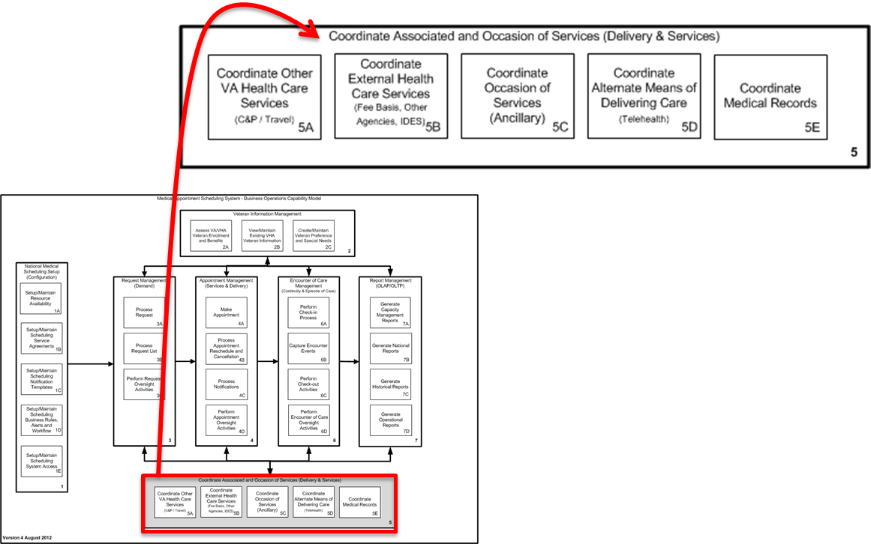
Table 23 - Coordinate Associated and Occasions of Services Sub-Capabilities
COORDINATE ASSOCIATED AND OCCASION OF SERVICE SUB-CAPABILITIES
The Coordinate Associated and Occasion of Services capability fosters open access between VA facilities and outside VA to promote effective information sharing between stakeholders. The ability to view available enterprise resources allows for the coordination and fulfillment of requests (such as C&P process, telehealth, fee basis, IDES, ancillary, travel and medical records). The ability to coordinate care and communicate with other government partners (such as DoD, CDC, and NIH) will provide more options, and track care across agencies.
5A | Coordinate Other VA/VHA Health Care Services | The Coordinate Other VA Health Care Services sub-capability exchanges information across VA facilities and VA departments (such as VBA's compensation and pension exam management process). Providing the ability to exchange information from care received outside the Veteran’s home facility ensures schedulers can readily view and work with other healthcare services both internal and external to their facility.
5B | Coordinate External Health Care Services  (Private/Other Agencies) | The Coordinate External Health Care Services sub-capability emphasizes the need to coordinate, track, and transition care inside the government network (such as with the DoD and CDC) or outside with other private providers. Factors that contribute to an episode of care for a Veteran include the transition from active to inactive duty or inactive to active duty, care delivered by private physicians and health record updates, or other cross agency agreements. Each scheduled appointment should trigger the capture, update or synchronization of each encounter into a single medical health record.
5C | Coordinate Occasion of Services (Ancillary) | The Coordinate Occasions of Services (Ancillary) sub-capability ensures that providers and schedulers use care coordination agreements to schedule tests and labs required prior to an appointment. All related appointments will be linked. This connection of provider care with ancillary tests enables a holistic view of all of the Veteran's healthcare encounters.
5D | Coordinate Alternate Means of Delivering Care  (Telehealth) | The Coordinate Alternate Means of Delivering Care sub-capability allows for innovation by focusing on delivery methods outside the traditional face-to-face encounter between patient and provider so that Veterans can receive the correct benefits, while meeting expectations for quality, timeliness and responsiveness when scheduling an appointment.
5E | Coordinate Medical Records | The Coordinate Medical Records Services sub-capability expands on VA's established electronic healthcare record capability to include sharing information between agencies (DoD) and private healthcare partners.

Examples of Common Associated and Occasion of Service Situations
Table 14 - Common Associated and Occasions of Service Situations describes how outpatient scheduling relies on Coordination of Associated and Occasions of Service.
Common Associated and Occasion of Service Situations
Coordinate with Partner Organizations
Active duty person requires care at VHA facility | An option to active duty persons is to receive care at a VHA facility. If this occurs, VHA scheduling personnel need to have visibility to the person’s medical records and eligibility status.
Veteran Transitions from Active Duty | When a Veteran initiates the VBA process by enrolling for VHA benefits over the internet, the scheduling process is triggered by the receipt of the Veteran’s request via the NEAR (New Enrollee Appointment Request – Call List). In this scenario, though, the Veteran takes the initiative to call his local facility to begin the scheduling process.  The first appointment is to establish the Veteran’s Compensation and Pension (C&P) status. The person handling the request must coordinate with VBA, DoD, and the C&P Coordinator (if one assigned) to ensure multiple requests are not in the queue. A service level agreement for this practice outlines the need to schedule an ancillary appointment as a prerequisite to the C&P appointment. The scenario ends with completed ancillary test results, C&P exam and a consult request for a specialist to be setup in order to monitor a lifelong health situation.
Telehealth Scheduling | When a provider determines that he or she may wish to meet with a Veteran via telehealth or consult with a Veteran and another provider via telehealth, scheduling becomes more complicated. The schedulers must include the correct equipment, correct facilities, the providers, telehealth personnel and the Veteran.
Medical Records | A Veteran may obtain care between different facilities, sometimes across VistA instances. For example, the Veteran may primarily use a CBOC in his rural locale, but sometimes must drive for a few hours to go to a VAMC which happens to be in a larger city in another VistA instance, or even in a different VISN. Medical records are maintained at the facility or facilities where care was provided. Veterans and providers must have access to the complete picture of care, rather than the current state where each facility must be contacted personally to request any medical records maintained at that facility.
Coordinate Occasion of Care | A Veteran may have a scheduled appointment with a provider but before the provider meets the Veteran for care, asks that certain lab test be run. Coordinating care will allow schedulers to ensure the lab tests were completed prior to booking the appointment. Or, when the appointment with the provider is booked, an appointment for the labs (or other tests) will be booked and linked to the main appointment.
Table 24 Common Associated and Occasions of Service Situations

Coordinate Associated and Occasion of Care Process Flows and Business Needs (5)
The business requires the capability to provide open access between VA facilities and outside VA to promote effective information sharing between stakeholders. The business requires the ability to view available enterprise resources to enable the coordination and fulfillment of requests (such as C&P process, telehealth, fee basis, IDES, ancillary, travel and medical records). The business requires the ability to coordinate care and communicate with other government partners (such as DoD, CDC, and NIH) to provide more options, and track care across agencies.

Coordinate Other VA Health Care Services (5A)
Figure 23 - Coordinate Other VA Health Care Services Process Flow
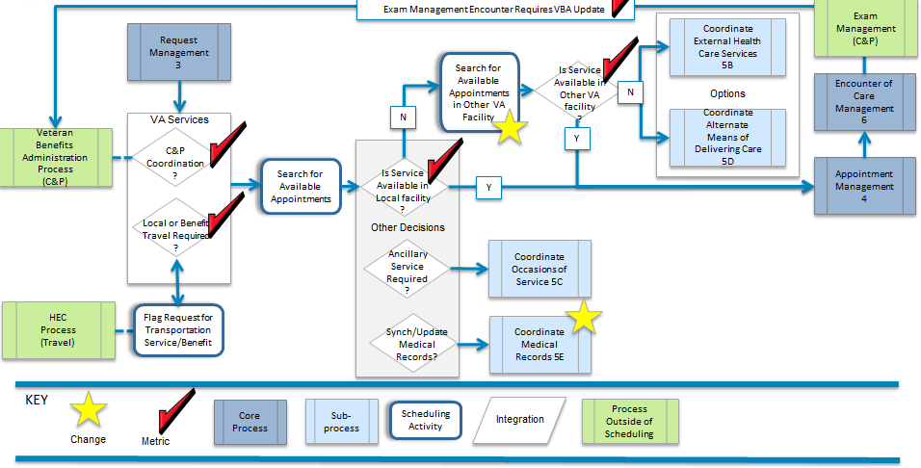
The business requires the ability to coordinate services and access to care by providing Veterans, their families, and other healthcare stakeholders with integrated access to services by enabling the exchange of information across VA. Coordinated activities within VA will be tracked and date/time stamped.

Coordinate External Health Care Services (5B)
Figure 24 - Coordinate External Health Care Services Process Flow
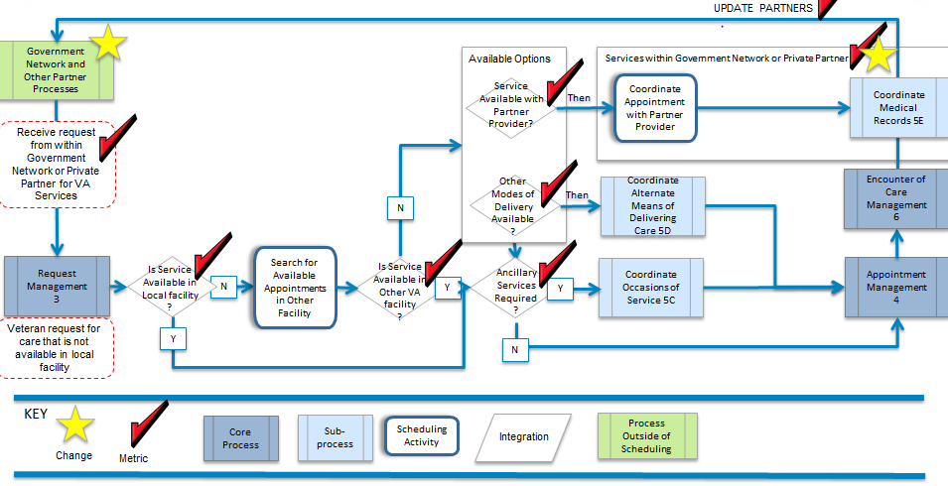
The business requires the ability to coordinate services and access to care by providing Veterans, their families, and other healthcare stakeholders with integrated access to services by enabling the exchange of information inside the government network (such as with the DoD and CDC) or outside with other private providers. Coordinated activities inside the government network and outside VA will be tracked and date/time stamped.

Coordinate Occasions of Service (Ancillary) (5C
Figure 25 - Coordinate Occasions of Service (Ancillary) Process Flow
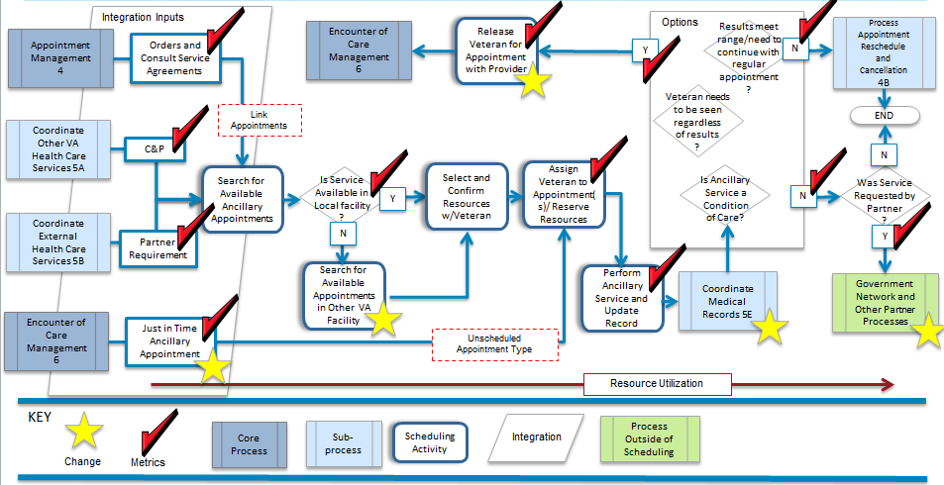
The business requires the ability to improve and integrate services across VA to increase reliability, quality, and accuracy of delivery through established care coordination agreement protocols and to better control and monitor the coordination and completion of appointments linked with required associated ancillary test.

Coordinate Alternate Means of Delivering Care (5D)
Figure 26 - Coordinate Alternate Means of Delivering Care Process Flow
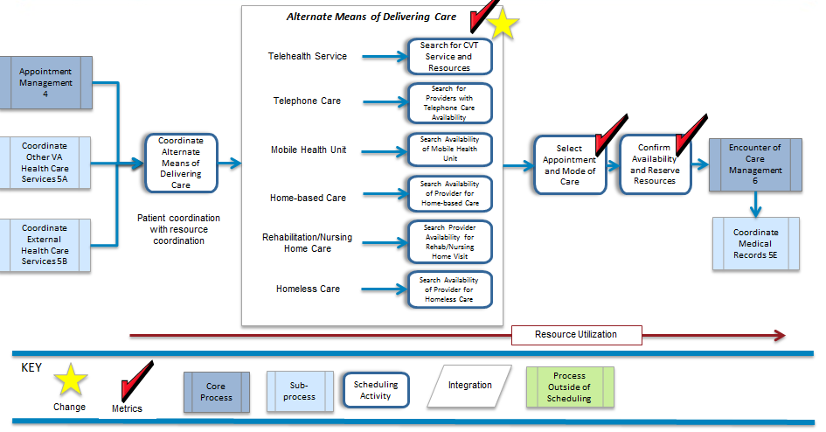
The business requires the flexibility to develop a range of effective delivery methods that are convenient to Veterans and their families (such as the emergent telehealth option or by enabling more mobile options to support outreach programs) where traditional services are not available.

Coordinate Medical Records (5E)
Figure 27 - Coordinate Medical Records Process Flow
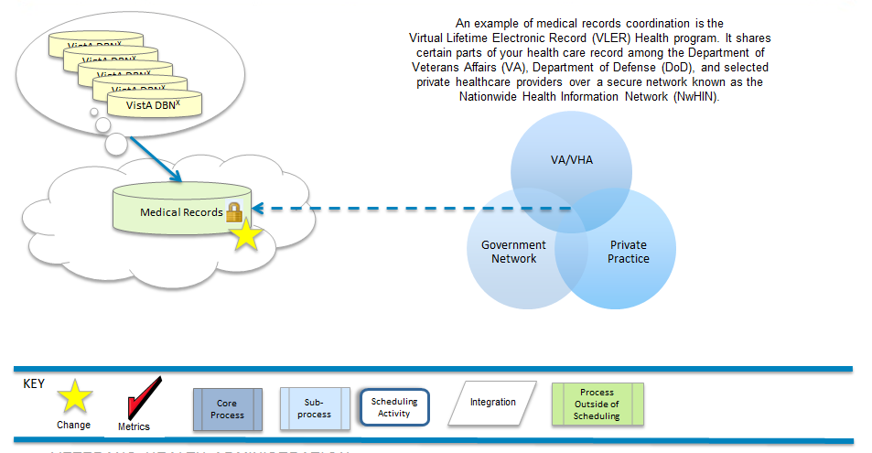

The business requires integrated access to electronic healthcare records across VA and between partners (such as DoD and private healthcare partners) to support near-real-time decision making concerning level of care and priority of care. Access to electronic healthcare records will be tracked and date/time stamped.

Manage Encounter of Care

Process Overview for Manage Encounter of Care
The Manage Encounter of Care capability summarizes the life cycle of an appointment and merges it with the medical treatment information. These activities contribute to the spectrum of metrics used in wait-time reporting, capacity and resource planning, and follow-up activities to reach continuity of care goals.
The Manage Encounter of Care capability describes the entire process from check in to check out and needs to track and provide access to information regarding the Veteran’s arrival and departure times.
Part of the encounter includes processing medical-related activities which provide care and services for the Veteran. However, the specific information about services provided is not entered by the scheduler, but by the provider and is captured in the specific encounter documentation programs such as CPRS, Event Capture, Surgery Package, Radiology, Laboratory, and Veteran Care Encounter.
After the Veteran is checked-in and receives care, the next step is to complete check-out activities. Check-out activities include: scheduling future appointments and follow-up care, updating information, and administrative closing of the encounter to enable it to be processed by downstream systems for billing and workload analysis.

Unique/High Priority Business Needs
Manage Encounter of Care
Feature or Characteristic | Measure of success
Current VistA reporting and DSS coding must continue to support non-scheduling business processes as it currently does today | All scheduling data extracts continue to support other non-scheduling processes without disruption
Timestamps to capture Veteran cycle of care and episode of care, starting from first contact with VA | Veteran contact date / wait time or care cycle can be tracked by type of services received, time to complete requested service or segment of services received
Efficiently exchange scheduling data with encounter data throughout scheduling process | Data is not lost and data quality is improved because of decreased manual entry of data
Table 25 Manage Encounter of Care

Capability Model Description
There are four sub-capabilities which describe the function for Encounter of care. They are outlined in Table 15 - Manage Encounter of Care Sub-Capabilities.
Figure 28 - Encounter Management (Framework View)
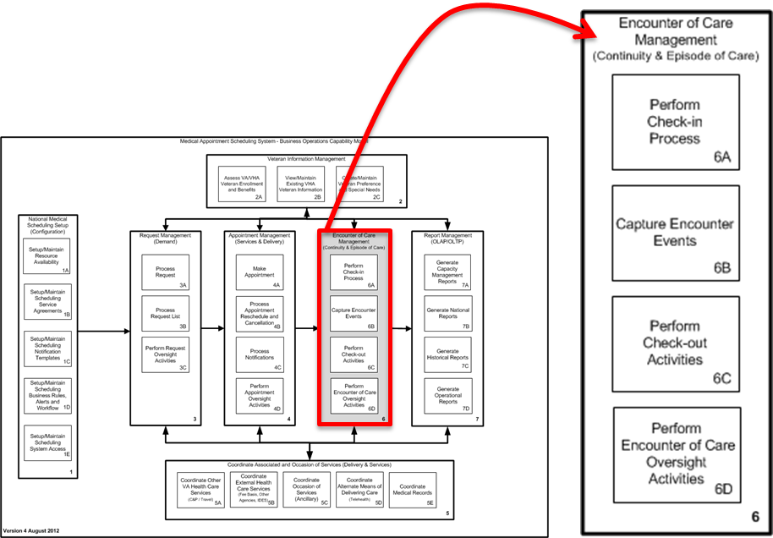
manage ENCOUNTER OF CARE - SUB-CAPABILITIES
The Encounter of Care Management capability summarizes the life cycle of an appointment and merges it with the medical treatment information. These activities contribute to the spectrum of metrics used in wait-time reporting, capacity and resource planning, and follow-up activities to reach continuity of care goals.
6A | Perform Check-in Process | The Perform Check-in Activities sub-capability provides the flexibility to view a list of scheduled appointments in preparation for the daily workload. The process provides the ability to perform check-in activities for appointments utilizing multiple formats (such as a list view, a calendar view, a patient view, or a provider view for schedulers; or kiosks and other innovative options for Veterans).
6B | Capture Encounter Events | The Capture Encounter Events sub-capability captures information pertaining to events of the encounter and metrics for wait-time studies.
6C | Perform Check-out Activities | The Perform Check-out Activities sub-capability completes the episode of care by matching and dispositioning appointments that resulted in an encounter and concludes the wait-time range of metrics. The check-out will capture any orders for new care or services and/or follow-up care.
6D | Perform Encounter of Care Oversight Activities | The Perform Encounter of Care Oversight Activities sub-capability encompasses a variety of proactive management tools and techniques to monitor and report operational efficiencies or deficiencies in near real-time from service-line to national level.
Table 26 Manage Encounter of Care Sub-Capabilities

Examples of Common Encounter of Care Situations
The situations noted in Table 16 - Common Encounter of Care Situations describe examples of how the encounter of care is used in VHA.
Examples of Common Encounter of Care Situations
Administrative Activities:
Once an appointment has been made, daily operational activities ensue to support the organization and coordination of committed resources. Generation of reports and lists from the scheduling application helps to maintain an efficient operation by providing the necessary information for just-in time decision making. Whether a Veteran was a no-show or the encounter of care completed, a series of administrative activities take place to disposition the appointment and encounter.
Generate various operational reports and lists | Generation of operational reports and lists is performed throughout the process to help ensure an efficient coordination of activities and resources.
Disposition Appointment and Encounter | Coordination of appointment and encounter information is essential in capturing and monitoring resource workflow and utilization.
Daily Appointment Check-in/Check-out:
Many activities take place during check-in and check-out processes. In some cases, a Veteran might check-in at a kiosk provided by the facility, but in many cases the Veteran checks in at a receptionist type set-up. Various scenarios of the process include: basic appointment with either a financial or non-financial obligation (e.g. travel voucher, co-pay), walk-ins or cancelations, no shows, checked in but left without being seen (LWBS), coordination of same day appointments and special needs, special alerts to clerks and providers, and hand-off between provider and check-out process.
Appointment Check-in/Check-out: Financial/Non-Financial | Two scenarios not necessarily handled in the scheduling practices of the check-in and check-out process but are triggered by these activities include co-pay and travel reimbursement.  To date, most of the co-pay activities are included in the billing activities outside of scheduling; however, since the co-pay is associated with the type of service and a Veteran’s eligibility, it seems logical for the Appointment Managements Kept process to include steps to validate the association and business rules that govern the final billing.  Another scenario with a financial component is the travel reimbursement agreement with the Veteran. It is the confirmation and validation that the Veteran fulfilled their obligation in the appointment and encounter process that enables the issuance of a travel voucher during the check-out process.  - Service must ensure workflow occurs in a standardized manner to include Veteran check-in with scheduling staff, nurse interviews, provider visits, and check-out processes
Itinerary of Multiple Same Day Appointments and Veteran with Special Needs | An efficient operation is one that coordinates all activities affecting timely service of care. Tracking a Veteran’s check-in/check-out status from one appointment to the next on days with multiple same day appointments would significantly improve the ability for a service to monitor, coordinate, and manage Veteran movement and provide a just-in-time need for a resource to attend to Veterans with special needs.
Walk-ins, No-shows, and LWBS | Although walk-ins help to fill the gaps in the daily schedule, no-shows and LWBS trigger other processes and reporting criteria concerning effectiveness of service.
Check-out and Follow-up Appointments | The check-out scenario is an area where efficiencies can be recognized. In cases where a follow-up is requested by the provider, the appointment should be made during the check-out process. The same should be accomplished regardless of the provider or service (e.g. Primary to Specialty or Specialty to Specialty)  - Orders are documented during the encounter and are available for scheduling prior to the check-out process.  - Providers must document rational and timeframes for medications, diagnostic tests, laboratory studies, return appointments, consultations and procedures before the Veteran leaves the examination room.  - The check-out process should occur following ever encounter. Check-out process may consist of:  - Nurse-administered Veteran education  - Clinical pharmacist education and review of prescription orders  - Collection of Veteran feedback  - Scheduling of diagnostic studies, consultations, and follow-up visits  - The check-out process must also include the verification of the disposition of the appointment and the encounter.
Table 27 Common Encounter of Care Situations

Encounter of Care Management (Continuity of Care) (6)
The business requires the ability to view, prepare, and manage information about daily appointments, coordination with other services, patients with special needs, and check-in activities. The business requires the ability to monitor a patient's progress though the events of an encounter, and capture any orders for new services or follow-up care during the check-out process. The business requires that encounter of care activities be tracked and date/time stamped.

Perform Check-in Process (6A)
Figure 29 – Perform Check-in Process Flow (6A)
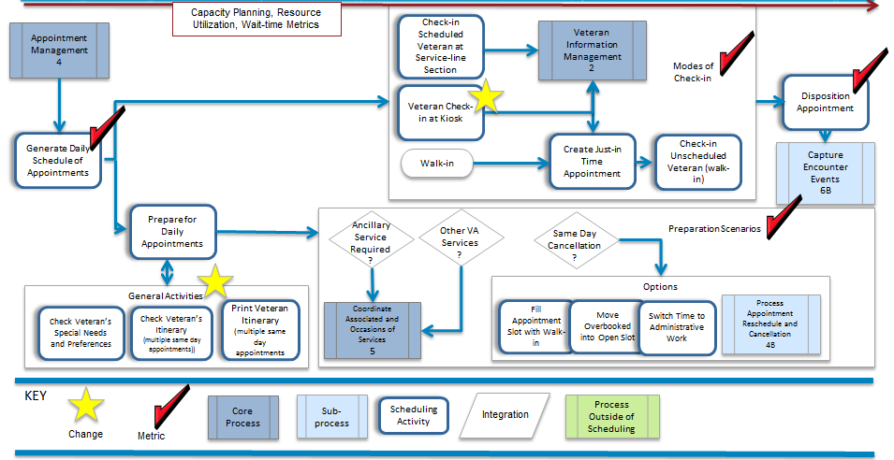
The business requires the flexibility to view a list of scheduled appointments in preparation for the daily workload, and the ability to perform check-in activities for appointments utilizing multiple formats (such as a list view, a calendar view, a patient view, or a provider view for schedulers; or kiosks and other innovative options for Veterans).

Capture Encounter Events Process Flow (6B)
Figure 30 - Capture Encounter Events Process Flow (6B)
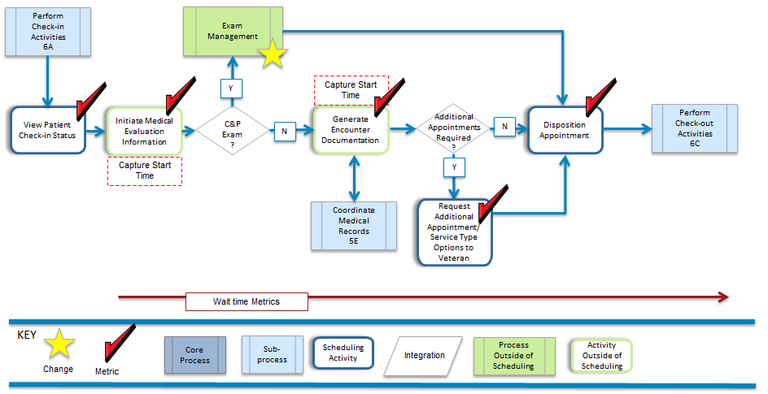
The business requires the ability to capture, track, and date/time stamp the events of the encounter related to scheduling.

Perform Check-out Activities Process Flow (6C)
Figure 31 - Perform Check-out Activities Process Flow (6C)
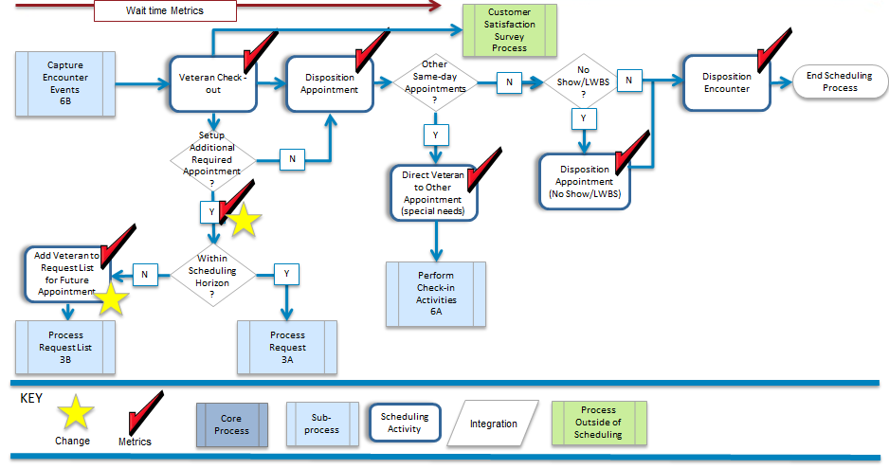
The business requires the ability to match and disposition appointments that resulted in an encounter and capture the wait-time range of metrics. The business requires the ability to capture any orders for new care or services and/or follow-up care during check-out.

Perform Encounter of Care Oversight Activities Process Flow (6D)
Figure 32 - Perform Encounter of Care Oversight Activities Process Flow (6D)
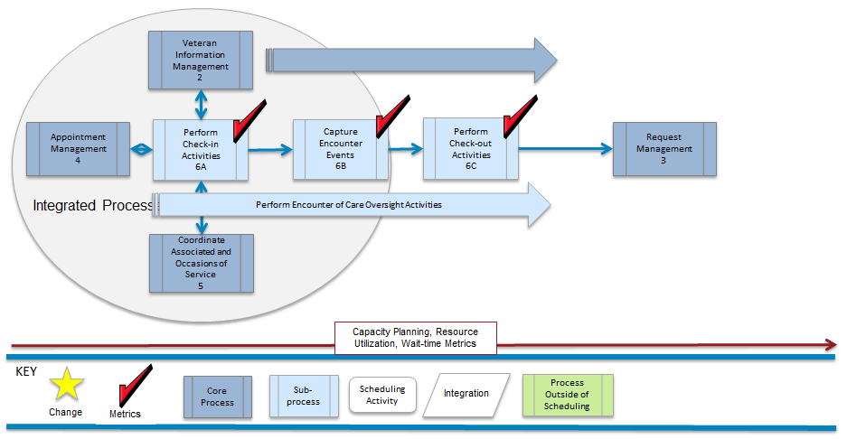
The business requires the ability to monitor the check-in process, encounter events, and check-out activities for rapid decision making and issue resolution, as well as, the ability to report (structured, user defined, and ad-hoc) operational efficiencies or deficiencies in near-real time. Processing encounter of care activities will be tracked and date/time stamped.

Report Management

Process Overview for Report Management
Report Management is an overarching business capability which uses data from the application and/or interfacing systems (internal and external). Data is used to produce reports from service line level to national level and may be exported and shared with external partners. The vision for Report Management is that aggregation of data obtained from the scheduling solution will enable VHA management to better analyze its operations at any level across the VHA landscape on current performance, performance measures and predictive analytics for future direction.
Sources for current legacy reporting will need to be maintained as VHA moves forward with the future setup of Medical Appointment Scheduling System (MASS). Sources of historical reports and reporting data include, but are not limited to:
- Veteran’s Service Support Center (VSSC)
- Austin Information Technology Center (AITC)
- Corporate Data Warehouse (CDW)
- Facility database instances

Unique/High Priority
Report Management
Feature or Characteristic | Measure of success
Current VistA reporting and DSS coding must continue to support non-scheduling business processes as it currently does today | All scheduling data extracts continue to support other non-scheduling processes without disruption
Timestamps to capture Veteran cycle of care and episode of care, starting from first contact with VA | Veteran contact date / wait time or care cycle can be tracked by type of services received, time to complete requested service or segment of services received
Efficiently exchange scheduling data with encounter data throughout scheduling process | Data is not lost and data quality is improved because of decreased manual entry of data
Current VistA reporting and DSS coding must continue to support non-scheduling business processes as it currently does today | All scheduling data extracts continue to support other non-scheduling processes without disruption
Timestamps to capture Veteran cycle of care and episode of care, starting from first contact with VA | Veteran contact date / wait time or care cycle can be tracked by type of services received, time to complete requested service or segment of services received
Efficiently exchange scheduling data with encounter data throughout scheduling process | Data is not lost and data quality is improved because of decreased manual entry of data
Table 28 Report Management Unique/High Priority Business Needs

Capability Model Description
Table 17 - Report Management Sub-Capabilities describes VHA report management needs for each of the sub-capabilities necessary to perform strategic, tactical and operational insight and decision-making.

Figure 33 - Reporting (Framework View)
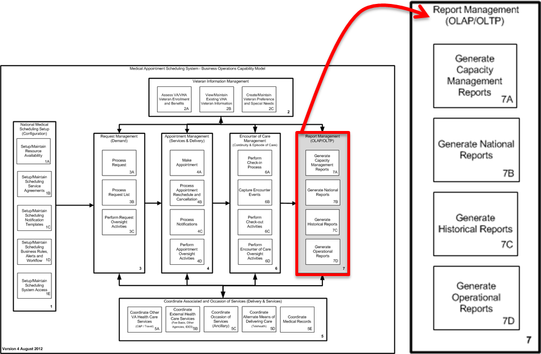
REPORT MANAGEMENT - SUB-CAPABILITIES
Report Management is an overarching business capability which uses data from the scheduling application and/or interfacing systems (internal and external). Data is used to produce reports from the service line level to the national level and may be exported/shared with external partners.
7A | Generate Capacity Management | The Generate Capacity Management sub-capability concentrates on capacity planning of resources and work force utilization throughout the scheduling operation. As a planning tool, resource availability and utilization is compared to projected demand, actual demand, and fulfilled appointments; and aims to provide available resources where care is needed. Data is used to produce reports from the service-line level to the national level.
7B | Generate National Report | The Generate National Report sub-capability allows information from scheduling and non-scheduling sources (such as clinical information, patient cost, insurance, and benefits) to be aggregated and consolidated to a national data center from various service-lines and facilities across VHA that contains information gathered from scheduling and non-scheduling sources (such as clinical information, patient cost, insurance, and benefits). These reports are used to present the efficiencies or inefficiencies of the healthcare line of business to VA leadership, Congress and other organizations.
7C | Generate Historical Reports | The Generate Historical Reports sub-capability allows information to be aggregated and consolidated to a national data center from new and legacy systems. These reports provide both a summary and detailed view of historical data that must be maintained in accordance with public laws and VA policies. Data is used to produce reports to determine trends, to plan for future activities, and to present the information at the national level to VA leadership, Congress, and other organizations
7D | Generate Operational Reports | The Generate Operational Reports sub-capability provides a variety of operational performance and audit reports of daily healthcare scheduling activities which are aggregated and consolidated from the service-line level to the national level in order to track and monitor activity based costing, performance against plan, access to care (such as missed opportunities and wait time), quantity and quality of care received (such as return visit rate), and clinical outcome goals including continuity of care.
Table 29 Report Management Sub-Capabilities

Examples of Common Reports Generated During Report Management
The situations noted in Table 18: Common Reports Generated during Report Management describe examples when reports are used in VHA.
Common ReportS GENERATED DURING REPORT Management
Capacity Management Reports:
The business requires the capability to produce capacity planning reports for demand, available resources, and work force utilization throughout the scheduling operation to support predictive analytics and ability to forecast changes in demand and resource needs. The business requires tools (such as a dashboards and other types of formats) to support workload forecasting, planning, and leveling; and to monitor 'just-in-time' utilization of staff and resources to meet demand (such as backlogged, current, and future requests). The business requires the ability to reconcile unmatched demand and supply.
Workload |  | The need to manage workload at the local level is paramount in achieving equilibrium between demand and available resources at the point these two factors become out of balance. Workload results are currently batch transmitted to Austin Information Technology Center (AITC). The business requires information from the service line level to the national level in near real-time.
Workload and Utilization Management |  | Workload and utilization management is an example of how other program areas use data within the scheduling processes. There are currently over 50 workload and utilization reports available from VSSC and include trends for unique patients, top outpatient procedures, top diagnosis, patient cost and workload, outpatient visits and first time users, disbursed amounts for various non-VA care categories, and various inpatient type concerns.  The National Patient Care Database (NPCD) reports provide tools to assist sites reviewing in-house outpatient workload and demographics at the clinic stop level for outpatient Veteran patient population. Analysis of outpatient visits, encounters and uniques are available at the National, VISN, Facility and Division level, for a multitude of demographics (including Rural areas).
National Reports: National reports are populated by aggregating information from stations, clinics, and facilities across VHA.
The business requires current national reporting requirements be maintained (such as specified information, algorithms, and formatting). The reports must accurately reflect the data being aggregated and consolidated to a national data center from various service-lines and facilities across VHA in near real-time. These standard national reports contain information gathered from scheduling and non-scheduling sources (such as clinical information, patient cost, insurance, and benefits), and are used to present the efficiencies or inefficiencies of the healthcare line of business to VA leadership, Congress and other organizations.
Congressional Reports |  | Currently, there are three key reports setup within VSSC to exhibit clinic wait time performance to Congress; however, throughout the year, Congress presents requests for just-in-time information on a myriad of issues involving the national footprint down to an individual network/VISN or facility.  Examples of reports:  - New and Established Patients and Wait Times for Completed Appointments - Top 50 Clinics summarizes performance within 14 days of the appointment desire date in both Primary and Specialty Care services. It also rates within 30 days of desire date for all Compensation & Pension appointments.  Access List (built on FY11 logic) focuses entirely on the desired date of the Veteran as the default option, although it allows the user to see the original appointment creation date method if so desired. The Top 50 Clinic listing remains unchanged from FY2010, but this new version divides list of 50 into 2 sub-categories (Primary Care & Specialty Care). Each group will have its own unique target in FY2012.
High Reliability Systems Reports |  | High Reliability Systems uses reports from VSSC which focus on two major areas of performance:  - Clinic Wait Time and Performance Reports - Both are used to work with network directors to assess, monitor and react to performance issues.  - Network Director Performance Reports - are used to assess performance including access measures, clinical measures and scheduling measures. The critical scheduling pulls vary by year with new criteria depending on the kinds of measure that needs to be tracked.  This capability will require that the system is able to present ad-hoc sets of information in the form of scorecards and dashboards with drill down functionality to the root data source.  - Wait Time Reports - were created to monitor performance against two of the three VA’s strategic objectives, ‘Make it easier for Veterans and their families to receive the right benefits, meeting their expectations for quality, timeliness and responsiveness’ and ‘Build our internal capacity to serve Veterans, their families, our employees, and other stakeholders efficiently and effectively.’  The span of analysis involves pending appointments, completed appointments (new enrollee and established patients), Veterans on the Electronic Wait Time List that are over/under 30 days, missed opportunities due to cancellations, provider detail history, Veteran classification, top 50 clinics, various call center metrics, pending future appointments, patient appointment and encounter history, “no Vet left behind”, new and established patients linked to consult wait times, no show missed opportunities, mental health non show and cancellation by patient follow up, clinical utilization and capacity, appointment cancellation and reschedule rates, and access list national trends segregated by primary care, specialty care and C&P trends.  - These reports are also used by others throughout the VHA.
Clinical Care |  | There are over 30 clinical care reports available from VSSC. Information available in this domain supports some components of the Medical Appointment Scheduling System (MASS) setup, manage Veteran information, and coordinate associated and occasions of service capabilities.  Some examples of the information presented in the clinical care area includes: Primary care staffing ratios, primary care staffing and room utilization, provider/capacity/modeled panel and active panel list, primary care almanac, patient aligned care teams, PACT program, PCMM coordinator list and referral case manager list, various mental health, telehealth workload and care coordination home telehealth outcome briefings, care coordination home telepath visits, vendors and outcome briefing books, amputations, after hours mental health.
Capital and Planning |  | Capital and Planning reports tend to be more prescriptive and project utilization by treating facilities, market, and enrollment by Veteran population, Special conflict and gender. projections from the VA National Center for Veterans Analysis and Statistics and the VHA Office of the ADUSH for Policy and Planning for enrollee OEF/OIF status and Gender for years 2010-2031 by VISN, is utilized to assess demand and supports workload/utilization planning decisions.
Special Focus |  | The majority of the special focus reports convey factors involving Operation Enduring Freedom (OEF)/Operation Iraqi Freedom (OIF)/Operation New Dawn (OND) and Non-VA Care – PHI concerns that are currently being monitored. Trends in rural health and a report developed as a joint incentive fund initiative combining VA and DoD purchased care information are also associated with this report category.
Historical Reports:
Historical reports are generated from a variety of legacy sources in order to see what happened in the past and to compare that to what is happening today. This provides VHA the ability to determine trends and gauge present activities versus past activities and to plan for future activities. Historical reports are also generated to review the logic and reporting format used in years past, as well as review data generated in past years reporting. Sources of historical reports and reporting data include, but are not limited to:

- Veteran’s Service Support Center (VSSC)
- Austin Information Technology Center (AITC)
- Corporate Data Warehouse (CDW)
- Facility database instances

The business requires the capability to maintain an archive of summary and detailed historical data from new and legacy systems, in accordance with public law and VA policy. The business requires the ability to maintain continuity of reporting as measures and metrics change. The business requires the ability to produce reports to determine trends, to plan for future activities, and to present the information at the national level to VA leadership, Congress, and other organizations.
Legacy and Historical Reports | Federal and VA regulations and VHA policy require that information pertaining to past metrics must be maintained per record management regulations.  Some examples of historical reports include past performance of facilities for appointments made and kept, appointments cancelled and rescheduled.
Operational Reports:
The business requires the capability to produce a variety of operational performance and audit reports of daily healthcare scheduling activities which are aggregated and consolidated from the service-line level to the national level in order to track and monitor activity based costing, performance against plans, access to care (such as missed opportunities and wait time), quantity and quality of care received (such as return visit rate), and clinical outcome goals including continuity of care. The business requires the ability to capture and track request date, Veteran/Provider desired date/agreed upon date, create date of an appointment, and location of available care.
Patients |  | There are many situations when a patient’s information is required within a given report. Currently, patient reports at the operational level generate activity by frequency, patient appointment statistics, care encounter lists, problem lists, patient profiles and routing slips.  The new solution needs the capability to generate information relevant to supporting the encounter of care, the continuity of care, and missed opportunities of all Veterans.
Appointment/Clinic |  | There are over 20 operational reports that pull information on appointments and clinics. The information is a mix of availability and utilization, case load, cancellations, check-ins, general/random appointment information, notifications and letters, and audits by supervisors. These reports need to be generated throughout the scheduling process to support common activities and prepare for daily routines.
Encounters |  | Operationally, reports generated with encounter information are used administratively to ensure the disposition of incomplete information and to ensure that the encounter is properly associated to a stop code for co-pay and other financial concerns.
Table 30 Common Reports Generated During Report Management

Report Management Concepts and Business Needs (7)
The business requires the capability to produce robust reports at the national, VISN, facility and service line levels to ensure policy compliance, and operational effectiveness, to monitor the quantity and quality of care received, and to achieve clinical outcome goals. The business requires that reports containing personally identifiable information that are required to be transmitted, retrieved, viewed, or printed meet all VA Handbook 6500 requirements. The business requires the ability to produce structured, ad-hoc, and user defined reports in a variety of output formats in near real-time.

Capacity Management (7A)
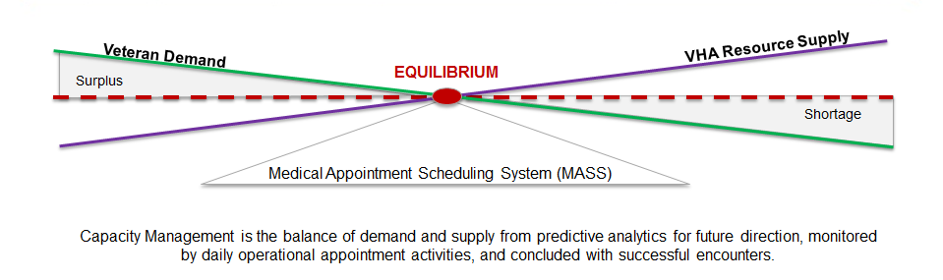
The business requires the capability to produce capacity planning reports for demand, available resources, and work force utilization throughout the scheduling operation to support predictive analytics and ability to forecast changes in demand and resource needs. The business requires tools (such as a dashboards and other types of formats) to support workload forecasting, planning, and leveling; and to monitor 'just-in-time' utilization of staff and resources to meet demand (such as backlogged, current, and future requests). The business requires the ability to reconcile unmatched demand and supply.

National Reports (7B)
The business requires current national reporting requirements be maintained (such as specified information, algorithms, and formatting). The reports must accurately reflect the data being aggregated and consolidated to a national data center from various service-lines and facilities across VHA in near real-time. These standard national reports contain information gathered from scheduling and non-scheduling sources (such as clinical information, patient cost, insurance, and benefits), and are used to present the efficiencies or inefficiencies of the healthcare line of business to VA leadership, Congress and other organizations.

Historical Reports (7C)
The business requires the capability to maintain an archive of summary and detailed historical data from new and legacy systems, in accordance with public law and VA policy. The business requires the ability to maintain continuity of reporting as measures and metrics change. The business requires the ability to produce reports to determine trends, to plan for future activities, and to present the information at the national level to VA leadership, Congress, and other organizations.

Operational Reporting (7D)
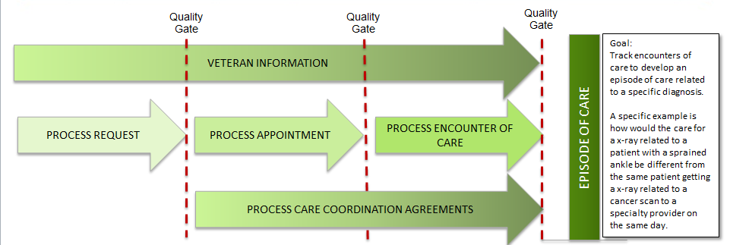
The business requires the capability to produce a variety of operational performance and audit reports of daily healthcare scheduling activities which are aggregated and consolidated from the service-line level to the national level in order to track and monitor activity based costing, performance against plans, access to care (such as missed opportunities and wait time), quantity and quality of care received (such as return visit rate), and clinical outcome goals including continuity of care. The business requires the ability to capture and track request date, Veteran/Provider desired date/agreed upon date, create date of an appointment, and location of available care.

Master Data and Functional Integration Points in VistA
VHA scheduling is comprised of a complicated mix of stand-alone occurrences (instances) of the scheduling software, with data necessary to run that instance and a series of modules that transmit different data to other systems and repositories. Functional integration points are described here as both those modules and the repositories used to transmit data to appropriate places. There are some data integrity issues as a result of non-standardized data in individual instances which cause difficulties for national level reporting, metrics, etc. As a new scheduling solution comes online, the data transmitted via the functional integration points outlined in this section must be evaluated and accommodated to ensure VHA data are not adversely affected. Part of the solution will be a more standardized approach to master data management.
Master records can be created, read, updated and deleted by authorized users and processes. Another way to consider master records is as objects, e.g. the Veteran object is all the information needed for any transaction where a Veteran is used, a service is all the information called when anything related to a service provided (or to be provided) is called, etc. How well these data are managed contributes to data integrity, security, and efficient operations.
Coordinating systems that contain potential master data to create an object and identify authoritative sources is a challenge because of dependencies VistA applications and modules have on various databases and each other. VHA views the Master Veteran Index as the most significant aspect of master data. This section identifies other contributors and consumers of what could be considered master data business objects across VHA. Master data business object management and migration may be performed in phases and start prior to a scheduling selection and implementation, particularly by identifying standards and authoritative sources.
Systems and master records which integrate with the existing scheduling package are noted below. Data are exchanged in a variety of manners, whether in communication modules or direct interfaces. Also, business rules are embedded as part of the exchanges and will need to be examined as part of the transition from the VistA environment to a new scheduling solution.

FUNCTIONAL INTEGRATIONS POINTS TO VISTA
PERSON INFORMATION
MVI/MPI (Master Veteran Index/Master Patient Index)
PIMS (Patient Information Management System)
ESR/HECMS/BIRLS/IVM/ARC (Enrollment System Redesign/ Health Enrollment Center Management System includes links to BIRLS & VADIR/ Beneficiary Identification Records Locator System/ Income Verification Matching/ Allocation Resource Center)
ADR (Ambulatory Care Reporting Project)
CDW (Corporate Data Warehouse)
NHE/PDX (Network Health Exchange/ Patient Data Exchange)
BILLING INFORMATION
ADT (Admissions, Discharges, and Transfers)
DSS (Decision Support System)
TRANSPORTATION INFORMATION
BT (Beneficiary Travel)
VTS (Veteran Transportation Service)
MEDICAL INFORMATION
Medical Records
PCE (Patient Care Enhancement)
CCOW (Clinical Context Object Workgroup)
CCR (Clinical Case Registries)
HDR (Health Data Repository)
NPCD (National Patient Care Database)
Ancillary Tests/Lab Package/Radiology Package
PROVIDER INFORMATION
PCMM (Primary Care Management Module)
NHCPD (National Health Care Practitioner Database)
Person Class File (per VistA)
SCHEDULING INFORMATION
AM (Appointment Management)
LM (List Manager)
RR (Recall Reminder)
EWL (Electronic Wait List menu)
NEAR (New Enrollee Appointment Request Management)
Consult Package
RPC Broker
CAPRI/C&P EXAM/VETSNET/VADIR
MUMPS Talk/AudioCare
REPORTING INFORMATION
VSSC (VHA Support Service Center)
PAIT (Patient Appointment Information Transmission)
SAS (Statistical Analysis Software)
ACRP (Ambulatory Care Reporting Project)
Scheduling Outputs/VistA
VA SYSTEMS
MyHealtheVet
SQWM (Surgery Quality Workflow Manager)
LSRP (Lab Systems Redesign Program)
ENTERPRISE INFRASTRUCTURE & SERVICES
MDWS (Medical Domain Web Services)
VistAWeb
CPRS/RDV (Computerized Patient Record System/ Remote Data View)
SOA (Service Oriented Architecture)
ESB (Enterprise Service Bus)
VIE (Vitria Interface Engine)
SDS (Standard Data System)
VistA Kernel
VA Fileman
HL7 (Health Level 7)
BHIE (Bidirectional Health Information Exchange with DoD)
TIU (Text Integration Utility)
Identity/Access Management
Table 31 Functional Integration Points to VistA

Supporting Materials

Acronyms
AAC | Austin Automation Center
ACAP | Access and Clinic Administration Program
ADA | Americans with Disabilities Act
ADPAC | Automated Data Processing Application Coordinator
AMIE | Automated Medical Information Exchange
API | Application Program Interface
ASCII | American Standard Code for Information Interchange
ASP | Application Service Provider
BN | Business Need
BPR | Business Process Reengineering
BRD | Business Requirements Document
C&P | Compensation and Pension
CA | Certification and Accreditation
CBOC | Community Based Outpatient Clinic
CBPM | Current Business Process Model
CDC | Center for Disease Control
CGI | Common Gateway Interface
CORBA | Common Object Request Broker Architecture
COTS | Commercial Off-The-Shelf
CPLCAM | Customer Program Life Cycle Assessment Methodology
CPRS | Computerized Record System
CPRS | Computerized Patient Record System
DCOM | Distributed Component Object Model
DEERS | Defense Enrollment Eligibility Reporting System
DoD | Department of Defense
DSS | Decision Support Service
DSS | Decision Support Services
ERM | Enterprise Requirements Management
ESM | Enterprise Systems Management
EWS | Enterprise-Wide Scheduling
FBPM | Future Business Process Model
FIPS | Federal Information Processing Standard
FTE | Full Time Equivalent
FTEE | Full-Time Equivalent Employee
FTP | File Transfer Protocol
FU | Follow-up
GAO | Government Accounting Office
GAO | Government Accountability Office
GCPR | Government Computer-based Patient Record
GSM | Global Session Manager
GUI | Graphic User Interface
GUI | Graphical User Interface
HINQ | Hospital Inquiry
HIPAA | The Health Insurance Portability and Accountability Act of 1996
HIS | Health Information Service
HL7 | Health Level 7
HTML | Hypertext Markup Language
IAA | Interagency Agreement
IBM | International Business Machines Corporation
IE | Microsoft Internet Explorer
IHI | Institute for Healthcare Improvement
IHS | Indian Health Service
IIS | Internet Information Server
IMAP | Integrating Medicine and Public Health
IT | Information Technology
IT/IRM | Information Technology/Information Resource Management
LDAP | Lightweight Directory Access Protocol
MASS | Medical Appointment Scheduling
MPI | Master Patient Index
MTF | Medical Treatment Facilities
MUMPS | Massachusetts General Hospital Utility Multi-Programming System
NIH | National Institute of Health
NIST | National Institute of Standards and Technology
NSR | New Service Request
ODBC | Open Database Connectivity
OI&T | Office of Information and Technology
OIG | Office of Inspector General
OIT | Office of Information and Technology
OMG | Object Management Group
ORB | Object Request Broker
OWNR | Owner Requirement
PACT | Patient Aligned Care Team
PCC | Primary Care Clinic
PCMM | Primary Care Management Module
PCP | Primary Care Practitioner
PDF | Portable Document Format
PIMS | Patient Information Management System
PKI | Public Key Infrastructure
PRF | Patient Record Flag
RAD | Resource Access Decision
RAEM | Requirements Analysis and Engineering Management
RAID | Redundant Array of Independent Disks
RO | Regional Office
RTF | Rich Text Format
SGML | Standard Generalized Markup Language
SME | Subject Matter Expert
SMTP | Simple Mail Transfer Protocol
SOAP | Simple Object Access Protocol
SQL | Structured Query Language
SS | System Specification
SSL | Secure Sockets Layer
TCP/IP | Transmission Control Protocol / Internet Protocol
TIU | Text Integration Utilities
VA | Department of Veterans Affairs
VACO | Veterans Affairs Central Office
VAMC | Veterans Affairs Medical Center
VB | Visual Basic
VBA | Veterans Benefits Administration
VHA | Veterans Health Administration
VISN | Veterans Integrated Service Network
VistA | Veterans Health Information Systems and Technology Architecture
VSSC | VHA Support Service Center
XMI | XML Metadata Interchange
XML | Extensible Markup Language
XSL | Extensible Style-sheet Language
Table 32 Acronyms

Descriptions of Terms
Advanced Access | An appointment scheduling carve-out strategy that emphasizes scheduling nearly all appointments on a same day basis and minimal appointment types. Most of a section’s appointment slots remain open until the start of the day. Very few slots are scheduled in advance of 24 hours. This is effectively open access taken to the logical extreme.
Ambulatory Care Reporting Project | Process of collecting and storing encounter-based clinical, diagnostic, and administrative outpatient data for daily transmission to the Austin Automation Center.
Ancillary Service | Now known as “Occasion of Service,” a specified identifiable instance of an act of technical and administrative service involved in the care of a patient or consumer, which is not an encounter and does not require independent clinical judgment in the overall diagnosing, evaluating, and treating the patient's condition(s).
Ancillary Test | Diagnostic testing performed by the laboratory, radiology, or EKG sections.
Ancillary Test Results | Diagnostic results of performed ancillary tests.
Ancillary Test Results Notification | Information concerning the completion and the results of ancillary tests.
Appointment | An Appointment is the generic term used to refer to the association of one or more patients and/or named groups to one or more time intervals that are associated with one or more resources in a specific timeslot for the purpose of recording a scheduled or unscheduled health care encounter.
Appointment Dependencies | need use cases/user stories/examples, such as when a lab must be completed prior to an appointment
Appointment List | List of appointments, by physician, clinic, etc.
Appointment Metrics | Summary of statistics related to appointments.
Appointment Notification | A notification about a patient’s scheduled appointment(s) normally delivered to the patient via mail or telephone.
Appointment Record | Information regarding a patient's appointment history. Includes information such as appointment date and time, appointment status, etc.
Appointment Request | A request for a reserved date and time period to be reserved with a medical resource. Appointment requests are normally initiated by a patient or provider.
Appointment Slot | The available time with available resources, during which an appointment may be scheduled.
Appointment Type | A broad, generic term designating the type of care to be provided during a medical appointment. Appointment types are frequently used to designate blocks of time on a schedule that relate to a designated patient care activity. Current VHA examples of appointment types (VISTA File 409.1, Appointment Type File) are regular, prima-facia, and research. Other examples of appointment types that may be used for medical appointment scheduling are initial, urgent, and follow-up.
Architecture | The style or method of design and construction that comprises the elements of an information system and defines the purpose and interrelationships of those elements.
Business Process | A group of activities that takes input, transforms it, and provides output to an internal/external user.
Business Process Reengineering (BPR) | The fundamental analysis and redesign of business processes and management systems, job definitions, organizational structures and beliefs and behaviors to achieve dramatic performance improvements to meet contemporary requirements. IT is a key enabler in this process.
Business Rule | A statement that defines or constrains some aspect of the business that includes directives that influence the human activity and guides the business behavior.
Business Rule Statement | A declarative statement of structure or constraint for which the business places upon it.
Capability | A Capability is satisfied by business process and performed by a role, i.e. an individual or team in the organization. Capabilities can be broken down into supporting capabilities (sub-capabilities), if necessary.
Capacity Planning | Process of determining the provider capability need by VA to meet changing demands for care.
Care Coordination Agreement | A Care Coordination Agreement is a written agreement defining workflow rules between any two or more services that send work to one another. Ideally, this document is developed based on discussion and consensus between the two or more involved services.
Carve-Out | The practice of holding certain types of appointments for specific purposes. This method accepts the presumption that demand for medical appointments can be measured and predicted. Once estimated, the number of appointments of a certain type can be carved-out to satisfy the demand for that particular appointment type.
CCOW | CCOW-compliant applications coordinate with each other via a behind-the-scenes context manager that enables them to work together in ways that behave like a single system from the caregiver's perspective. The context manager notifies the CCOW-compliant applications whenever the identity of the user, the patient selected, or the specific clinical observation selected changes. As the caregiver moves between applications, they are able to view the appropriate information without re-identifying the patient or observation desired.
Client/Server | Client/server describes the relationship between two computer programs in which one program, the client, makes a service request from another program, the server, which fulfills the request. Computer transactions using the client/server model are very common.
Clinic | A Clinic is a location and resource where a Veteran can seek care.
Compensation And Pension Evaluation Results | The recorded results of a C&P medical evaluation accomplished by the provider and provided to the VBA.
Compensation and Pension Request | A request for a C&P appointment at a VA medical facility for a patient needing a Compensation and Pension medical evaluation. Normally received from the VBA.
Component Administrator | The individual that performs installation, initial setup, and configuration management of the scheduling component.
Computer Off-The-Shelf (COTS) Software | An item of software that has been produced by a vendor and is available for general purchase. Such items are at the unit level or higher. Such items must have been sold and delivered to government or commercial users, must have passed user’s acceptance testing, be operating under user’s control, and within the user environment. Further, such items must have meaningful reliability, maintainability, and logistics historical data.
Computerized Patient Record System (CPRS) | The VistA package (in both GUI and character-based formats) that provides access to components of the patient chart.
Configure Patient Notification Requests | Configure the means for communication regarding appointments to accommodate the desires of the patient and the needs of the clinic, to include pre appointment instruction language, timing of notifications and delivery mechanism (text, email, phone, etc.).
Consult | A Consult is defined as a request for a specialty clinic or a provider to attend a Veteran on a consultation basis. Since providers sometimes consult without an appointment, the services must still be tracked and tied to the Veteran and the encounter. In addition to the basic consult request, orders are provided for coordination of associated and other occasions of service in conjunction with the specialty consult appointment request.
Consult Tracking | Consult/Request Tracking is a VistA product that is also part of CPRS (it can function as part of CPRS, independently as a standalone package, or as part of TIU). It’s used to request and track consultations or procedures from one clinician to another clinician or service.
Count v. Non-count clinics | In the creation of Clinic Profiles, clinics are designated as either Count Clinics or Non-Count Clinics. Count Clinics are transmitted to PCE as encounters. Non-Count Clinics are not transmitted to PCE. There are generally two reasons why a clinic might be designated as non-count: 1) if the clinic is administrative in nature and therefore not providing patient care and, 2) if the workload associated with the clinic is transmitted to PCE automatically through another means (a VistA package other than Scheduling) then the clinic is setup as non-count to avoid sending duplicate workload to PCE (for example, occasions of service).
CVT appointment pair | Patient and provider appointments to fulfill Clinical Video Telehealth care delivery
Dates | create date, desired date, scheduled appointment date, completed date
Desired Date | The desired appointment date is the date the patient or the provider wants the patient to be seen.
Discharge | The process of checking out patients once they have completed their treatment with a provider for a particular appointment and visit.
DSS Identifier | A DSS Identifier is a new VHA term that was effective on October 1, 1996, which characterizes VHA Ambulatory Care Clinics by a six-character descriptor. The DSS Identifier value is transmitted to the National Patient Care Database with each separate outpatient encounter into the NPCD field “DSS Identifier.” A primary stop code and a secondary stop code compose the DSS Identifier.
DSS Identifier | DSS Identifiers are used to measure workload for all outpatient encounters. They are the single designation by which VHA defines clinical work units for costing purposes.
Electronic Wait List (EWL) | The EWL is the official VHA wait list. The EWL is used to list patients waiting to be scheduled, or waiting for a panel assignment. In general, the EWL is used to keep track of patients with whom the clinic does not have an established relationship (e.g., the patient has not been seen before in the clinic).
Eligibility | Eligibility is information concerning a patient’s entitlement to receive VHA care.
Eligibility Determination | The act of qualifying a presenting patient for VHA medical care, usually involves researching available military records presented by the patient or received from other trusted sources.
Eligibility Verification | The act of verifying that a positive eligibility determination has been made. Usually involves checking information available from a reliable source (e.g., HINQ).
Emergent Care | Emergent or emergency care is the resuscitative or stabilizing treatment needed for any acute medical or psychiatric illness or condition that poses a threat of serious jeopardy to life, serious impairment of bodily functions, or serious dysfunction of any bodily organ or part.
Encounter | An encounter is a professional contact between a patient and a provider vested with responsibility for diagnosing, evaluating, and treating the patient’s condition.
Enrollment | The Health Eligibility Center (HEC) is responsible for determining eligibility of Veterans for VHA medical care. The HEC is the authoritative source for Veteran eligibility and subsequent enrollment priority. To be enrolled, a Veteran must meet basic eligibility criteria. The HEC gathers all the information needed to make eligibility decisions and records and processes the information using the HEC System.
Framework | Graphic view of the activities and functions of outpatient scheduling, grouped in modules of related activities.
Full-Time Equivalent Employee (FTEE) | Employment figures expressed as a computed statistic representing the number of full-time employees that could have been employed if the reported number of hours worked by part-time employees had been worked by full-time employees. This statistic is calculated by dividing the “part-time hours paid” by the standard number of hours for full-time employees in the particular government and then adding the resulting quotient to the number of full-time employees.
Full-Time Equivalent Employee (FTEE) | Employment figures expressed as a computed statistic representing the number of full-time employees that could have been employed if the reported number of hours worked by part-time employees had been worked by full-time employees. This statistic is calculated by dividing the ''part-time hours paid'' by the standard number of hours for full-time employees in the particular government and then adding the resulting quotient to the number of full-time employees.
High Priority Reschedule List | A “tickler” list of high priority patients (e.g., those that pose potential threats to themselves or society if not closely managed). This list ensures that when these patients miss scheduled appointments, it does not go unnoticed and they receive priority for rescheduling.
Hospital Inquiry (HINQ) | The Hospital Inquiry (HINQ) module allows VAMC to obtain veteran eligibility information from four remote VBA computer systems. Returned HINQ data may be loaded directly into the local Patient file through various screens.
Individual Appointment Cancellation Request | Information used to cancel an individual appointment.
Individual Schedule Information | Contains information related to the scheduled availability of a specific resource. It may indicate specific times the resource will and will not be available.
Link consults to appointments | Business process whereby appointment is linked to the consult request.
Long Term Waiting List | A holding area for appointment requests that fall outside the planning horizon which may also have a reminder system in place to re-activate appointment requests at a prescribed time (e.g., one month prior to the desired appointment date/time).
Management Level | Refers to either a Veterans Integrated Service Network or a group of medical treatment facilities integrated as a Health Care System with a single VistA installation. Within this document it may also be used to denote a level of management that defines resources, establishes standards, and establishes policy.
New Enrollee | A new enrollee is a previously non-enrolled Veteran who applies for VA health care benefits and enrollment by submitting VA Form 10-10EZ, Application for Health Benefits, is determined to be eligible, and is enrolled.
New Enrollee Appointment Request (NEAR) Call List | The NEAR Call List is a tool to be used by enrollment staff to communicate to Primary Care Management Module (PCMM) Coordinators or scheduler, at the Veteran’s designated preferred location, that a newly enrolled Veteran has requested an appointment during the enrollment process.
New Patient | For VHA Wait Time Measurement purposes, a “new patient” is any patient not seen by a qualifying provider type within a defined stop code or stop code group at that facility, within the past 24 months.
Non-Service Connected (NSC) | NSC refers to a condition or disability VA has not determined was incurred in, or has been aggravated by, military service.
No-Show | Used to describe patients who do not arrive for scheduled appointments that were not canceled. No-show is also used as an “appointment status” designator that is associated with patients that do not arrive for their scheduled appointments.
Notification of Cancelled Appointment | Information about a patient’s canceled appointment(s)
Occasion of Service | Formerly known as ancillary service, an “occasion of service” is a specified identifiable instance of an act of technical and administrative service involved in the care of a patient or consumer, which is not an encounter and does not require independent clinical judgment in the overall diagnosing, evaluating, and treating the patient's condition(s).
Open Access | An appointment scheduling carve-out strategy that emphasizes scheduling a significant portion of appointments on a same day basis and minimal appointment types. A set percentage (generally 30-50% [20]) of a section’s appointment slots remain open until the start of the day.
Operating System (OS) | An operating system (sometimes abbreviated as “OS”) is the program that, after being initially loaded into the computer by a boot program, manages all the other programs in a computer.
Patient | Veteran that is requesting medical treatment from the VHA medical facility.
Patient Appointments | Patient's appointments for a specified time range.
Patient Check-In Status | Information as to whether a patient has checked in for an appointment or not.
Patient Demographics Record | Information about the patient’s demographics such as the patient's name, date of birth, address, phone number(s) and insurance information.
Patient Eligibility | Information concerning the eligibility status of the patient.
Patient Eligibility Record Verification | Information that the patient's eligibility information has been verified.
Patient Information | Patient-centric information such as demographic information.
Patient Means Test Status Record | Information concerning the means test status of the patient.
Patient Notifications | Communications with patients regarding care, to include appointment reminders
Patient Scheduling Preferences | Patient preferences to be considered when scheduling appointments, such as preferred day/time of day for appointments.
Patient Special Needs | Special needs for the patient such as need for wheelchair, use of DAV van, translator, security concern, etc.
Policy | Policy can be defined as a general statement of direction for an organization or enterprise
Primary Care | Providing Primary Care makes available to Veterans the full continuum of care that VHA offers. Primary Care addresses the daily, routine medical needs (i.e., initial diagnoses, annual exams and continual treatment of illness and preventive care). Through Primary Care, Veterans are encouraged to promote their health and well-being, prevent disease; receive treatment for existing acute illnesses; recover function to its highest level and utilize the long-term care when it is needed.
Primary Care Management Module (PCMM) | PCMM allows users to set up and define a health care team, assign staff to positions within the team, assign patients to the team, and assign patients to practitioners. The PCP and primary care team information captured in PCMM is transmitted and stored at the Austin Corporate Franchise Datacenter (CFD), and is used for national reporting and performance measurement.
Primary Care Provider (PCP) | PCPs manage the overall care provided to a majority of veterans in the Department of Veterans Affairs (VA) health care system. Their workload capacity is an important factor in determining the total number of patients that can be cared for in the system.
Process Improvement Feature | A feature of the replacement scheduling system that, when implemented, should improve the scheduling appointment process.
Profile | A profile is a group of standard parameters and attributes used to configure scheduling system elements such as management hierarchical structures, medical treatment facilities, divisions, departments, sections, users, appointment types, resources, etc.
Provider | A provider is an individual licensed to deliver health care and services to patients.
Recurring Appointments | Set of appointments that repeat on a defined schedule. Recurring Appointments start with a desired date for the FIRST appointment made and then consecutive appointments made from there do not require a desire date
Registration | Enrolled Veterans must be able to seek care at any VA facility without being required to reestablish eligibility for VA health care enrollment purposes. A Veteran needs the ability to attend different facilities to register for the current encounter and not need to duplicate the entire “new Veteran” process.
Resource | A resource is an entity that provides a service during the course of a patient’s treatment. A resource can be a physician, therapist, assistant, exam room, treatment room, operating room, or a piece of equipment.
Resource | A Resource is generally a room, equipment or provider.
Resource Management | The efficient and effective deployment of an organization’s resources when they are needed.
Resource Set | Any combination of provider, facility, equipment needed to satisfy an appointment
Scenario Diagram | A diagram that shows interaction between objects with an emphasis on the sequence in which the objects pass information or actions between themselves. The objects could be people, computer systems, locations, etc.
Schedule Administrator | The individual responsible for the definition, creation, and maintenance of schedules for a medical section in accordance with service/section-level defined configuration settings.
Section | Refers to an abstract representation of a future business model hospital location such as Primary Care (323), Optometry (408), Physical Therapy (205), etc. These locations may have resources with associated schedules. This representation would replace the current VistA clinic configuration, which consists of a one provider to one VistA clinic configuration. Within this document a section may also denote the level at which schedules are actually created, monitored, and maintained.
Service | Identifies the major service categories that are assigned to hospital locations, such as Medicine, Surgery, Mental Health, etc. Within this document it may also be used to denote a level of management.
Service Connected (SC) | Service connection or “service-connected” means that VA has determined that a condition or disability was incurred in, or has been aggravated by, military service.
Short Term Waiting List | A list used for patients that wish to be seen sooner than available resources allowed when initially selecting an appointment date/time. This list flags patients as candidates for earlier appointment slots if resources become available (e.g., through cancellations) prior to the scheduled appointment date/time.
Short-term Pending List | This feature provides a “ready list” of patients available to fill an open slot on short notice.
Specialty Care | Specialty care consists of two types: Consultative Care and Highly Specialized Care. Consults are used regularly to request specialist care, evaluation and treatment for a Veteran. A consult is a document which facilitates and communicates consultative and non-consultative service requests and subsequent activities.
Stop Code | A three-digit number corresponding to an additional stop/service a patient received in conjunction with a clinic visit. Stop code entries are used so that medical facilities may receive credit for the services rendered during a patient visit.
System Administrator | The individual that configures, maintains, and manages the information system on which the scheduling component resides.
Target Date | The desired, ideal appointment date.
Telehealth | Scheduling a telehealth session requires coordinating multiple sites, multiple providers and equipment. Telehealth generally involves multiple sites, and multiple providers.
Text Integration Utility (TIU) | A package for document handling, that includes Consults, Discharge Summary, and Progress Notes, and will later add other document types such as surgical pathology reports. TIU components can be accessed for individual patients through the CPRS, or for multiple patients through the TIU interface.
Traditional Appointment Scheduling | Traditionally appointment scheduling involves making appointments available for any purpose as soon as the scheduling window of opportunity opens. Appointments are scheduled on a first come-first served basis and can be scheduled weeks or months in advance. It is currently the most widely used approach to schedule creation within the VHA today.
Travel Reimbursement | VA benefit applied to specific appointment conditions
Triage | The sorting or screening of patients seeking hospital care to determine which service (e.g., medical, surgical, or non-physician) is initially required and with what priority.
Urgent Care | Urgent Care is care for an acute medical or psychiatric illness or for minor injuries for which there is a pressing need for treatment to manage pain or to prevent deterioration of a condition where delay might impair recovery.
Veterans Health Information Systems And Technology Architecture (VistA) | The VA’s health care information system, which encompasses in-house-developed applications developed by VHA staff, office automation applications, locally developed applications and COTS applications.
Visit | An outpatient visit is the physical presence of a person (at or away from the facility) who has obtained outpatient services during a single 24-hour period.
VistA | Veterans Health Information Systems and Technology Architecture (VistA) of the Veterans Health Administration (VHA), Department of Veterans Affairs (VA). VistA software, developed by the VA, is used to support clinical and administrative functions at VHA sites nationwide. It is both roll-and-scroll- and GUI-based software that undergoes a quality assurance process to ensure conformity with name spacing and other VistA standards and conventions (see SAC). Server-side code is written in Mumps (M), and via Kernel, runs on all major M implementations regardless of vendor. Client-side code is written in Java or Borland Delphi and runs on the Microsoft operating system.
Wait Time | The time between when an appointment is requested and when the appointment is scheduled.
Waiting List | A holding area for appointment requests that fall outside the planning horizon which may also have a reminder system in place to re-activate appointment requests at a prescribed time (e.g., one month prior to the desired appointment date/time).
Workflow | A sequenced series of events, generally an automated process where each step follows the preceding ones without delay.
Table 33 Descriptions of Terms

National Services
For Reference Only
National Service | Abbreviation
Ambulatory Care Services | Amb Care
Anesthesia Service | Anesthesia
Blind Rehabilitation | Blind Reh
Chaplains Service | Chaplain
Dental Service | Dental
Dermatology Service | Derm
Dialysis Service | Dialysis
Domiciliary Service | Dom
Geriatric Extended Care Service | GerExtCare
GRECC Service | TBD
Laboratory Service | Path/Lab
MAS Patient Contact Service | TBD
Medicine Service | Medicine
Neurology Service | Neurology
Nuclear Medicine Service | Nuc Med
Nursing Service | Nursing
Nutrition Service | Nutrition
Optometry/Ophthalmology Service | Optm/Ophtm
Pharmacy Service | Pharmacy
Podiatry Service | Podiatry
Prosthetics Service | Prosthetics
Psychiatry (PSI) Service | Psychiatry
Psychology (PSO) Service | Psychology
Radiation Therapy Service | Rad Thrpy
Radiology Service | Radiology
Recreational Therapy Service | Recreation
Rehab Medicine Service | Rehab Med
Social Work Service | Social Wk
Speech Pathology/Audiology Service | Audio/Spch
Spinal Cord Injury Service | SCI
Surgery Service | Surgery

References
Department of Veteran Affairs VA Information Resource Center, “Cyber Seminar Series 2011”, http://www.virec.research.va.gov/support/training-newuserstoolkit/introtovadata.htm
Department of Veterans Affairs Office of Information and Technology Product Development, “Master Patient Index (MPI) HL7 Interface Specifications Version 2.21”, Revised June 2011, http://www.va.gov/vdl/documents/Infrastructure/Master_Veteran_Index_(MPI)/mpif1_0is_2-21.pdf
Department of Veterans Affairs, Directive 2010-027, “VHA Out Patient Scheduling Processes and Procedures, June 9, 2010, http://www1.va.gov/vhapublications/ViewPublication.asp?pub_ID=2252
Department of Veterans Affairs, “Final Report on the Veteran Scheduling and Waiting Times Measurement and Improvement Study”, July 11, 2008
Department of Veterans Affairs, Health Services Research and Development Service, “The Health Care System for Veterans: An Interim Report”, http://www.cbo.gov/ftpdocs/88xx/doc8892/MainText.3.1.shtml
Department of Veteran Affairs Memorandum, “2005 Facility Complexity Model”, October 11, 2005
Department of Veteran Affairs, “Strategic Plan Refresh FY 2011 – FY 2015” http://www.va.gov/VA_2011-2015_Strategic_Plan_Refresh_wv.pdf
Department of Veterans Affairs, Memorandum VAIQ 7085364, “Issuance of Project Management Accountability System Guide version 2.1”, June 28, 2011
Department of Veterans Affairs Veterans Health Information Technology Common Services/Identity Management Service, “Person Service Identity Management (PSIM) Interface Control Document Version 2.2.1”, December 2010, http://tspr.vista.med.va.gov/warboard/ProjectDocs/MVI/PSIM_Interface_Control_Document.pdf
Department Of Veteran Affairs, Memorandum, “VA Identity Management Policy (VAIQ 7011145)”, June 28, 2010.
Department of Veteran Affairs, Memorandum, Project Management Accountability System Guide v 2.0, VAIQ 7023849,
Department of Veteran Affairs Strategic Plan. (2010-2014).
https://www.voa.va.gov/DocumentView.aspx?DocumentID=222
Department of Veterans Affairs, Office of Health Information Health Data and Informatics National Data Systems, VHA Corporate Databases Monograph, 2010, www.virec.research.va.gov/References/Links/VHACorporateDatabasesMonograph_2010.pdf
United States Government Accountability Office Report to the Ranking Member, Committee on Veterans’ Affairs, U.S. Senate, “ Information Technology Management Improvements Are Essential to VA’s Second Effort to Replace Its Out Patient Scheduling System, GAO 10-579, May 2010, http://www.gao.gov/new.items/d11141r.pdf
Veterans Health Administration, “Business Reference Architecture”, July 2011 Architecture Release, http://vaww.esm.infoshare.va.gov/sites/ba/default.aspx
Veterans Health Administration, Directive “Consult Policy“, 2008-056, September 16, 2008, http://www1.va.gov/vhapublications/ViewPublication.asp?pub_ID=1765
Veterans Health Administration, “ Corporate Databases Monograph 2010”, Office of Health Information Health Data and Informatics National Data Systems, June 2010
Veterans Health Administration Office of Information, HealtheVet Scheduling Deliverable 4.1, “Independent Enterprise Risk Assessment for HealtheVet Scheduling”, March 31, 2011
Veterans Health Administration Office Of Information, “Interim Scheduling Replacement Stand Up and Execution”, Task 3.4 Assessment of RSA Product – Analysis of Alternatives Evaluation Criteria Development, Reporting Period: May 8, 2009
Veterans Health Administration Office of Health Information Strategic Plan. (2010 – 2014).
Veterans Health Administration, Scheduling Replacement NSR #20070570, “Business Requirements Document” April, 2011
VHA Directive 2010-027 (VHA OUTPATIENT SCHEDULING PROCESSES AND PROCEDURES). (June 9, 2010)
“Business and Operational Implications of the Current Scheduling/Workload Capture System Task Force White Paper, Joint National Leadership Board Task Force Chartered by the Health Systems Committee (HSC) and the Business Performance Improvement Committee (BPIC)”, Washington, DC, May 2011
“Current Business Process Model, Veterans Health Administration Outpatient Appointment Scheduling Replacement Project”, Southwest Research Institute, September 25, 2001
“Future Process Business Model, Veterans Health Administration Outpatient Appointment Scheduling Replacement Project”, Southwest Research Institute, November 14, 2001
“Process Improvement Framework, Veterans Health Administration Outpatient Appointment Scheduling Replacement Project”, June 7, 2002

GAO Report, VA Health Care Status of Efforts to Improve Efficiency and Access (Report No. GAO/HEHS-98-48), http://www.gao.gov/archive/1998/he98048.pdf
GAO Report, VA Hospitals – Issues and Challenges for the Future (Report No. GAO/HEHS-98-32), http://www.gao.gov/archive/1998/he98032.pdf
GAO Report (HEHS-00-90) to the Ranking Democratic Member, Committee on Veterans Affairs, House of Representatives, Veterans Health Care, VA Needs Better Data on Extent and Causes of Waiting Times, May 1, 2000 http://www.gao.gov/archive/2000/he00090.pdf
GAO Report, Major Management Challenges and Program Risks – Department of Veterans Affairs (Report No. GAO-01-255), http://www.gao.gov/pas/2001/d01255.pdf
GAO Report, Audit of the Veterans Health Administration’s Outpatient Scheduling Procedures (Report No. 04-02887), http://www.va.gov/oig/52/reports/2005/VAOIG-04-02887-169.pdf
GAO Report, Audit of the Veterans Health Administration’s Outpatient Waiting Times (Report No. 07-00616-199), http://www.va.gov/oig/52/reports/2007/vaoig-07-00616-199.pdf
VA OIG, Audit of Veterans Health Administration’s Efforts to Reduce Unused Outpatient Appointments (Report No. 08-00879-36), http://www.va.gov/oig/52/reports/2009/VAOIG-08-00879-36.pdf
VA OIG, Review of Interagency Agreement between the Department of Veterans Affairs and Department of Navy, Space Naval and Warfare Systems Center (SPAWAR) (Report No. 09-01213-142), http://www.va.gov/oig/52/reports/2009/VAOIG-09-01926-207.pdf
VA OIG, Review of the Award and Administration of Task Orders Issued by the Department of Veterans Affairs for the Replacement Scheduling Application Development Program (RSA) (Report No. 09-01926-207), http://www.va.gov/oig/52/reports/2009/VAOIG-09-01926-207.pdf
GAO Report, Information Technology – Management Improvements Are Essential to VA’s Second Effort to Replace Its Outpatient Scheduling System (Report No. GAO-10-579), http://www.gao.gov/new.items/d10579.pdf

