Phyllis Bower
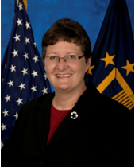
Ms. Phyllis A. Bower was appointed as the Executive Director of the Office of Acquisition Operations in October 2014. As the Executive Director, Office of Acquisition Operations, Ms. Bower is responsible for providing business and contracting solutions for a variety of major programs. She leads a professional contracting organization of approximately 500 acquisition professionals in Washington DC; Austin, TX; Eatontown, NJ; Fredericksburg, VA and Frederick, MD.

Ms. Bower has over 30 years of progressively responsible experience in federal acquisition. Prior to her appointment, she served as the Associate Executive Director for the Strategic Acquisition Center in Fredericksburg, VA. Ms. Bower began her government career as a Navy acquisition intern, and remained with the Navy for nine years. She subsequently worked for several agencies, and served in positions including: Chief, Quality Assurance Team for the National Institutes of Health; Head of the Contracting Activity, Acquisition and Logistics Division for the National Institute of Standards and Technology; and Head of the Contracting Activity, Competition Advocate, and Associate Director for Strategic Acquisition for the Nuclear Regulatory Commission.

